DEPARTMENT OF CITRUS OVERVIEW
April 2007 Report No. S07-02

Agency Responsibilities
The Florida Department of Citrus regulates, conducts research for, and promotes Florida’s citrus industry. The Legislature established the department to protect and enhance the quality and reputation of Florida citrus fruit and processed citrus products in both domestic and foreign markets.
The department is also responsible for implementing the policies of the Florida Citrus Commission, which serves as the agency head. The commission consists of 12 members appointed by the Governor and confirmed by the Senate for staggered three-year terms. Florida Citrus Commission members represent citrus growers, processors, and handlers.
Agency Organization
The department conducts its activities through three programs.
- Marketing plans and conducts advertising, publicity, and sales promotion campaigns to increase the consumption of citrus fruits and processed citrus products and byproducts
- Research conducts economic, marketing and scientific research relating to citrus fruits and products
- Administration plans and manages agency-wide operations and the department’s regulatory activities, such as licensing growers.
In addition, the department prepares and disseminates information to citrus stakeholders such as growers, processors, and industry associations. For a chart of the department’s organizational structure, see Exhibit 1 on page 2.
Agency Resources
The department is appropriated funding from the Citrus Advertising Trust Fund. The trust fund’s sources of revenue are excise taxes (“box taxes”) placed on each box of citrus moved by Florida growers through commercial channels, and federal grants. For Fiscal Year 2006-07, the Legislature appropriated $67.5 million and 90 positions for the department from this trust fund. (See Exhibit 2.)
Exhibit 2
Legislative Appropriations and Staffing for the
Department of Citrus
Appropriation | FY 2004-05 | FY 2005-06 | FY 2006-07
General Revenue | $10,000,000 | $0 | $0
Trust Funds | $70,664,026 | $70,794,365 | $67,539,120
Total | $80,664,026 | $70,794,365 | $67,539,120
FTE | 120 | 90 | 90
OPS | 15 | 15 | 15
Source: Legislative Appropriations System/Planning and Budgeting Subsystem (LAS/PBS), August 2006, and Department of Citrus Report to the Sunset Advisory Committee, December 2006.
However, actual department expenditures have been lower than the legislative appropriations in Fiscal Years 2004-05 and 2005-06 (expenditures were $52 million in Fiscal Year 2004-05 and $46 million in Fiscal Year 2005-06). This is due to actual citrus crop production being significantly lower than USDA estimates. As such, the department has had less box tax revenue available to pay for its activities. The department expects this trend to continue and it has requested general revenue funding to supplement its tax receipts for Fiscal Year 2007-08.
For more details on the department’s resources for Fiscal Year 2006-07, see Exhibit 3.

Exhibit 1
The Florida Department of Citrus’ Organizational Structure
Source: OPPAGA analysis and Department of Citrus Sunset Advisory Review survey.
Source: Department of Environmental Protection.
Exhibit 3
Department of Citrus Resources by Budget Entity for Fiscal Year 2006-07 ¹
Program | Federal Funds | State Trust Funds | TOTAL | FTE Positions |  | OPS Positions
Marketing | $11,637,000 | $ 41,512,580 | $53,149,580 | 24 |  | 1
Research | 3,020,755 | 6,358,030 | 9,378,785 | 27 |  | 2
Administration | 0 | 5,010,755 | $5,010,755 | 39 |  | 12
TOTAL | $14,657,755 | $ 52,881,365 | $67,539,120 |  | 90 |  | 15
¹ These numbers do not represent the Department’s actual expenditures, which are lower than the appropriated amounts.
Source: Legislative Appropriations System/Planning and Budgeting Subsystem (LAS/PBS), August 2006, and Department of Citrus Report to the Sunset Advisory Committee, December 2006.

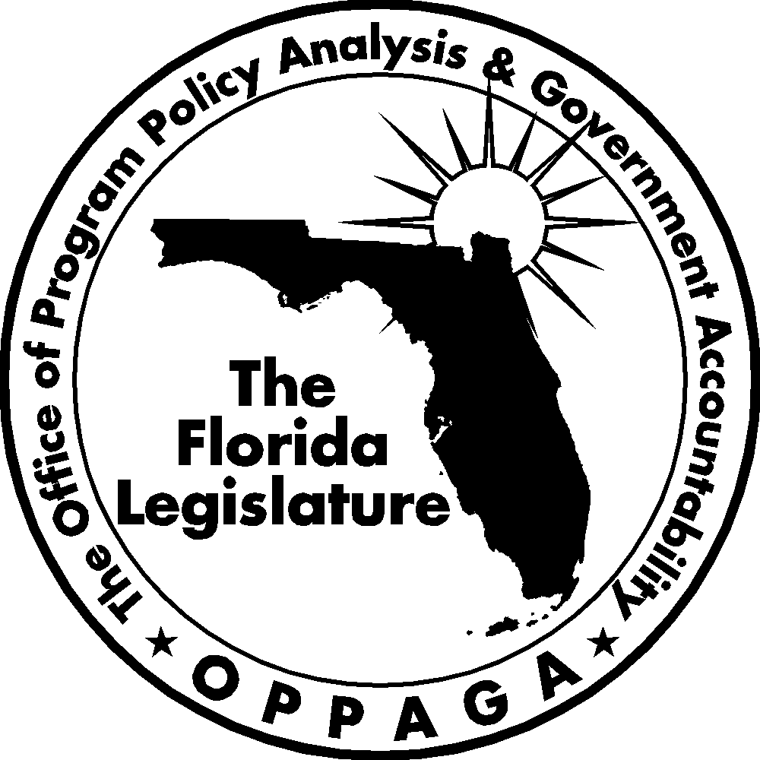
The Florida Government Accountability Act Sunset Reviews
The 2006 Legislature passed the Florida Government Accountability Act
(Ch. 2006-146, Laws of Florida) to create a Sunset review process. The act
- establishes the process, criteria, and schedule for the Legislature to assess
whether state agencies and advisory committees need to continue to exist;
- provides for the creation of a Legislative Sunset Advisory Committee and describes the membership and organization of the committee and committee duties;
- requires reports and assistance from state agencies and the Legislature’s Office of Program Policy Analysis and Government Accountability (OPPAGA).
Using these reports and other information, the Sunset Advisory Committee is to produce a report that includes recommendations to abolish, continue, or reorganize an agency or advisory committee under review.
Project supervised by Emily Leventhal (850/487-9239)
Tom Roth, Staff Director
Cover photo by Kent Hutchinson
Gary R. VanLandingham, OPPAGA Director

Office of Program Policy Analysis and Government Accountability
111 W. Madison Street, Room 312 ■ Claude Pepper Building ■ Tallahassee, Florida 32399-1475
(850) 488-0021 SUNCOM 278-0021 Fax: (850) 487-3804
www.oppaga.state.fl.us

The department reports that production levels were reduced due to hurricane damage and diseases such as canker and greening.

