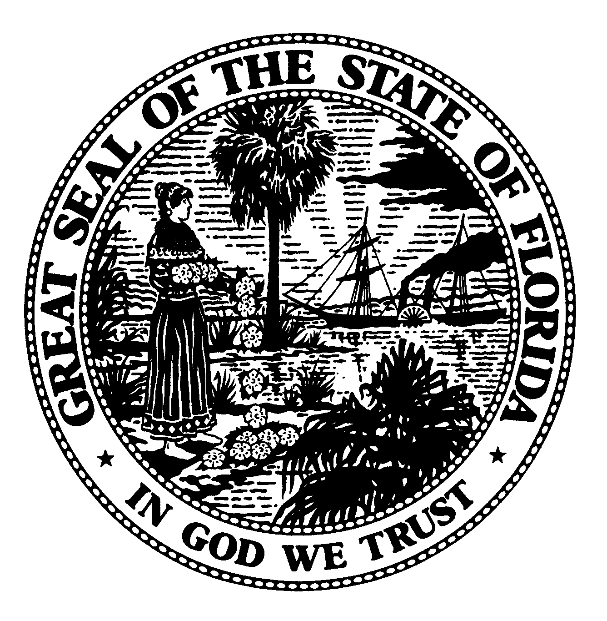 | The Florida Legislature  Office of Program Policy Analysis and  Government Accountability | 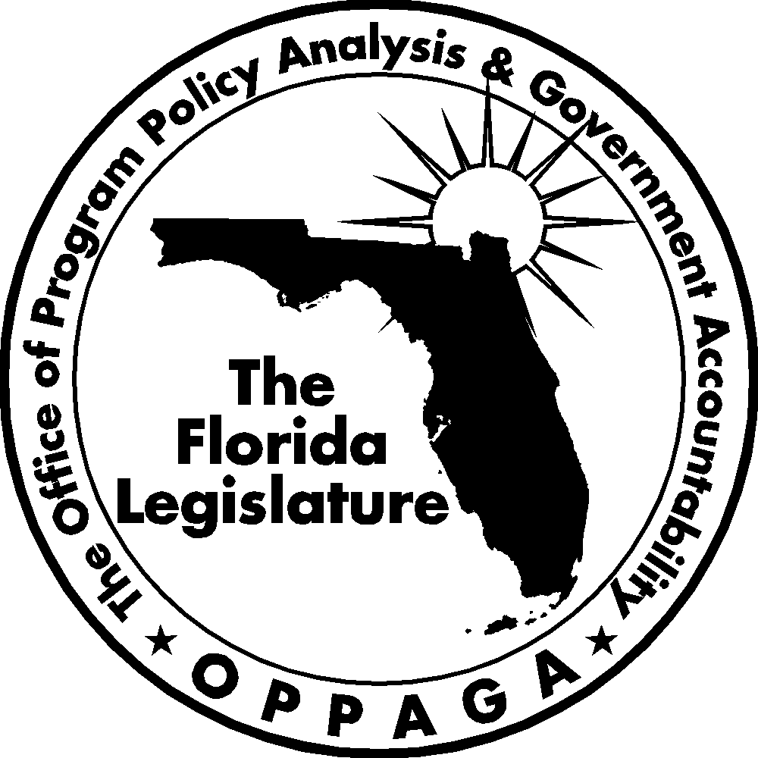
Sunset Memorandum

Conservation Land Management
Options for Legislative Consideration

December 20, 2007

Summary
To support the Sunset Review process, the Legislature directed OPPAGA to assess land management activities conducted by the Department of Agriculture and Consumer Services, the Department of Environmental Protection, and the Fish and Wildlife Conservation Commission. Separate memos address land management activities conducted by the state’s five water management districts and the state’s land acquisition activities.
This memo provides information about public access to the state’s conservation lands and assesses the agencies’ effectiveness in managing these lands. It also presents four policy options for the Legislature to consider regarding state conservation land management. These options include maintaining the current system of land management by three separate state agencies (Option 1); creating a council to coordinate and oversee land management activities (Option 2); centralizing land management activities under one state agency (Option 3); and centralizing all land management activities under a new entity (Option 4). The memo discusses the advantages and disadvantages of each option.

Agency Responsibilities
The state of Florida manages more than 3.7 million acres of conservation lands. These lands include state parks, preserves, forests, wildlife management areas, and other conservation and recreation lands that are managed to protect important natural and cultural resources and for public use and enjoyment. In addition to these state conservation lands, the federal government manages 4.0 million acres, the water management districts manage 1.4 million acres, and county and municipal governments manage 386,161 acres (see Exhibit 1 for a map of all state, federal, and local conservation land in Florida).
Exhibit 1
The State of Florida Manages More Than 3.7 Million Acres of Conservation Land
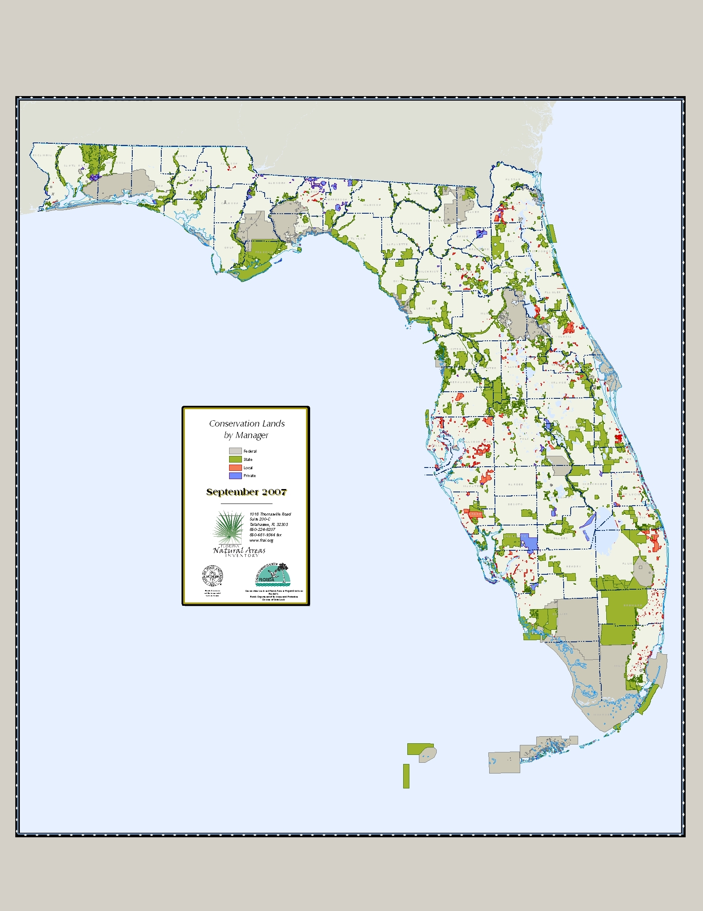
Source: Florida Natural Area Inventory.

Exhibit 2
Three State Agencies Manage the Majority of State Conservation Lands
Agency | Program | Management Purpose |  | Acres Managed
Department of Agriculture and Consumer Services | Forestry | Provide multiple use and sustainable forest management  (including silviculture and fire management) |  | 1,016,029
Department of Environmental Protection | Recreation and Parks | Protect natural and cultural resources and provide outdoor recreational opportunities |  | 724,629
Department of Environmental Protection | Coastal and Aquatic Managed Areas | Manage Aquatic Preserves, National Estuarine Research Reserves, National Marine Sanctuary, and Coral Reef Conservation Programs |  | 55,948
Department of Environmental Protection | Greenways and Trails | Manage statewide system of greenways and trails for recreational and conservation purposes |  | 83,840
Fish and Wildlife Conservation Commission | Wildlife Management Areas | Provide fish and wildlife protection and conservation, public recreation including and hunting, fishing and other outdoor activities |  | 1,402,278
Fish and Wildlife Conservation Commission | Wildlife and Environmental Areas | Protection and enhancement of habitat important to upland listed wildlife
TOTAL |  |  | 3,282,724
Source: Department of Agriculture and Consumer Services, Department of Environmental Protection, and the Fish and Wildlife Conservation Commission.
As shown in Exhibit 2, the state’s system for managing conservation land is decentralized. Three state agencies primarily have management responsiblities: the Department of Agriculture and Consumer Services; the Department of Environmental Protection; and the Fish and Wildlife Conservation Commission. Each of these agencies manages conservation lands differently based on its legislatively mandated responsibilities. For example, the Fish and Wildlife Conservation Commission primarily manages lands to conserve and protect fish, wildlife, and their habitats and to provide hunting opportunities. However, it allows other recreational activities, such as camping and hiking, when compatible with these primary purposes.
The Acquisition and Restoration Council, administratively housed in Department of Environmental Protection, is responsible for recommending which state agency should become the primary manager of newly aquired state lands. The council bases its recommendation primarily on the land acqusition goals the parcel is intended to meet, and how these goals match the agencies’ missions and roles in conservation land management. The Governor and Cabinet make the final decision on which agency will be the manager when they approve the land purchase. Depending on which agency is designated as the lead manager, the amount and types of land management activities conducted and recreational opportunities that will be available to the public will vary. For example, hunting is not allowed in state parks, so this recreational activity may not be available if a parcel is assigned to the Department of Environmental Protection to become a new park; in contrast, hunting may be allowed if the parcel is assigned to the Fish and Wildlife Conservation Commission or the Department of Agriculture and Consumer Services.

The Florida Statutes require that agencies facilitate multiple uses for conservation lands, such as public access and enjoyment; resource conservation and protection; ecosystem maintenance and protection; and protection of threatened and endangered species. Agencies conduct a variety of land management activities to achieve these multiple uses, including facility construction and maintenance, prescribed burning, wildlife management, control of exotic species and invasive plants, preserving historical and cultural resources, managing visitors, and restoration of natural habitats. Agencies often coordinate their activities to facilitate these multiple uses. For example, the Department of Agriculture and Consumers Services is the primary manager of timber lands, but it will often be assisted by the Fish and Wildlife Conservation Commission to manage hunting activities on these lands.
Each of the agencies also participate in land management planning and reviews. Land management plans provide guidelines for managing each state land parcel. Managing agencies are statutorily required to submit a land management plan to the Acquisition and Restoration Council within a year of acquisition and at least once every 10 years for each parcel they manage. At a minimum, the land management plan must include a
- statement of the purpose for which the lands were acquired;
- list of key management activities necessary to preserve and protect natural resources and restore habitat;
- specific description of how the managing agency plans to identify, locate, protect, and preserve, or otherwise use fragile, nonrenewable natural and cultural resources;
- priority schedule for conducting management activities;
- cost estimates for conducting priority and other management activities; and
- determination of the public uses and public access.
The Department of Environmental Protection is required to coordinate land management reviews to determine whether conservation lands owned by the state are being managed in accordance with land management plans. , The reviews are conducted by interagency teams that include one individual from the county or local community where the land is located, state agency representatives (i.e., Department of Agriculture and Consumer Services, Department of Environmental Protection, and Fish and Wildlife Conservation Commission staff), a private land manager, a member of the local soil and water conservation, and a member of a conservation organization. Department staff reported that, in Fiscal Year 2006-07, there were approximately 379 parcels managed by state agencies that had management plans, of these 156 are statutorily required to be reviewed every 5 years, and the department completed 25 land management reviews.

Exhibit 3
State Agencies Spent Nearly $220 Million on Land Management Activities in Fiscal Year 2006-07
Program | General  Revenue | Trust  Funds | Total | FTE
Department of Agriculture and Consumer Services | $9,001,890 | $ 26,064,266 | $ 35,066,156 | 506 ¹
Fish and Wildlife Conservation Commission | 0 | 23,641,461 | 23,641,461 | 89 ²
Department of Environmental Protection | 0 | 161,128,386 | 161,128,386 | 1,090.5
Total | $9,001,890 | $210,834,113 | $219,836,003 | 1,685.5
¹ The Division of Forestry also has 765 FTE positions for fire prevention and management.
² The Fish and Wildlife Conservation Commission has an addition 90 positions that include biological, acquisition, planning, and administrative support.
Source: The Department of Agriculture and Consumer Services, Department of Environmental Protection, and the Fish and Wildlife Conservation Commission.
Resources
The three state agencies with land management responsibilities receive funding for these activities from a variety of sources, including General Revenue and trust funds. Land management expenditures have generally increased over the last six years from $173 million in Fiscal Year 2001-02 to approximately $220 million in Fiscal Year 2006-07. The amount of funds expended by each agency is primarily determined by the number of acres managed and the level of management required, based on the statutory mission of the agency. The Department of Environmental Protection expended the highest amount of funds on land management activities, $161.1 million, in Fiscal Year 2006-07. See Exhibit 3.
Over the Fiscal Year 2003-04 to Fiscal Year 2005-06 period, the largest percentage of these expenditures was for capital improvements, which includes new facility construction and facility maintenance. As shown in Exhibit 4, over the three-year period, these expenditures accounted for an average of approximately a quarter of the state’s total land management expenditures. The next highest expenditures were for resource management (22%); these activities include prescribed burning, invasive plant control, and hydrological management.

Exhibit 4
On Average, From Fiscal Year 2003-04 to Fiscal Year 2005-06, Capital
Improvements Were the Largest Land Management Expense
Source: Land Management Uniform Cost-Accounting Councils Annual Reports 2004, 2005, 2006.
Most conservation land is accessible to the public, but authorized uses vary
The Florida Statutes require conservation land managers to provide public access to natural
resource-based recreation where feasible and consistent with the goals of protection and conservation of natural resources. Most state conservation land is open to the public for a wide variety of recreational activities. Specifically, 3,279,551 acres or 99.9% of state lands managed by the three agencies are accessible to Florida citizens and visitors. However, the permitted activities on individual parcels vary greatly based on the land’s characteristics and the missions of the managing agencies.
Each agency manages lands based on its legislatively mandated responsibilities. Therefore, available recreational activities on land managed by the three agencies vary (see Exhibit 5). For example, the Fish and Wildlife Conservation Commission provides hunting access on most of the wildlife management areas it manages, which is consistent with its responsibility for hunting regulation and game management. Conversely, the Department of Environmental Protection does not allow hunting within most state parks, greenways, and state trails it manages due to safety concerns for visitors, but does allow hunting in some coastal and aquatic management areas and a portion of the Cross Florida Greenway. The Department of Agriculture and Consumer Services allows hunting in most state forests. Fishing is authorized in slightly over half of the state forests, about two-thirds of the parks and recreation lands, and over three-quarters of the wildlife management areas.
Exhibit 5
A Variety of Recreational Opportunities Are Allowed on State Conservation Lands
 | Number of Managed Areas that Are Open to the Public
Recreational Oppurtunity¹ | 33 State Forests  (1,016,029 Acres) | 160 Parks and Recreation Lands  (724,629 Acres) | 11 Greenways and Trails  (83,840 Acres) | 51 Coastal and Aquatic  Managed Areas  (55,948 Acres) | 37 Wildlife Management Areas  (1,402,278 Acres) | Total  292 Areas  (3,282,724 Acres)
Biking | 23 | 58 | 8 | 7 | 25 | 121
Camping | 19 | 65 | 1 | 21 | 16 | 122
Canoeing/Kayaking | 19 | 85 | 2 | 41 | 20 | 167
Equestrian Activities | 17 | 31 | 7 | 3 | 18 | 76
Fishing | 20 | 105 | 2 | 48 | 29 | 204
Hiking | 25 | 121 | 8 | 16 | 34 | 204
Hunting | 28 | 0 | 1 | 12 | 27² | 68
Motorized Boating | 8 | 61 | 1 | 46 | 21 | 137
Recreational Infrastructure | 22 | 126 | 3 | 24 | 27 | 202
Swimming and Beach Activities | 4 | 72 | 0 | 44 | 0 | 120
Tours | 7 | 86 | 0 | 0 | 4 | 97
Watercraft Access Points | 19 | 34 | 1 | 0 | 15 | 69
Wildlife Viewing | 29 | 116 | 1 | 46 | 36 | 228
¹ The types of recreational opportunities provided by the state agencies vary. For example camping may include primitive camping, full facility camping, group camping, campfire circles, and RV camping.
² The 10 Wildlife Management Areas not open to hunting are closed because of local government agreements, small parcel size, or extreme environmental sensitivity.
Source: OPPAGA analysis of information from Department of Agriculture and Consumer Services, Department of Environmental Protection,
and Fish and Wildlife Conservation Commission websites and staff.
However, some state lands are not open to the public. The three agencies reported that 3,173 acres of lands they manage are not open to the public. Most of this acreage (1,430) has been closed by the Department of Environmental Protection primarily because it is currently being repaired or developed for future public use, such as developing new greenways and trails. The Fish and Wildlife Conservation Commission does not allow access to 1,305 acres in wildlife management areas due to acquisition contract provisions, to protect infrastructure or sensitive environments or to help ensure public safety. Finally, the Department of Agriculture and Consumer Services does not allow the public access to 438 acres of land it manages because these areas are not easily accessible by car or foot.
Agencies generally make information on the recreational opportunities available to the public on their websites and brochures. Agencies provide multiple ways for users to search for activities, such as by park, state region, or activity type. For example, the Fish and Wildlife Conservation Commission allows users to search its website by both activity type (e.g., hunting and fishing) and wildlife management area. Similarly, the Department of Environmental Protection Division of Recreation and Parks’ website allows users to search by detailed activity categories as well as geographical location.
However, there is no centralized source of information about recreational opportunities on state conservation land. Members of the public must seek information from each state agency to determine what recreational opportunities are available on state recreation lands. The Legislature could address this issue and improve information provided to the public about recreational opportunities by directing the three agencies to standardize the information they provide to citizens and visitors. Alternatively, the Legislature could direct the agencies to work with VISIT FLORIDA to develop a centralized website that provides information on all state conservation lands and the recreational opportunities available on them. The centralized website should be fully searchable by activity type, geographical location, and managing agency and should include property maps.
Agencies demonstrate mixed results in land management
Agencies showed mixed results on their performance measures that relate to land management for Fiscal Year 2006-07. As shown in Exhibit 6, the Department of Agriculture and Consumer Services exceeded its performance standard for the number of state forest visitors during the year, but it did not meet standards for providing forest-related technical assistance to other public land management agencies and for the number of acres authorized for prescribed burning. Similarly, the Department of Environmental Protection exceeded its standard for increasing the percentage of visitors to state parks, but did not meet its standard for the percentage of managed acres with invasive species controlled. The Fish and Wildlife Conservation Commission exceeded its performance standard for the number of acres managed for wildlife.
Exhibit 6
In Fiscal Year 2006-07, State Agencies that Manage Conservation Lands Met Standards for 7 of 13 Performance Measures Related to Land Management
 |  |  | Standard  Fiscal Year  2006-07 | Actual Performance  Fiscal Year  2006-07
Department of Agriculture and Consumer Services |  | Number of acres of state forests managed by the department | 1,007,000 | 1,016,029
Department of Agriculture and Consumer Services |  | Number of state forest visitors served | 650,000 | 909,122
Department of Agriculture and Consumer Services |  | Number of hours spent providing forest-related technical assists to public land management agencies | 13,300 | 9,152
Department of Agriculture and Consumer Services |  | Percentage of state forest timber-producing acres adequately stocked and growing | 61% | 63%
Department of Agriculture and Consumer Services |  | Number of acres authorized to be burned through prescribed burning ¹ | 2.3 million | 1.8 million
Department of Environmental Protection | State Park System | Percentage change in the number of state parks acres restored or maintained in native state from the prior fiscal year | 2% | -17%
Department of Environmental Protection | State Park System | Percentage increase in the number of visitors from the prior fiscal year | 1.3% | 7.3%
Department of Environmental Protection | Greenways and Trails | Percentage of managed acres with invasive or undesirable species controlled | 35% | 25%
Department of Environmental Protection | Coastal and Aquatic Areas | Total number of degraded acres in National Estuarine Research Reserves enhanced or restored | 1,658 | 3,275
Department of Environmental Protection | Coastal and Aquatic Areas | Percentage change in the number of degraded areas in National Estuarine Research Reserves enhanced or restored from those enhanced or restored in the previous fiscal year | 1% | 250%
Department of Environmental Protection | Coastal and Aquatic Areas | Percentage change of managed lands infested by invasive plants | 1% | 17%
Department of Environmental Protection | Coastal and Aquatic Areas | Percentage increases in the number of visitors | 3% | -.74%
Fish and Wildlife Conservation Commission |  | Number of acres managed for wildlife ² | 5,539,815 | 5,663,890
¹ This measure includes all authorized prescribed burning in Florida by county, state, federal, and private land managers.
² The Fish and Wildlife Conservation Commission is lead manager on 1.4 million acres and is a cooperating manager on an additional 4.2 million acres.
Source: Department of Agriculture and Consumer Services, Department of Environmental Protection, and Fish and Wildlife Conservation Commission Fiscal Year 2007-08 Long-range Program Plans.
The agencies reported several reasons for not achieving performance standards. The Department of Agriculture and Consumer Services cited unfavorable weather conditions as one reason why it did not meet its target for prescribed burns, and indicated that it provided fewer than anticipated hours of forest-related technical assists to public land management agencies due to other priorities such as suppressing wildfires and responding to other emergencies. The Department of Environmental Protection similarly cited drought conditions for limiting prescribed burning and staff shortages for limiting its invasive plant control activities.
Performance measures need improvement. The agencies’ current performance measures provide limited information about the condition and uses of the conservation lands they manage. This hinders the state’s ability to identify the conservation status of these lands, track progress towards achieving conservation and recreation goals, and assess funding needs. For example, a state park identified the control and removal of invasive plants as a goal, however there are no performance measures that report progress on invasive plant control in state parks. In addition, performance measures do not quantify the availability of recreational opportunities, like miles of trails, days of hunting allowed statewide, and number of fisherman who reach bag limits.
To address this problem, the Legislature could direct agencies to establish and report performance measures on the condition and uses of conservation lands. A more complete set of performance measures would include those noted below.
- Percentage and number of acres of public lands that are open to various recreational uses
- Percentage and number of visitors satisfied with recreational experiences
- Percentage and number of acres identified for restoration activities that attain restoration goals
- Percentage and number of acres of managed lands in good/fair/poor condition
- Percentage and number of acres of public conservation lands on which upland invasive, exotic plant control operations have been conducted
- Percentage and number of acres of public lakes and rivers in which invasive, non-native aquatic plants are in maintenance condition
- Status of endangered/threatened/ special concern species on publicly managed conservation areas
- Percentage and number of acres burned according to the agency’s prescribed burning schedule
To develop these measures, the Department of Agriculture and Consumer Services, the Department of Environmental Protection, and the Florida Fish and Wildlife Conservation Commission should jointly develop a system to assess, quantify, and rate the condition of state lands. At a minimum, the system should enable agencies to report annually the condition of state lands on a scale of poor, fair, good, and excellent. These ratings should be based on state and agency management objectives and performance measures.
Land management review process should be enhanced. Agencies’ ability to manage conservation lands would also be strengthened if the land management review process were modified. Specifically, land management plans should be improved, more information should be provided to review participants, more time should be provided to conduct the reviews, and the results of the reviews should be better reported to stakeholders.
Our assessment of land management plans found that many do not detail specific needed activities or provide timelines for achieving stated goals. For example, the plans often lack basic information about the type, amount, and cost of management activities to be conducted. Plans also often lack details on what work needs to be done to meet a goal such as restoring a property’s hydrological features or how long it will take to restore it. Without this information, review teams lack benchmarks to assess progress toward achieving land management goals.
In addition, to assess the land management review process, we surveyed persons who had participated in these reviews and observed four review sessions. Survey respondents were generally positive about the land management review process, with 79% indicating that the process is useful. However, these respondents also raised several concerns about the review process. For example, many respondents indicated that they did not receive enough information before a review to adequately prepare them to participate in the process. Overall, over one-fifth (22%) of participants reported that additional information on the process or property was needed to facilitate an effective review. Finally, some participants indicated that there was not sufficient time to conduct reviews and that some designated persons do not participate. To improve the land management review process, the Department of Environmental Protection convened a workgroup in September 2007. Conservation land managers and other stakeholders will assist the department in modifying the review process, with the workgroup’s top priorities being to
- improve the synthesis of land management review data to a legislative report;
- modify land management plans to include measurable scientific and financial data and modifying the format to be more reader-friendly; and
- assess the appropriateness and improving the expertise of team composition.
Options for Legislative Consideration
The state currently manages over 3.7 million acres of conservation land at a management cost of approximately $220 million annually. As the state acquires more conservation land, these costs will increase, as will the need to effectively manage these lands and track, and report performance. However, the current management system is decentralized among three agencies, and the existing accountability system needs improvement.
Exhibit 7 presents four policy options for the Legislature to consider. These options include maintaining the current system of conservation land management by three separate state agencies (Option 1); creating a council to coordinate and oversee land management activities (Option 2); centralizing land management activities under one state agency (Option 3); and centralizing all land management activities under a new entity (Option 4). The exhibit summarizes the policy options and describes the advantages and disadvantages associated with each option.

Exhibit 7
The Legislature Could Consider Several Options to Modify Management of State-Owned Conservation Lands
Option |  | Advantages |  | Disadvantages
Option 1 – Maintain Current System of Conservation Land Management by State Agencies
Maintain the current organizational structure of land management by the Department of Agriculture and Consumer Services, Department Environmental Protection, and the Fish and Wildlife Conservation Commission. | - Agencies would retain the ability to focus on specialized land management activities related to mission and goals  - Would preserve the established funding mechanism |  | - Current structure may not provide adequate mechanisms for coordinating activities across agencies  - Agency mission may limit types of land management activities on state lands
Option 2 –Create a Council to Coordinate and Oversee Land Management Activities
Create an interagency council to coordinate and oversee land management activities undertaken by state agencies. The council would be responsible for creating a system to track land management activities and the condition of state lands. | - Current model for an interagency council exists in the Acquisition and Restoration Council  - Agencies would retain the ability to focus on specialized land management activities related to their mission and goals  - Would maintain current organizational structure of state agencies managing land  - Establishing a separate council would increase focus on conservation land management  - Council could make recommendations on how to distribute land management funds based on legislative priorities  - Would increase accountability and oversight of land management activities |  | - Would increase administrative costs; based on current expenses of the Acquisition and Restoration Council, these costs could be at least $70,000 annually  - Land management agencies may disagree with council’s priorities  - Would separate land management from acquisition process and require increased coordination, because the Acquisition and Restoration Council currently oversees both acquisition and management decisions
Option 3 - Centralize Land Management Activities Under One State Agency
Centralize land management under one of the three current state land managing agencies. Under this model, the land management responsibilities, functions, activities, staff, funding, and equipment of the Department of Agriculture and Consumer Services, the Department of Environmental Protection, and the Fish and Wildlife Conservation Commission would be transferred to one agency. This agency would oversee all state-owned conservation and recreational areas, including state parks, state forests, greenways and trails, water bodies, wildlife management areas, and coastal and aquatic areas. In addition, the agency would undertake all management activities currently conducted by the three agencies, including facility construction and maintenance, prescribed burning, imperiled species recovery, wildlife management, trail maintenance, control of exotic species and invasive plants, restoration of natural habitats, and visitor services. Placement of land management activities with any of the three agencies has advantages and disadvantages, as described below.
Criteria for Legislative consideration in centralizing land management should include
- Cost efficiencies and reductions in administrative and operating costs
- Improved coordination of staff and equipment use
- Centralized policy-making
- Reduction in duplication

Options | Advantages | Disadvantages
Department of Agriculture and Consumer Services | - Department is the second largest manager of state conservation land  - Department has the most expertise and resources for timber and fire management  - Would consolidate policy and decision-making  - Would centralize accountability and oversight of land management activities  - Would eliminate duplication of land management activities currently conducted by multiple agencies (e.g., prescribed burning and invasive plant control) | - May be objections from existing agencies  - Transition from decentralized to centralized system may be difficult  - Could be conflicts from integrating staff from agencies with various statutory missions and goals  - Department mission may not be consistent with full range of conservation land uses
Department of Environmental Protection | - Department has largest number of visitors to state-owned managed areas - state parks  - Staff has expertise in invasive plant management  - Department currently staffs the Acquisition and Restoration Council and land management reviews  - Would consolidate policy and decision-making  - Would centralize accountability and oversight of land management activities  - Would eliminate duplication of land management activities currently conducted by multiple agencies (e.g., prescribed burning and invasive plant control) | - May be objections from existing agencies  - Transition from decentralized to centralized system may be difficult  - Could be conflicts from integrating staff from agencies with various statutory missions and goals
Fish and Wildlife Conservation Commission | - Department is the largest land manager of state land  - Department performs management activities on the majority of state land acres as primary or coordinating land manager  - Department’s primary mission is conservation, including fish, wildlife, habitat, recreation, and land management, which is generally consistent with overall land management functions  - Currently implementing an objective-based vegetation management approach to resource management that takes into consideration land condition and focuses management activities to improve land  - Would consolidate policy and decision-making  - Would centralize accountability and oversight of land management activities  - Would eliminate duplication of land management activities currently conducted by multiple agencies (e.g., prescribed burning and invasive plant control) | - May be objections from existing agencies  - Transition from decentralized to centralized system may be difficult  - Could be conflicts from integrating staff from agencies with various statutory missions and goals

Agency Placement Options | Advantages | Disadvantages
Option 4 - Centralize all land management activities under a new entity
Under this model, the land management responsibilities, functions, activities, staff, funding, and equipment of the Department of Agriculture and Consumer Services, the Department of Environmental Protection, and the Fish and Wildlife Conservation Commission would be transferred to a new entity. This entity would oversee all state-owned conservation and recreational areas, including state parks, state forests, greenways and trails, water bodies, wildlife management areas, and coastal and aquatic areas. In addition, the entity would undertake all management activities currently conducted by the three agencies, including facility construction and maintenance, prescribed burning, imperiled species recovery, wildlife management, trail maintenance, control of exotic species and invasive plants, restoration of natural habitats, and visitor services. | - Land management activities would be the sole focus of the new entity  - Would consolidate policy and decision-making  - Would centralize accountability and oversight of land management activities  - Would eliminate duplication of land management activities currently conducted by multiple agencies. (e.g., prescribed burning and invasive plant control) | - Would result in increased costs associated with establishing a new administrative structure  - Would increase the number of state agencies  - May be objections from existing agencies  - Transition from decentralized to centralized system may be difficult  - Could be conflicts from integrating staff from agencies with various statutory missions and goals
Source: OPPAGA analysis.

Section. 253.034, (2)(c), F.S., provides that conservation lands are lands that are currently managed for conservation, outdoor-based recreation, or archaeological or historic preservation.
The Acquisition and Restoration Council is responsible for evaluating, selecting, and ranking state land acquisition projects for the Florida Forever program, subject to approval or modification by the Board of Trustees. The council annually reviews Florida Forever acquisition proposals, decides which proposals should receive further evaluation, and determines the final project boundaries. Exceptions to this are lands purchased by the in-holding and addition programs of, the Department of Agriculture and Consumer Services, the Department of Environmental Protection and the Fish and Wildlife Conservation Commission.
Section 253.034(1), F.S.
Section 253.034(5), F.S.
Chapter 259.036, F.S.
Specifically, the statute requires review teams to assess the extent to which existing management plan provides sufficient protection to threatened or endangered species, unique or important natural or physical features, geological or hydrological functions or archaeological features, the extent to which the land is being managed in accordance with the purposes for which is was acquired, and the extent to which actual management practices, including public access, are in compliance with the adopted management plan.
Trust funds include the Conservation and Recreation Land Trust Funds, the State Park Trust Fund, Incidental Trust Fund, and the State Game Trust Fund.
Section 253.034, F. S.
In addition, the state has purchased development rights to 515,627 acres through less-than-fee acquisitons. These lands remain in private ownership and are typically closed to the public.
VISIT FLORIDA is the state’s official tourism marketing corporation created in 1996. VISIT FLORIDA is not a government agency, but rather a not-for-profit corporation that carries out the work of the Florida Commission on Tourism, which was created as a public/private partnership by the Florida Legislature in 1996.
We attended land management reviews at Edward Ball Wakulla Springs State Park, Wakulla State Forest, J.R. Alford Greenway, and Alfred B. Maclay Gardens State Park in April 2007. We also surveyed 334 individuals who participated in a land management review between July 2004 and June 2007, with 143 (43%) responding.

