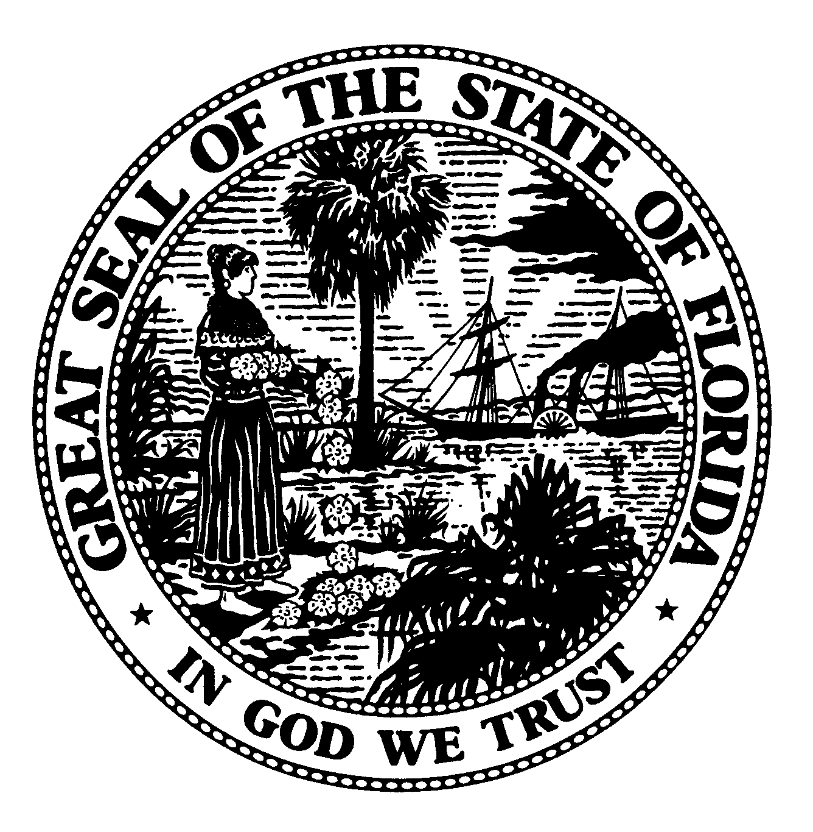 | The Florida Legislature  Office of Program Policy Analysis and  Government Accountability | 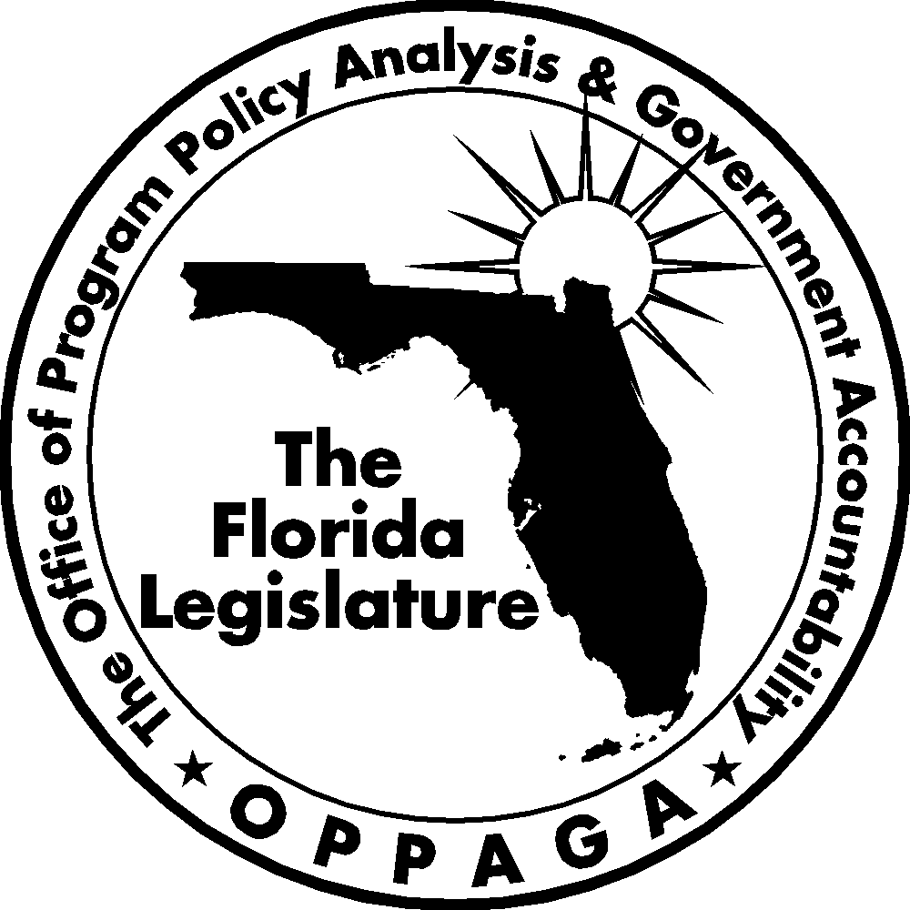
Sunset Memorandum

Department of Agriculture and Consumer Services
Agricultural Economic Development Program
Legislative Options

January 8, 2008

Summary
To support the Sunset Review Process, the Legislature directed OPPAGA to examine the Department of Agriculture and Consumer Services (DACS). This memo focuses on the Agricultural Economic Development Program and its purpose, organization, responsibilities, resources, and performance. The memo also offers options for legislative consideration.
OPPAGA developed three options for the Legislature to consider for the Agricultural Economic Development Program. These options include (1) reducing the program’s need for general revenue funding by increasing or establishing fees for regulatory and inspection activities; (2) eliminating general revenue funding for the Florida Agriculture Promotional Campaign and requiring matching funds for the division’s other marketing assistance activities; and (3) privatizing the State Farmers’ Market Program and transferring responsibility for operating and maintaining the markets to other entities. For each option, we describe advantages and disadvantages.

Purpose, Organization, and Responsibilities
The Agricultural Economic Development Program is charged with improving production and sale of Florida agriculture products. The department seeks to accomplish this goal through a variety of inspection, disease management, and marketing activities. The program works closely with industry representatives to identify needs for research and testing, as well as to manage disease outbreaks and other problems as they arise.
The program comprises five divisions.
- Animal Industry – enforces animal health regulations in Florida to protect the state from animal pests and diseases. Program activities include inspecting and tracking animals entering the state, and controlling and eradicating animal diseases.
- Aquaculture – oversees the development, regulation, and coordination of aquaculture in Florida. Program activities include inspecting shellfish processing plants, testing water quality, managing aquaculture leases and certifications, and restoring oyster beds.
- Fruit and Vegetables – conducts inspections to ensure the quality of Florida’s produce. Program activities include inspecting fruit and vegetables, licensing citrus fruit dealers, and registering packing and processing facilities.
- Marketing and Development – encourages the production and consumption of Florida agricultural products through national marketing campaigns. Program activities include conducting market research, facilitating communication between growers/producers and retailers, regulating agricultural product dealers, and managing the state’s Food Distribution Program and Farmer’s Markets.
- Plant Industry – seeks to protect plants and honeybees from harmful diseases. Program activities include conducting research, apiary inspections, and control measures.
Although administered by the Office of Agricultural Law Enforcement, Agricultural Interdiction Stations are also included as a part of the Agricultural Economic Development Program by the department. Interdiction station personnel inspect highway shipments of agricultural commodities regulated by the department, and also identify potential revenue from taxable commodities being imported into the state and transmit the bills of lading to the Department of Revenue.
Resources
The Legislature appropriated $145.6 million in trust funds and general revenue and 1,213 full time positions for the Agricultural Economic Development Program for Fiscal Year 2007-08 (see Exhibit 1). The program receives 58% of its funding from general revenue and 42% from trust funds. With the exception of the Division of Fruits and Vegetables, which is funded entirely by trust funds, the program’s divisions are largely funded by general revenue.
Exhibit 1
The Legislature Appropriated $145.6 Million to the Agricultural Economic Development Program for
Fiscal Year 2007-08
Program | General Revenue | Trust Funds | Total | FTE
Agricultural Interdiction Stations | $ 17,464,040 | $ 413,177 | $ 17,877,217 | 242
Animal Industry | 10,449,560 | 3,911,625 | 14,361,185 | 150.5
Aquaculture | 5,530,849 | 2,640,931 | 8,171,780 | 52.5
Fruit and Vegetables |  | 13,221,482 | 13,221,482 | 206
Marketing and Development | 36,674,533 | 18,247,617 | 54,922,150 | 195
Plant Industry | 14,929,895 | 22,105,590 | 37,035,485 | 367
Total | $85,048,877 | $60,540,422 | $145,589,299 | 1,213
Source: Chapters 2007-72 and 2007-326, Laws of Florida.
Performance
As shown in Appendix A, the Agricultural Economic Development Program met the established standards for 17 of its 29 legislatively mandated performance measures in Fiscal Year 2006-07 (the most recent period for which performance data is available). For example,
- 98.5% of the shellfish facilities inspected by the Division of Aquaculture were found to be in compliance with permit and food safety regulations, which exceeded the standard of 80%; and
- 99.9% of the vehicles inspected at Agricultural Interdiction Stations were found to be free of pests and diseases, which exceeded the standard of 99.4%. The program has exceeded its standard for this measure for each year since Fiscal Year 2004-05.
However, the Agricultural Economic Development program did not meet the established standards for 12 performance measures, including the examples below.
- The program did not meet its standard for the number of square feet leased at Farmers Markets, leasing 1.9 million square feet compared to the standard of 2 million square feet. The department explained that it did not meet this standard because hurricane-damaged facilities and facilities under reconstruction were unavailable for occupancy.
- The Division of Plant Industry did not meet its standard for the number of cartons of citrus certified fly-free, certifying 8.1 million cartons compared to the standard of 10 million cartons. The department stated that it did not meet this standard due to citrus diseases such as canker and greening that reduced the size of Florida’s citrus crop and hence the number of cartons needing to be certified by the department.
- The Agricultural Interdiction Stations did not meet the standard for the amount of revenue generated from transmitting bills of lading from interdiction stations to the Department of Revenue in Fiscal Year 2006-07, with $8.3 million generated compared to the standard of $9.1 million. The stations also did not meet this standard for the prior two fiscal years. The department reported that this standard was not met in Fiscal Year 2006-07 due to more companies in Florida complying with laws and regulations.
The department has not addressed an issue identified in 2001 and 2004 OPPAGA reviews of the program. These reports concluded that the Division of Marketing could improve the performance of its economic development activities by establishing a comprehensive marketing plan each year that establishes overall strategies and objectives, and provides for an evaluation of the success of each major marketing campaign. As of December 2007, the Division of Marketing had not developed such a comprehensive marketing plan.
Program Need
The services performed by the Agricultural Economic Development Program help to prevent, control, and eradicate specific agricultural and animal pests and diseases that could potentially adversely affect Florida’s agricultural industry and public health. In addition, the program performs activities that help promote Florida’s agricultural products and contribute to increased economic activity throughout the state. Accordingly, it would not be in the state’s best interest to eliminate the program. However, as discussed below, the Legislature may wish to consider options to reduce the program’s reliance on general revenue funding and reduce some activities.
Options for Legislative Consideration
Section 216.0236, Florida Statutes, provides that it is the Legislature’s intent that all costs of providing a regulatory service or regulating a profession or business be borne solely by those who receive the service or who are subject to regulation. If the Legislature wished to reduce general revenue funding for the program, it may consider the following options: (1) increasing or creating fees for the Agricultural Economic Development Program’s regulatory and inspection activities, (2) increasing fees for the Florida Agricultural Promotional Campaign, (3) requiring matching funds for marketing assistance activities, and (4) privatizing the state farmers’ markets. Exhibit 2 summarizes these policy options and describes the advantages and disadvantages associated with each option.
Increase or create fees to make the Agricultural Economic Development Program’s regulatory and inspection activities more self-sufficient
If the Legislature wished to make program activities more self-sufficient, it could increase various regulatory fees. As shown in Appendix B, most of the program’s fees are capped by statute and, with the exception of the fees charged for animal inspections, are already at the established cap. (See Appendix C for information on the fees charged for animal inspections by the Division of Animal Industry and Appendix D for information on fees charged for agricultural dealer’s licenses by the Division of Marketing and Development.) Consequently, the Legislature may wish to consider raising or removing the statutory fee caps for the following regulatory activities.
- Aquaculture certifications. The Division of Aquaculture collects an annual ($50) fee for aquaculture certifications that are required for any person engaging in aquaculture activities. This fee has not been increased since 1997. In Fiscal Year 2006-07, aquaculture certification fees generated approximately $49, 048. However, 95% of the activity’s total costs of $408,368 were funded by general revenue ($387,162). In order for this function to be self-sufficient, the annual certification fee would have to be raised to approximately $416. While it may not be feasible to increase fees to this level, a smaller increase would help reduce the need for general revenue funding. For example, doubling the certification fee to $100 would reduce the need for general revenue funding by approximately $49,000.
- Animal inspections. The Division of Animal Industry collects 23 fees for inspections of animals that range from $2 to $1,250 (see Appendix C). Most of these fees have not been changed in many years. Appendix B shows that 91% of the activity’s total costs of $6,155,673 in Fiscal Year
2006-07 were funded by general revenue. The Legislature may wish to increase these fees to reduce the function’s reliance on general revenue funding. For example, the Legislature could raise the fees for registering livestock brands and livestock hauler permits. Currently, owners using a brand to identify their livestock pay a fee of $10 for a new brand application or to transfer a brand, and $5 to renew a brand. Some other states, such as Missouri, charge higher fees to register brands ($35 for a new application, $10 for a brand transfer, and $20 to renew a brand). Additionally, the department charges persons hired to haul livestock an annual permit fee of $5. However, Alabama charges $30 for this permit. Raising brand registration fees to the level charged by Missouri and the livestock hauler fee to the level charged by Alabama would generate approximately $57,000 in revenue.
- Apiary inspections. The Division of Plant Industry collects fees for beekeeper registrations which range from $10 to $100 depending on the number of bee colonies operated by a registrant. In Fiscal Year 2006-07, beekeeper registration fees generated approximately $51,000. However, 85% of the activity’s total costs of $1,144,529 were funded by general revenue ($971, 221). In order for this function to be self-sufficient, the registration fee would need to be increased to $1,140. While it may not be feasible to increase fees to make this function self-sufficient, a smaller increase would help reduce the need for general revenue funding. For example, doubling the current fees to $20 to $200 depending on the number of bee colonies operated by a registrant would generate approximately $50,000 in revenue.
The Legislature could also establish fees for shellfish processing plant inspections. These plants are inspected between two and four times per year, and the department does not charge fees for this activity. Appendix B shows that 91% of the activity’s total cost of $389,000 in Fiscal Year 2006-07 was funded by general revenue with the remainder funded by a trust fund. Because of the small number of processing plants in the state (100), it would not be feasible to fully recover program costs unless fees were set at a high level. Assuming each plant was inspected four times per year, the department would need to charge approximately $972 per inspection to cover the activity’s cost in Fiscal Year 2006-07. While it may not be feasible to increase fees to such a level, some smaller increase may not have a substantial impact on industry and would reduce the need for general revenue funding. For example, an annual inspection fee of $250 would generate $25,000 in revenue.
Eliminate general revenue funding for the Florida Agriculture Promotional Campaign
The Legislature may wish to consider eliminating general revenue funding for the Florida Agricultural Promotional Campaign. This campaign uses the “Fresh from Florida” logo to help consumers identify Florida-grown agricultural commodities. The campaign charges processors, producers, and industry associations a fee of $50 for participation in the Florida Agricultural Promotional Campaign. The campaign’s fees generated approximately $51,100 in Fiscal Year 2007-08. However, the vast majority of the campaign’s funding during this year was from general revenue ($4,110,000). General revenue funding for the campaign has increased substantially in recent years, growing from $656,000 in Fiscal Year 2002-03 to $4.11 million in Fiscal Year 2007-08.
In contrast, California’s Department of Food and Agriculture administers a similar campaign called “Buy California” that is funded entirely by member fees. Participants in California’s campaign each contribute $15,000 to $25,000 annually. Florida’s annual fee for participation in the Florida Agricultural Promotional Campaign would need to be raised to $4,022 per participant in order for the campaign to become self-sufficient. The Legislature may also wish to consider a smaller fee increase, such as raising the contribution fee to $500, which would not have as large of an impact on the industry but would reduce the need for general revenue funding by $511,000.
The Legislature also may wish to consider requiring that matching funds be provided for the Division of Marketing’s marketing campaigns and market research projects. The division’s campaigns and research activities are usually conducted in response to requests by industry groups. While such groups sometimes contribute funding to the division, they are not required to do so. In contrast, the State of Texas requires industry groups to provide dollar-for-dollar matching funds in order to receive funding from the Texas Department of Agriculture’s Go Texan Partner Program. This program provides grants to industry groups to increase consumer awareness and sales of Texas agricultural products through specific promotional activities. Requiring matching funds could help reduce the Division of Marketing’s reliance on general revenue funding.
Privatize the State Farmers’ Market Program
The mission of the State Farmers’ Market Program is to assist in the marketing of farm products by providing the information, leadership, and facilities necessary to move farm products from the farm to the consumer via a distributor, and to assure the consumer a better quality product at a reasonable price and a fair return to the producer. This program is administered by the Division of Marketing and Development, which operates 13 markets located throughout the state. The program is currently self-supported by fees charged by entities using the farmers markets, including packing house, cooler, and office rental fees and truck scale fees. However, the program’s capital investments historically have been paid for by general revenue.
In recent years, the department has closed other farmers markets, including one that previously operated in Bonifay. The Legislature may wish to consider privatizing the remaining farmers markets and transferring responsibility for operating and maintaining them to other entities, including local governments, non-profit entities, or for-profit corporations. This action would result in long-term cost savings to the state as the state markets private owners or counties would assume responsibility for both facility operation and future capital improvements. It would also reduce the size of state government, but would not have an impact in reducing current general revenue funding, as the markets are currently self-supporting from user fees. However, it would eliminate the future need for general revenue funding for capital improvements.
Exhibit 2
The Legislature Could Consider Several Options for the Agricultural Economic Development Program
Option | Advantages | Disadvantages
Raise or Create Fees to Make the Agricultural Economic Development Program’s Regulatory and Inspection Activities More Self-Sufficient
Increase fees for regulatory activities, such as animal inspections, aquaculture certifications, and apiary inspections | - Will reduce reliance on general revenue funding  - Costs will be more directly borne by regulated industries | - May discourage participation in the division’s activities  - May lead to industry opposition  - May give industry an Increased incentive to move to other states that charge lower fees  - May increase the prices of Florida products to consumers, possibly adversely affecting the competitiveness of those industries
Raise Fees for the Division of Marketing and Development’s Florida Agriculture Promotional Campaign and Require Matching Funds for the Division’s Other Marketing Assistance Activities
Increase the annual participation fee for the Florida Agriculture Promotional Campaign and require the program to be self-supporting  Require client industries to provide matching funds for marketing assistance such as campaigns and research projects | - Will reduce reliance on general revenue funding  - Costs will be more directly borne by businesses or industry groups that benefit from campaigns or request market assistance | - Some smaller growers or industries may not be able to afford the increased fees or matching funds
Privatize State Farmers’ Markets
Privatize State Farmers’ Markets by transferring facilities to other entity, which could include local governments, non-profit entities, or for-profit entities | - Would avoid need for general revenue subsidy for operations or long-term capital improvements  - Would reduce size of government | - Would not produce current general revenue savings as markets are currently self-supporting for operations  - Could adversely affect agricultural industry if entity that assumes responsibility for markets does not maintain current service levels or substantially increases user fees
Source: OPPAGA analysis.

Appendix A

The Agricultural Economic Development Program Met Standards for 16 of 29 Performance Measures in Fiscal Year 2006-07
In the table below, the program’s performance measures that met their standards in Fiscal Year
2006-07 are shown in the shaded rows.
Performance Measure | Fiscal Year 2006-07
Performance Measure | Actual Performance | Standard
Agricultural Interdiction Stations
Number of vehicles inspected at agricultural interdiction stations | 12 million | 11.7 million
Number of vehicles inspected transporting agricultural or regulated commodities | 2.6 million | 2.5 million
Percent of vehicles inspected that are free of pests and diseases | 99.9% | 99.4%
Number of bills of lading transmitted to DOR | 72,268 | 88,578
Amount of revenue generated by bills of lading transmitted to DOR | $8.3 million | $9.1 million
Animal Industry
Number of animal site inspections performed | 17,443 | 16,500
Number of tests and/or vaccinations performed on animals | 473,317 | 522,416
Percent of positive test results from livestock and poultry tested for specific disease for which monitoring, controlling and eradication activities are established | .32% | .43%
Aquaculture
Number of acres tested | 1.45 million | 1.45 million
Number of shellfish processing plants inspected | 96 | 100
Number of shellfish processing plant inspections | 370 | 375
Percent of shellfish facilities in significant compliance with permit and food safety regulations | 98.5% | 80%
Number of leases verified for compliance | 841 | 688
Number of bushels of processed shell and live oysters deposited to restore habitat on public oyster reefs | 265,856 | 366,760
Fruit and Vegetable
Number of tons of fruit and vegetables inspected | 8.1 million | 9 million
Dollar value of fruit and vegetables that are shipped to other states or countries that are subject to mandatory inspection | $2.061 billion | $1.925 billion
Marketing and Development
Florida agricultural products as a percent of the national market | 2.91% | 3.11%
Number of marketing assists provided to producers and businesses | 558,809 | 61,163
Number of buyers reached with agricultural promotion campaign messages | 13.98 billion | 3.65 billion
Number of leased square feet at State Farmers’ Markets | 1.9 million | 2 million
Percent of available square feet of State Farmers’ Markets leased | 85% | 95%
Total sales of agricultural and seafood products generated by tenants of the State Farmers’ Markets | $666.4 million | $250 million
Pounds of federal commodities and recovered food distributed | 83.3 million | 70 million
Plant Industry
Percent of newly introduced pests and diseases prevented from infesting Florida plants to a level where eradication is biologically or economically unfeasible | 96% | 83%
Number of commercial citrus acres surveyed for citrus canker | 491,094 | 100,000
Number of plant, fruit fly trap, and honeybee inspections performed | 829,916 | 1.4 million
Billions of sterile med flies released | 4.2 billion | 3.4 billion
Number of plant, soil, insect and other organism samples processed for identification or diagnosis | 326,734 | 300,000
Number of cartons of citrus certified as fly-free for export | 8.1 million | 10 million
Source: The Department of Agriculture and Consumer Services.

Appendix B
The Department’s Agricultural Economic Development Program Charges a Variety of Regulatory Fees
The table below summarizes information on the program’s regulatory fees, such as whether an activity is required to be self-supported by fees; an activity’s general revenue expenditures as a percentage of its total costs; when an activity’s fees were last increased; whether the fees are capped by statute; and the activity’s current fee level.
 | Required to be Self-Sufficient | Financially Self-Sufficient | Funding  Source  FY 2006-07 | General Revenue Expenditures  FY 2006-07 | Total  Costs  FY 2006-07 | General Revenue as Percentage of Total Costs | Statute Last Revised | Fee Capped by Statute | Fee Currently Set at Cap | Current Fee
Animal Industry
Animal Inspection Fees ¹ | No | No | General Revenue, General Inspection Trust Fund | $ 5,578,590 | $ 6,155,673 | 91% | Varies by fee 1975 – 2006 | Yes | In some cases | Varies by inspection
Aquaculture
Aquaculture Certification | No | No | General Revenue, General Inspection Trust Fund | 387,162 | 408,368 | 95% | 1997 | Yes | Yes | $50
Shellfish Processing Plant Inspection | No | No | General Revenue, General Inspection Trust Fund | 353,070 | 388,918 | 91% | N/A | N/A | No fee | N/A
Fruit and Vegetables
Fruit and Vegetable Inspections | Yes | Yes | General Inspection Trust Fund, Citrus Inspection Trust Fund | 0 | 13,221,482 | 0% | Fees revised annually by the division | No | N/A | Varies by inspection
Marketing and Development
Agricultural Dealer’s Licenses ² | No | No | General Inspection Trust Fund | 0 | 1,159,823 | 0% | 1993 - 2005 | Yes | In some cases | Varies by license
Plant Industry
Apiary Registration | No | No | General Revenue, General Inspection Trust Fund, Plant Industry Trust Fund | 971, 221 | 1,144,529 | 85% | 1995 | Yes | Yes | $100
Citrus Budwood Registration | No | No | General Revenue, Citrus Inspection Trust Fund, Plant Industry Trust Fund | 9, 064 | 605, 392 | 1.5% | 1998 | Yes | Yes | $5
Total ³ |  |  |  | $7, 299, 107 | $23, 084,185 | 32%
¹ There are 23 different animal industry fees ranging from $2 to $1500; some of the fees are currently set at their statutory cap. See Appendix C for more detail.
² There are 6 different fees ranging from $50 to $300; only one of the fees is not set at its statutory cap. See Appendix D for more detail.
³ This figure only represents the costs of the program’s regulatory activities.
Source: Department of Agriculture Legislative Budget Request Fiscal Year 2008-09, Schedule 1A.

Appendix C
Division of Animal Industry Fees – Introduction of Animals into the State
Fee Title | Statute | Statute Last Revised | Statutory Fee Cap | Current Fee
Livestock: Marks and Brands; Stamping Beef | 534 | 1997 | $5 - $1,000 | $5 - $1,000
Recording of marks or brands | 534.021 | 1997 | $10 | $10
Certified copies of marks and brands | 534.031 | 1975 | $2 | $2
Renewal of certificate of mark or brand | 534.041 | 1997 | $5 | $5
Transfer of ownership of mark or brand | 534.051 | 1975 | $10 | $10
Livestock hauler’s permit; display of permit on vehicle; Bill of Lading | 534.083(1) | 1991 | $5 | $5
Animal Industry | 585.002 | 2005 | $200 | $5 - $200
Equine interstate Passport Card Application | 585.002 | 2006 | $200 | $5 - $15
Negative EIA Test verification Card Application | 585.002 | 2006 | $200 | $5
Equine Event Extension | 585.002 | 2006 | $200 | $5 -$10
Application for Permit to Feed Garbage to Swine | 585.002 | 2002 | $200 | $50, $100, $150, $200
Request for a permit to conduct EIA tests | 585.002 | 1999 | $200 | $50
Request for approve quarantine premises | 585.002 | 1999 | $200 | $200
Request for inspection for approval as a quarantine facility | 585.002 | 1993 | $200 | $150; $100
Entry of horse into CEM testing/treatment program | 585.002 | 1993 | $1,500 | $1,250; $750
Application and permit to transport animal carcasses/refuse | 585.002 | 1999 | $200 | $200
Official Certificate of Veterinary Inspection (OCVI) | 585.002 | 2002 | $200 | $65
OCVI Equine | 585.002 | 2002 | $200 | $65
VS Form 9-3 | 585.002 | 2002 | $200 | $50
Special Individual | 585.002 | 2002 | $200 | $30
OCVI Avian | 585.002 | 2002 | $200 | $100
OCVI Dog/Cat movement | 585.002 | 2002 | $200 | $65
OCVI Dog/Cat sale | 585.002 | 2002 | $200 | $65
Source: Department of Agriculture and Consumer Services Legislative Budget Request Fiscal Year 2008-09, Schedule 1A.

Appendix D
Division of Marketing and Development – Agricultural Dealer’s Licenses Fees
Fee Title | Statute | Last Revised | Statutory Fee Cap | Current Fee
Agricultural Dealers
License Fee | 604.19 | 2005 | $500 | $170; $230; $300
Supplemental Location Fee | 604.19 | 2005 | $100 | $100
Delinquent Renewal | 604.19 | 2005 | $100 | $100
Complaint Filing Fee | 604.21 | 2005 | $50 | $50
Livestock Markets
License Fee | 534.48 | 1993 | $100 | $100
Thoroughbred Horse Sales
License Fee | 535.05 | 1993 | $300 | $300
Source: Department of Agriculture and Consumer Services Legislative Budget Request for Fiscal Year 2008-09, Schedule 1A.

The Department of Agriculture and Consumer Services does not control the amount of revenue generated from bills of lading. Its interdiction officers are responsible for identifying bills of lading that appear to have potential for tax recovery, and then scanning and forwarding these documents to the Department of Revenue for processing. Department of Revenue employees are responsible for reviewing and then selecting bills of lading to further investigate for the purpose of collecting unpaid sales and use taxes.
Agricultural Development Program Met Standards, But Activities Should Become Financially Self-Supporting, OPPAGA Report No. 01-60, November 2001; Progress Report: Program Improves Measurement and Interdiction Activities; Still Supports the State Fair and Dependent Markets, Report No. 04-28, March 2004.
The Florida Agricultural Marketing Campaign currently has 1,022 members.
The Legislature appropriated $12,000,000 in general revenue for state farmer market repairs and renovations in Fiscal Year 2007-08, but this funding was vetoed by the Governor.

