 | The Florida Legislature  Office of Program Policy Analysis and  Government Accountability | 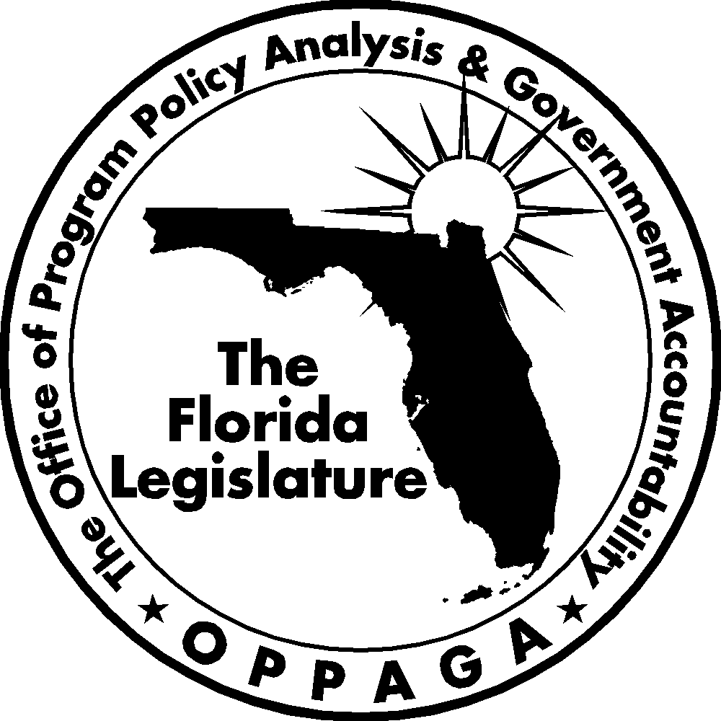
Sunset Memorandum

Department of Agriculture and Consumer Services
Food Safety and Quality Program
Legislative Options

January 8, 2008

Summary
To support the Sunset Review process, the Legislature directed OPPAGA to examine the Department of Agriculture and Consumer Services. This memo assesses the department’s Food Safety and Quality Program and its purpose, organization, responsibilities, resources, and performance. The memo also offers options for legislative consideration.
OPPAGA developed four policy options for the Legislature to consider for the Food Safety and Quality Program. These options include (1) increasing fees to make the Division of Food Safety’s inspection activities self-sufficient; (2) abolishing the Division of Food Safety’s poultry and egg classification function; (3) establishing fees for the Division of Dairy Industry to make its regulatory activities more self-sufficient; and (4) reducing the Division of Dairy Industry’s inspection workload by using certified private inspectors, decreasing the frequency of inspections to the minimum level required by the Grade A Pasteurized Milk Ordinance, and/or using milk haulers instead of department dairy inspectors to deliver milk samples for laboratory testing. For each option, we describe advantages and disadvantages.

Purpose, Organization, and Responsibilities
The Food Safety and Quality Program’s purpose is to ensure the safety and wholesomeness of dairy and food products in the state. The department seeks to accomplish this goal by permitting and inspecting food and dairy establishments and conducting laboratory analyses of food products.
The program comprises the Division of Food Safety and the Division of Dairy Industry.
- Division of Food Safety – permits and inspects approximately 48,600 retail food stores, food processing plants, and food distribution points where food is sold to the public. The division also tests food samples to ensure that packages are properly labeled and that foods are free of pathogens, contamination, and adulteration. It also conducts grading and inspection services to poultry and egg packaging plants, and monitors water vending machines and bottled water for labeling, processing, and purity.
- Division of Dairy Industry – permits and licenses approximately 2,100 dairy farms, milk processing plants, frozen dessert manufacturers, single-service container manufacturers, milk distribution depots, bulk milk tankers/haulers, and milk receiving, transfer, and wash stations. The division inspects these facilities to ensure they comply with sanitation and labeling requirements.
Resources
The Legislature appropriated $21,024,690 in general revenue and trust funds and 318 positions to the Food Safety and Quality Program for Fiscal Year 2007-08 (see Exhibit 1). The program receives approximately 18% of its funding from general revenue and 82% from trust funds.
The Division of Food Safety received approximately 11% of its funding from general revenue, 21% from the Federal Grants Trust Fund, and 68% from the General Inspection Trust Fund. The Division of Food Safety charges various annual permit and operating fees that range from $35 and $500. The division sets these fees based upon the level of resources it uses to monitor permit holders and licensees. The division also charges a flat fee of $110 for reinspections.
Exhibit 1
The Legislature Appropriated $21 Million to the Food Safety and Quality Program for Fiscal Year 2007-08
Program | General Revenue | Trust Funds | Total | FTE
Division of Food Safety | $2,033,875 | $17,213,024 | $19,246,899 | 293
Division of Dairy Industry | 1,753,650 | 24,141 | 1,777,791 | 25
Total | $3,787,525 | $17,237,165 | $21,024,690 | 318
Source: Chapters 2007-72 and 2007-326, Laws of Florida.

The Division of Dairy Industry received almost all (approximately 99%) of its funding from general revenue and 1% of its funding from the General Inspection Trust Fund. The Division of Dairy Industry currently charges three fees:
- a frozen dessert plant license fee of $200 for an initial application and $100 for annual renewals,
- a milkfat tester’s permit application fee of $125, and
- a temporary marketing permit fee of $50.
The Division of Dairy neither charges fees for the other six permits it administers nor charges inspection or re-inspection fees.
Performance
As shown in Appendix A, the Food Safety and Quality Program achieved approved standards for 7 of its 10 legislatively mandated performance measures in Fiscal Year 2006-07. For example, the department conducted 62,197 milk and milk product analyses which exceeded the approved standard of 56,000. Further, 91.52% of the food establishments the program inspected exceeded food safety and sanitation standards, which exceeded the standard of 91%.
However, the program did not meet its standard for inspecting dairy establishments (conducting 1,769 inspections versus a standard of 2,000) in Fiscal Year 2006-07. The department explained that it did not meet this standard because of a decline in the number of dairy farms and dairy inspector vacancies. Moreover, the program was close to, but did not meet the established standard for the percentage of food products analyzed that meet health standards (90.88% versus 91.20%); this represented a lower performance than it achieved in the prior two fiscal years. The department explained that it did not meet this standard because of several factors, including an increased targeted testing of soft cheeses for pathogens and fish species substitutions. The program was also close to but did not meet its standard for the percentage of produce or other food samples analyzed that meet pesticide residue standards (attaining a 97.72% compliance rate versus the standard of 97.8%).
Program Need
The primary public benefit of the Food Safety and Quality Program’s activities is helping to ensure the safety and wholesomeness of food and dairy products sold to consumers in Florida. While many food establishments have quality control mechanisms in place, food-borne illnesses remain a public health problem. Abolishing the program could increase the occurrence of such illnesses, which are a danger to public health and the financial well-being of Florida businesses. Abolishing the state’s inspection program for dairy facilities would also prevent these facilities from legally shipping milk and milk products to other states. Accordingly, abolishing the program would not be in these state’s interest. However, as discussed below, the Legislature could take action to reduce the program’s costs and need for general revenue funding.

Options for Legislative Consideration
OPPAGA developed four policy options for the Legislature to consider for the Food Safety and Quality Program. These options include (1) increasing fees to make the Division of Food Safety’s inspection activities self-sufficient; (2) abolishing the Division of Food Safety’s poultry and egg classification function; (3) establishing fees for the Division of Dairy Industry to make its regulatory activities more self-sufficient; and (4) reducing the Division of Dairy Industry’s inspection workload by using certified private inspectors, decreasing the frequency of inspections to the minimum level required by the Grade A Pasteurized Milk Ordinance, and/or using milk haulers instead of department dairy inspectors to deliver milk samples for laboratory testing. Exhibit 2 summarizes these policy options and describes the advantages and disadvantages associated with each option.
Division of Food Safety
Increase fees to make the Division of Food Safety’s regulatory and inspection activities self-sufficient
Section 216.0236, Florida Statutes, provides that it is the Legislature’s intent that all costs of providing a regulatory service or regulating a profession or business be borne solely by those who receive the service or who are subject to regulation. The Division of Food Safety charges 31 types of permit fees for various food store establishments. These permit fees are used to help fund the division’s Food Store Inspection Program. Most (26) of these permits fees were increased by a department rule amended in November 2007 (See Appendix B). The permit fees that were not increased include packaged ice plant and supermarket permits fees that already reached their statutory caps. The November 2007 fee increases is expected to generate approximately $975,000, which should be sufficient to eliminate the Food Store Inspection Program’s need for general revenue funding ($966,122 in general revenue expended in Fiscal Year 2006-07).
However, it should be noted that the division also expended approximately $1.37 million in general revenue in Fiscal Year 2006-07 to help pay for the cost of its chemical residue testing laboratory. This laboratory is responsible for chemically analyzing food products to determine the presence of chemical contaminants or residues in or on human food, and for enforcing federal pesticide and antibiotic residue tolerances and guidelines adopted by the state. The department does not charge fees to help pay for the costs of chemical residue testing.
The Legislature may wish to consider requiring the department to further increase food store permit fees to cover the costs of its chemical residue testing activities. This could be done in two ways which are described below.
- Increasing permit fees for food stores whose fees are not already at the statutory cap. As shown in Appendix B, many of the permit fees that were increased by rule in November 2007 were not at their statutory caps. For example, raising these fees by $42 across the board would generate sufficient revenue to offset the division’s general revenue subsidy for chemical residue testing. However, such an approach would be contrary to the department’s practice of setting food store permit fees on a sliding scale based on its determination of consideration of risk and the difficulty incurred in inspecting various entities. For example, the department charges grocery stores and supermarkets that offer the widest variety of food products a permit fee of $500, which is at the statutory cap, while it will charge convenience stores a fee of $330 under the fee schedule rule amended in November 2007.
- Raising or removing the statutory caps on the division’s permit fees. For example, raising the permit fees for grocery stores and supermarkets, which takes the most time for department staff to inspect, to $1,000 would generate an estimated $963,500 in additional revenue that could be used to help offset the general revenue subsidy for chemical residue testing.
Eliminate poultry and egg packing plant inspections
Under a contract with the U.S. Department of Agriculture, the Division of Food Safety provides grading and inspection services for poultry and egg packing plants. The Legislature may wish to consider having the department withdraw from the federal contract, which would result in the U.S. Department of Agriculture grading poultry and eggs in Florida. Withdrawing from the federal contract would not reduce state general revenue funding as the function is funded by trust funds. However, it would reduce the size of state government. The Florida Department of Agriculture and Consumer Services reported that turning the poultry and egg grading function over to the federal government would eliminate 18 full-time equivalent (FTE) and 7 other personal service (OPS) employees.
Division of Dairy Industry
Establish fees for Division of Dairy Industry to make its regulatory activities more self-sufficient
As noted previously, the Division of Dairy Industry receives approximately 99% of its funding from general revenue. This is consistent with the provisions of s. 502.013(2)(a)2, Florida Statutes, which state that the Legislature intends to pay for the costs of the Division of Dairy Industry with general revenue except for the permit fees charged to milk fat testers.
If the Legislature wished to consider making the Division of Dairy Industry less reliant on general revenue funding, it could consider creating permit fees for the division’s dairy farms and plants, assessing a volume fee at the tanker level, and implementing re-inspection fees. However, it may not be feasible to shift to total fee funding of the division’s current activities. The division estimates that in order for these activities to be self-sufficient, each dairy farm would need to be charged an annual permit fee of $2,650 and each large milk processing plant would need to be charged an annual fee of $33,000. The department believes that charging such fees would be prohibitively costly and put Florida milk producers and processors at a competitive disadvantage against their competitors in surrounding states. However, recovering a greater percentage of the division’s costs through permit fees is feasible. Several other states charge fees for dairy permitting and licensing activities. For example, Wisconsin charges dairy manufacturing plants license fees ranging from $96 to $722 depending on the number of pounds of dairy products produced and charges milk producers a license fee of $24. If Florida adopted fees similar to those assessed by Wisconsin, it would receive an additional $17,582 in revenues.
Given that permit fees in Florida would need to be set at a high level for the program to become self-supporting, it may be more feasible to assess a volume fee on bulk milk at the time of delivery to a processing plant, which would be relatively easy to administer and these deliveries are already audited by the U.S. Department of Agriculture. The potential impact on consumers would be a relatively small increase in the retail price of milk products, and would result in regulatory costs being borne by the consumers of these products rather than taxpayers as a whole.
Additionally, the Legislature may wish to consider authorizing the Division of Dairy Industry to charge a re-inspection fee, which would give regulated entities a greater incentive to maintain compliance with state sanitation standards. Currently, the Division conducts re-inspections when its inspectors identify sanitation violations to determine whether the facilities subsequently correct these problems, which increases program workload but does not penalize violators. In contrast, the Division of Food Safety charges a fee of $110 for re-inspections.
Modify regulatory process to reduce Division of Dairy Industry workload
As an alternative to raising fees, the Legislature may wish to consider reducing the Division of Dairy Industry’s inspection activities, which would lower program costs. This could be accomplished by using certified private inspectors to conduct dairy farm inspections and reducing the division’s inspection workload to the level needed to meet interstate shipment standards.
Certifying private inspectors to conduct dairy farm inspections. Under this approach, the department would certify private individuals who possessed required skills and knowledge to conduct regulatory field inspections. The department’s role would be limited to establishing regulatory standards, certifying persons who met established criteria, and monitoring the certified inspectors’ performance. This approach would reduce state costs as the certified inspectors would charge fees to the businesses they inspected. Some other states, such as Pennsylvania, use certified private inspectors to inspect dairy farms and Florida currently uses this model for elevator safety inspections. The department estimated that using certified industry personnel to conduct farm inspections and collect samples at farms would reduce its costs by $391,600. However, the department contended that relinquishing control of these inspections would reduce the protection provided the public because of the lack of routine visits by state regulatory personnel.
Decrease frequency of inspections to the level needed to meet to meet the requirements of the Grade A Pasteurized Milk Ordinance. Another option would be to conduct only those inspections needed to comply with the inspection frequency requirements of the Grade A Pasteurized Milk Ordinance, which is developed by the National Conference on Interstate Milk Shippers and published by the U.S. Food and Drug Administration. Dairy plants and farms must comply with the Pasteurized Milk Ordinance in order to ship their products to other states. Florida has incorporated the ordinance in the statutes and the department has adopted it by reference in its rules.
The Grade A Pasteurized Milk Ordinance specifies minimum inspection requirements for state regulatory agencies. For example, it requires state regulatory agencies to inspect each dairy farm at least once every six months and each milk plant at least once every three months. Given that Florida has 161 dairy farms and 19 milk processing plants, it would need to conduct a total of 398 inspections to meet the ordinances inspection requirements.
Department inspectors currently conduct many more inspections than required by the ordinance’s standards. The department reported that its 12 inspectors conducted 1,280 inspections at Florida dairy farms and milk plants in Fiscal Year 2006-07, or more than three times as many required by the ordinance. The department asserts that conducting more than the minimum number of inspections helps ensure the quality of the state’s dairy products. However; this practice also increases program regulatory costs. Reducing the number of inspections would enable the Division to reduce its staffing level and reliance on general revenue while retaining the ability of Florida dairy operations to ship their products to other states.
Use milk haulers to collect official samples of dairy products. Another option to reduce program workload and costs would be to rely on milk haulers rather than division dairy inspectors to collect official samples of dairy products for testing in the department’s laboratory. This approach is used in other states including Kansas, South Carolina, and Wisconsin. In Wisconsin, milk haulers collect samples when they pick up products and deliver the samples to a certified lab for product quality testing. In South Carolina, milk haulers collect the official samples which are then picked up at the processing plants by state inspectors for testing in the state lab. Milk haulers visit dairy farms on a regular basis and already collect product samples for testing by industry labs. Either approach would reduce the program costs since department staff would not need to make separate visits to dairy farms to conduct inspections and collect product samples.

Exhibit 2
The Legislature Could Consider Several Options for Modifying the Food Safety and Quality Program and Reducing its Need for General Revenue Funding
Option | Advantages | Disadvantages
Increase Fees to Make Division of Food Safety Inspection Activities Self-Sufficient
Require the department to increase current fees for the Division of Food Safety and remove statutory cap on fee levels | - Would reduce reliance on general revenue funding and make activities self-sufficient, avoiding need to subsidize activity with general revenue  - Costs would be more directly borne by regulated entities. Charging inspection fees would give regulated entities an incentive to maintain compliance to avoid re-inspection fees. | - May experience opposition from private industry  - Could place Florida businesses at a competitive disadvantage if fees were higher than those charged by neighboring states, particularly if fees were relatively large  - May increase consumer prices
Abolish the Division of Food Safety’s Poultry and Egg Classification Function
Withdraw from federal contract to inspect poultry and egg processors | - Would reduce size of state government by eliminating 18 full-time and 7 OPS positions  - Federal government would take over function if not performed by Department | - Would not affect state general revenue as the function is funded by federal funds  - Federal government may not perform function in same manner as the department, which could affect industry
Establish Fees for Division of Dairy Industry to Make Regulatory Activities More Self-Sufficient
Create permit fees for dairy farms and plants, assess a volume fee at the tanker level, and/or implement reinspection fee | - Would reduce reliance on general revenue funding and make activities self-sufficient, avoiding need to subsidize activity with general revenue  - Costs would be more directly borne by regulated entities  - Charging inspection fees would give regulated entities an incentive to maintain compliance to avoid re-inspection fees | - May experience opposition from private industry  - Could place Florida businesses at a competitive disadvantage if fees were higher than those charged by neighboring states, particularly if fees were relatively large  - May increase consumer prices
Modify Regulatory Process to Reduce Division of Dairy Industry Workload
Certify private inspectors to conduct inspections, decrease frequency of inspections to the minimum level required by the Grade A Pasteurized Milk Ordinance, and/or reduce inspector workload by requiring milk haulers to deliver samples to labs or processing plants | - Would reduce department inspection workload and regulatory costs, reducing need for general revenue subsidy  - State would retain regulatory authority and would oversee quality of private inspections  - Would retain ability of Florida dairy operations to ship products to other states | - Department would be reliant on private inspectors to conduct required inspections  - Would result in higher costs for regulated businesses, which would pay private inspector fees. This could place Florida businesses at a competitive disadvantage if fees were higher than those charged by neighboring states, particularly if fees were relatively large.  - Could increase risk to the public if private inspectors fail to identify problems in regulated businesses, if private entities mishandle samples, or if regulated dairy facilities reduce compliance levels as the result of reduced state inspection activities.
Source: OPPAGA analysis.
Appendix A

The Food Safety and Quality Program Met Standards for 7 of the 10 Performance Measures in Fiscal Year 2006-07
In the table below, the program’s performance measures that met their standards in Fiscal Year 2006-07 are shown in the shaded rows.
Performance Measure | Fiscal Year 2006-07
Performance Measure | Actual Performance | Standard
Food Safety and Quality
Number of inspections of food establishments and water vending machines | 81,604 | 80,900
Number of food analyses conducted | 45,732 | 43,955
Number of chemical residue analyses conducted | 395,231 | 218,880
Percent of food establishments meeting food safety and sanitation requirements | 91.52% | 91.00%
Percent of food products analyzed that meet standards | 90.88% | 91.20%
Percent of produce or other food samples analyzed that meet pesticide residue standards | 97.72% | 97.80%
Dairy Industry
Number of milk and milk product analyses conducted | 62,197 | 56,000
Number of dairy establishment inspections | 1,769 | 2,000
Percent of milk and milk products analyzed that meet standards | 94.60% | 93.30%
Percent of dairy establishments meeting food safety and sanitation requirements | 87.00% | 86.00%
Source: Department of Agriculture and Consumer Services.

Appendix B

The Division of Food Safety Charges a Variety of Regulatory Fees
The table below provides information on the Division of Food Safety’s food store permit fees, such as the section of the Florida Statutes authorizing the fee, the year the fee was last revised, the fee’s statutory cap, and the current permit fee charged by the department.
Fee | Statute | Last Revised | Statutory Fee Cap | Current Fee
Bottling Plant | 500.12(1)(b) | 2001 | $500 | $385
Bottled Water Plant | 500.12(1)(b) | 1992 | $1,000 | $500
Canning Plant | 500.12(1)(b) | 2001 | $500 | $410
Convenience Store | 500.12(1)(b) | 2001 | $500 | $330
Convenience Store with Limited Food Service | 500.12(1)(b) | 2001 | $500 | $385
Convenience Store with Significant Food Service | 500.12(1)(b) | 2001 | $500 | $465
Food Salvage Center | 500.12(1)(b) | 2001 | $500 | $440
Food Storage Warehouse | 500.12(1)(b) | 2001 | $500 | $355
Grocery Store | 500.12(1)(b) | 2001 | $500 | $465
Health Food Store | 500.12(1)(b) | 2001 | $500 | $300
Health Food Store with Food Service | 500.12(1)(b) | 2001 | $500 | $385
Limited Sales | 500.12(1)(b) | 2001 | $500 | $100
Meat Market | 500.12(1)(b) | 2001 | $500 | $385
Minor Food Outlet | 500.12(1)(b) | 2001 | $500 | $300
Minor Food Outlet, Only Non-perishable Foods | 500.12(1)(b) | 2001 | $500 | $190
Minor Food Outlet with Limited Food Service | 500.12(1)(b) | 2001 | $500 | $355
Minor Food Outlet with Significant Food Service | 500.12(1)(b) | 2001 | $500 | $440
Mobile Vendor | 500.12(1)(b) | 2001 | $500 | $300
Packaged Ice Plant | 500.12(1)(b) | 1992 | $250 | $250
Processor, Other Non-perishable Foods | 500.12(1)(b) | 2001 | $500 | $330
Processor, Other Perishable Foods | 500.12(1)(b) | 2001 | $500 | $410
Rabbit or Game Processor | 500.12(1)(b) | 2001 | $500 | $330
Retail Bakery | 500.12(1)(b) | 2001 | $500 | $355
Retail Bakery with Food Service | 500.12(1)(b) | 2001 | $500 | $440
Salvage Store | 500.12(1)(b) | 2001 | $500 | $410
Seafood Market | 500.12(1)(b) | 2001 | $500 | $355
Seafood Processor | 500.12(1)(b) | 2001 | $500 | $440
Semi-permanent Vendor | 500.12(1)(b) | 2001 | $500 | $190
Supermarket | 500.12(1)(b) | 2001 | $500 | $500
Wholesale Bakery | 500.12(1)(b) | 2001 | $500 | $465
Water Vending | 500.459 | 1992 | $200 | $35
Source: Department of Agriculture and Consumer Services Legislative Budget Request for Fiscal Year 2008-09,
Schedule 1A and Rule 5K-4.020(4) and 5K-9.003, F.A.C.

Sections 11.901-11.920, F.S.
The General Inspection Trust Fund is exclusively for the Department of Agriculture and Consumer Services and is used to fund the department’s inspection activities.
Rule 5K-4.020, F.A.C.
Section 500.12(1)(b), F.S.
Section 500.09(7), F.S., and Rule 5K-4.020(7)(a), F.A.C.
Section 503.041(2), F.S.
Section 502.032(2), F.S., and Rule 5D-1.003, F.A.C.
Rule 5D-1.003, F.A.C.
This estimate assumes that the department will receive an additional $975,000 in revenue from its November 2007 fee increases.
Alabama and Georgia do not charge fees for their dairy programs.
A 2001 OPPAGA report estimated that a volume fee would have a potential impact of less that one cent per gallon. See Justification Review: Some Funding Shifts Are Possible for the State’s Food Safety and Quality Program, OPPAGA Report No. 01-53, November 2001.
Section 502.014(6), F.S.; Rule 5D-1.001 (1)(a), F.A.C.

