DEPARTMENT OF AGRICULTURE & CONSUMER SERVICES
OVERVIEW
April 2007 Report No. S07-01

Agency Responsibilities
The mission of the Department of Agriculture and Consumer Services (DACS) is to safeguard the public and support agriculture by
- ensuring the safety and wholesomeness of food and other consumer products;
- improving the production and sale of Florida’s agricultural products;
- preserving and protecting the state’s agricultural and natural resources; and
- protecting consumers from potential health and security risks and unfair and deceptive business practices.
Agency Organization
The department primarily accomplishes its mission through five programs.
- Office of the Commissioner and Administration provides executive leadership and administrative services to other department programs. It includes the Division of Administration, the Office of Agricultural Emergency Preparedness, the Office of Cabinet Affairs, the Office of Federal-State Relations, the Office of the General Counsel, the Office of the Inspector General, the Office of Legislative Affairs, and the Office of Public Information.
- Food Safety and Quality is responsible for ensuring the safety, wholesomeness, quality, and accurate labeling of food. The program includes the Division of Dairy Industry and the Division of Food Safety.
- Forest and Resource Protection is responsible for protecting Florida from the dangers of wildfires and for managing the state’s forest resources. The program includes the Division of Forestry.
- Consumer Protection is responsible for protecting consumers and their property from unlawful, unethical, and unsafe business practices. The program includes the Division of Agricultural Environmental Services, the Division of Consumer Services, and the Division of Standards.
- Agricultural Economic Development is responsible for assisting Florida’s agricultural industry with the production and marketing of commodities in order to maintain and enhance Florida agriculture in the national and international marketplace. The program includes Agricultural Interdiction Stations, the Division of Animal Industry, the Division of Aquaculture, the Division of Fruit and Vegetables, the Division of Marketing and Development, and the Division of Plant Industry.
The department also houses the Division of Licensing, which is responsible for protecting the public from unethical business practices on the part of persons providing private security, private investigative and recovery services; the Office of Agricultural Water Policy; and the Office of Agricultural Law Enforcement.
For a chart of the department’s programs, see Exhibit 1 on page 2.
Agency Resources
The Legislature appropriated $408,176,032 and 3,808 positions to the department for Fiscal Year 2006-07. (see Exhibit 2) This represents a 1.13% increase in funding and a slight decrease (.18%) in positions compared to the previous fiscal year.
For more details on the department’s resources for Fiscal Year 2006-07, see Exhibit 3.

Exhibit 1
The Department of Agriculture and Consumer Services’ Programs
Source: OPPAGA analysis.
Source: Department of Environmental Protection.

Exhibit 2
Legislative Appropriations and Staffing for the Department of Agriculture and Consumer Services
 | FY 2004-05 | FY 2005-06 | FY 2006-07
General Revenue | $145,313,136 | $143,083,844 | $147,653,162
Trust Funds | 221,214,169 | 260,481,627 | 260,522,870
Total Funds | $336,527,305 | $403,565,471 | $408,176,032
FTE | 3,831 | 3,815 | 3,808
OPS | 1,335 | 681 | 735
Source: Legislative Appropriations System/Planning and Budgeting Subsystem (LAS/PBS), August 2006, and Department of Agriculture and Consumer Services’ Sunset Review Report, December 2006.
Exhibit 3
Department of Agriculture and Consumer Services Resources by Program for Fiscal Year 2006-07
Office of Commissioner and Administration | Federal Funds | State Trust Funds | General Revenue |  | TOTAL | FTE  Positions | OPS  Positions
Agricultural Law Enforcement | $959,930 | $379,709 | $3,775,237 |  | $5,114,876 | 40.5 | 1
Agricultural Water Policy Coordination | 1,620,520 | 21,169,472 | 500,000 |  | 23,289,992 | 37 | 0
Executive Direction and Support Services | 3,300 | 6,812,600 | 8,837,752 |  | 15,653,652 | 192.75 | 9
Information Technology | 0 | 4,490,694 | 3,787,351 |  | 8,278,045 | 45 | 4
Licensing | 0 | 12,386,939 | 0 |  | 12,386,939 | 139 | 20
Food Safety and Quality
Dairy Industry | $0 | $20,274 | $1,693,367 |  | $1,713,641 | 25 | 0
Food Safety | 3,839,168 | 12,280,486 | 2,259,175 |  | 18,378,829 | 290 | 20
Forest and Resource Protection
Land Management | $26,530,638 | $32,010,910 | $10,260,218 |  | $68,801,766 | 506 | 81
Wildfire Prevention and Management | 8,324,519 | 11,708,518 | 48,405,036 |  | 68,438,073 | 769.5 | 56
Consumer Protection
Agricultural Environmental Services | $1,401,638 | $11,361,898 | $4,187,864 |  | $16,951,400 | 220 | 15
Consumer Services | 8,518 | 6,003,720 | 742,959 |  | 6,755,197 | 126 | 6
Standards | 0 | 9,703,923 | 2,230,256 |  | 11,934,179 | 188 | 4
Agricultural Economic Development
Agricultural Interdiction Stations | $330,000 | $204,159 | $15,848,846 | $16,383,005 |  | 241 | 0
Animal Industry | 3,426,745 | 1,109,843 | 8,609,764 | 13,146,352 |  | 151.50 | 13
Aquaculture | 833,700 | 1,260,046 | 6,339,680 | 8,433,426 |  | 52.5 | 6
Fruit and Vegetables | 0 | 13,277,801 | 0 | 13,277,801 |  | 222 | 45
Marketing and Development | 5,181,375 | 23,658,159 | 10,277,406 | 39,116,940 |  | 195 | 5
Plant Industry | 23,610,355 | 16,613,313 | 19,898,251 | 60,121,919 |  | 367 | 450
TOTAL | $76,070,406 | $184,452,464 | $147,653,162 | $408,176,032 |  | 3,808 | 735
Source: Legislative Appropriations System/Planning and Budgeting Subsystem (LAS/PBS), August 2006, and Department of Agriculture and Consumer Services’ Sunset Review Report, December 2006.

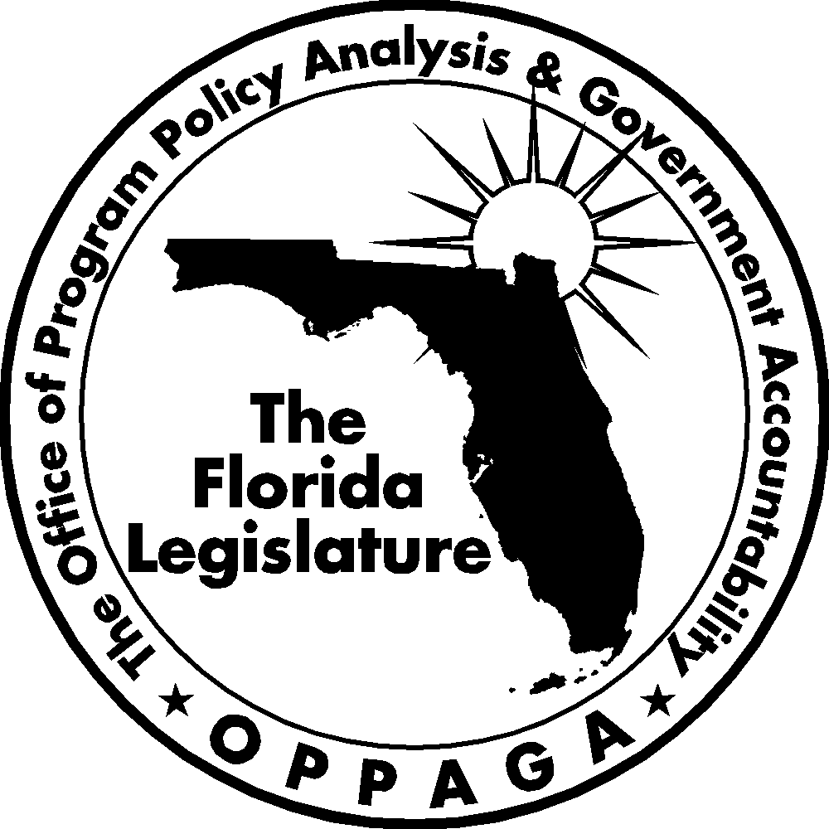
The Florida Legislature
Office of Program Policy Analysis and Government Accountability
The Florida Government Accountability Act Sunset Reviews
The 2006 Legislature passed the Florida Government Accountability Act (Ch. 2006-146, Laws of Florida) to create a Sunset review process. The act
- establishes the process, criteria, and schedule for the Legislature to assess whether state agencies and advisory committees need to continue to exist;
- provides for the creation of a Legislative Sunset Advisory Committee and describes the membership and organization of the committee and committee duties;
- requires reports and assistance from state agencies and the Legislature’s Office of Program Policy Analysis and Government Accountability (OPPAGA).
Using these reports and other information, the Sunset Advisory Committee is to produce a report that includes recommendations to abolish, continue, or reorganize an agency or advisory committee under review.
First Year Schedule for Agency Reviews
Agencies to be reviewed by July 1, 2008:
(a) Statutorily created responsibilities of the Fish and Wildlife Conservation Commission.
(b) Department of Agriculture and Consumer Services.
(c) Department of Citrus, including the Citrus Commission.
(d) Department of Environmental Protection.
(e) Department of Highway Safety and Motor Vehicles.
(f) Water management districts.
Project supervised by Jeanine Brown (850/487-4256)
Tom Roth, Staff Director
Cover photo by Kent Hutchinson
Gary R. VanLandingham, OPPAGA Director

The Office of Program Policy Analysis and Government Accountability
111 W Madison Street, Room 312 ■ Claude Pepper Building ■ Tallahassee, Florida 32399-1475
(850) 488-0021 SUNCOM 278-0021 Fax: (850) 487-3804
www.oppaga.state.fl.us

