DEPARTMENT OF COMMUNITY AFFAIRS
ADVISORY COMMITTEES ASSESSMENT
DECEMBER 2008 Report No. 08-S10

Scope
The Florida Government Accountability Act directs OPPAGA to review state agencies and their advisory committees, examine their costs, and evaluate their operations. As part of our review, we examined the advisory committees of the Department of Community Affairs to assess their purposes, activities, related costs, and need for continuation. Our review addressed the following questions for each advisory committee to determine its purpose, effectiveness, and public accessibility.
- Why was the advisory committee created and has it fulfilled its specific purpose?
- Does the advisory committee’s advice and support significantly contribute to the agency’s mission?
- Are advisory committee members representative of the public and stakeholders affected by its actions and can the public readily access advisory committee proceedings, materials, and products?
Background
The Department of Community Affairs is the state’s land planning and community development agency. The department seeks to ensure that
new growth complies with the state's growth management law, assists established communities in revitalizing their older neighborhoods, and plans for and responds to both natural and man-made disasters.
In Fiscal Year 2007-08, the department reported having three advisory committees:
- the Florida Building Commission, which adopts changes to the Florida Building Code;
- the Florida Communities Trust Governing Board, which selects local government projects to receive state financial grants for conservation and recreation land acquisition; and
- the Century Commission for a Sustainable Florida, which makes recommendations for addressing the consequences of the state’s future population growth directly to the Governor and Legislature and not to the department.
These three entities meet the statutory definition of being an advisory committee, but were not created to provide advice to the department.
Collectively, these committees incurred travel, staff, and other expenses totaling $7,586,661 in Fiscal Year 2007-08. (See Exhibit 1).
Exhibit 1
The Department of Community Affairs Reported $7,604,661 in Advisory Committee Costs in Fiscal Year 2007-08
Advisory Committee | Reported Cost
Florida Building Commission | $6,021,349
Florida Communities Trust Governing Board | 1,133,312
Century Commission for a Sustainable Florida | 432,000
Total | $7,586,661
Source: Department of Community Affairs.
Assessment and Recommendations
In assessing department advisory committees, we considered criteria including the intended purpose of each committee and if it had fulfilled that purpose, if it is effective in contributing to the department’s mission, if committee members are representative of the public and stakeholders affected by its actions, and public accessibility to the committee.
We concluded that while all three of the department’s advisory committees were not created to provide advice to the department, they serve a public purpose by providing opportunities for stakeholder input or expertise. In addition, the committees perform activities that are consistent with legislative intent and are related to the department’s mission, which includes providing assistance to local governments and implementing state growth management laws.
Based on our assessment of the Department of Community Affair’s three advisory committees, we recommend that the Legislature

Continue
- Florida Building Commission
- Florida Communities Trust Governing Board

We make no recommendation regarding the Century Commission for a Sustainable Florida as it makes recommendations for addressing the consequences of the state’s future population growth directly to the Governor and Legislature and not to the department.
For more detailed information on our assessment and recommendations, please see Exhibit 2.

Exhibit 2
The Department of Community Affairs Had Three Advisory Committees in Fiscal Year 2007-08
Florida Building Commission
Fiscal Year 2007-08 ▪ Cost: $6,021,349 ▪ Authorization: Statutory, created in 1998, Ch. 553, Part IV, Florida Statutes
Purpose: Responsible for adopting and updating the Florida Building Code and approving products for which the code establishes hurricane-related standards. Although the commission is administratively housed in the Department of Community Affairs, it is not advisory to the department. The department provides the commission with administrative, technical, and legal support that includes handling the commission’s budgeting, scheduling, and travel reimbursement.
Effectiveness: The commission maintains and updates the Florida Building Code and its component codes for plumbing, electrical, mechanical, energy conservation, accessibility, structural, and fire systems in buildings. It also establishes minimum standards for the safety and performance of buildings. The commission is assisted by 11 technical advisory committees and six special workgroups composed of experts in their fields. Recent accomplishments include completing the 2007 Florida Building Code, conducting an assessment of the code administration needs of local governments, and evaluating and implementing enhancements to the Florida Energy Code’s requirements for residential and commercial buildings. ¹
Public Access: The commission is composed of 25 members appointed by the Governor and confirmed by the Senate. The members are design professionals, contractors, and government experts in the various disciplines covered by the code. The commission meets monthly in various locations around the state. The commission’s meeting times, dates, agendas, and minutes are posted on its website. Meeting notices also appear in the Florida Administrative Weekly. The commission’s advisory committees and workgroups represent numerous stakeholders and allow for public input. The public can get additional information about the commission’s activities through the Building Code Information System (BCIS).
Assessment: The commission’s activities protect the health, safety and welfare of Florida’s citizens by developing and implementing sound construction practices for buildings. It is the only entity in the state that performs this function.
Recommendations: The commission should be continued.
¹ Section 553.77, F. S., requires the commission to update the Florida Building Code every three years. The Florida Energy Code for Building Construction is in Chapter 13 of the Florida Building Code.

Florida Communities Trust Governing Board
Fiscal Year 2007-08 ▪ Cost: $1,133,312 ▪ Authorization: Statutory, created in 1989, s. 380.504, Florida Statutes
Purpose: Responsible for reviewing and approving projects submitted for funding by local governments and non-profit environmental organizations. These projects are for the acquisition of community-based parks, open space, and greenways that further outdoor recreation and natural resource protection needs identified in local comprehensive plans. Although the board is administratively housed in the Department of Community Affairs, it is not advisory to the department. However, the department provides the board with staff and administrative support.
Effectiveness: During Fiscal Year 2007-08, the board reviewed 118 grant applications and approved funding for 23 projects totaling $84.4 million in Florida Forever funds.¹ Local governments provided $61 million in matching funds for these projects. The board also approved draft rules for the Stan Mayfield Working Waterfront Florida Forever Program.²
Public Access: The Florida Communities Trust Governing Board consists of six members, including the Secretaries of the Departments of Community Affairs and Environmental Protection and four public members appointed by the Governor and confirmed by the Senate. The four public members of the board include a former municipal elected official, a former county elected official, a representative from the development industry, and a representative from the non-profit environmental community. The board meets at least quarterly as required by state law and the meeting notices appear in the Florida Administrative Weekly.
Assessment: The Florida Communities Trust Governing Board awards grants on a competitive basis for projects consistent with the Legislature’s intent to assist local governments in bringing their comprehensive plans into compliance and implementing the goals, objectives, and policies of the conservation, recreation and open space, and coastal elements of those plans. Previous OPPAGA reports found that the board had trouble closing projects and expending its land acquisition funds several years ago, but later took action to improve its performance.³ If the board were abolished, the Florida Forever Acquisition and Restoration Council under the Department of Environmental Protection could select projects for acquisition at the local level. However, the council’s members represent state agencies and they make recommendations to the Governor and Cabinet regarding state purchases of conservation and recreation lands. The council also does not focus on local government conservation and recreation land purchases or on local government comprehensive plan requirements.
Recommendations: The board should be continued.
¹ The purpose of the Florida Forever Program is to purchase land that will be set aside for conservation and recreation purposes. In addition to the Florida Communities Trust, Florida Forever Funds are distributed to the state’s five water management districts and to the Department of Agriculture and Consumers Services, the Department of Environmental Protection, and the Florida Fish and Wildlife Conservation Commission.
² The Legislature established the Stan Mayfield Working Waterfronts Florida Forever Program in 2008 (Ch. 2008-229, Laws of Florida) to preserve working waterfronts. The law provided that 2.5% of Florida Forever funding would be distributed to this program.
³ Florida Communities Trust Improves Its Timeliness; Further Actions are Needed, OPPAGA Report No. 02-01, January 2002; Florida Communities Trust Has Taken Action to Expedite Land Acquisitions, OPPAGA Report No. 03-60, November 2003.
Century Commission for a Sustainable Florida
Fiscal Year 2007-08 ▪ Cost: $ 450,000 ▪ Authorization: Statutory, created in 2005, s. 163.3247, Florida Statutes
Purpose: Responsible for developing recommendations to help Florida’s citizens and state leaders prepare for a continued increase in population and to craft a plan that meets the challenges and opportunities caused by this growth. The Secretary of the Department Community Affairs selects an executive director who serves at the Secretary’s pleasure, but is under the supervision and control of the commission. The Department of Community Affairs contracts with the Collins Center for Public Policy to provide staff and administrative support to the commission.
Effectiveness: The commission has published two annual reports and several research reports. The second annual report published in January 2008 made recommendations in several areas, including: ensuring an adequate and reliable water supply for current and future generations, mapping Florida’s most critical natural resources and pursuing new conservation methods, and designing communities and buildings that are sustainable. The commission also held a Sustainable Water Conference in September 2008. However, neither the department nor the Legislature has implemented any of the commission’s recommendations.
Public Access: The commission is composed of 15 members appointed by the Governor, the President of the Senate, and Speaker of the House. The commission must meet at least three times a year in different regions of the state to solicit input on issues from the public and other stakeholders. The commission held eight meetings during Fiscal Year 2007-08. Meeting notices appear in the Florida Administrative Weekly and on the commission’s website. Meeting agendas and minutes are also available on the website. Commission members represent a variety of stakeholder groups, including local governments, school boards, developers and homebuilders, the business community, the agricultural community, and the environmental community.
Assessment: The Legislature created the commission based on the finding that Florida’s population is expected to double within the next 100 years, and that an increase of that magnitude will affect the state’s natural resources and public infrastructure. The Legislature intended for the commission to make recommendations regarding the state’s growth management system that would mitigate the negative aspects of the population increase. To date, the commission’s activities have been consistent with this intent. The Legislature appropriated $250,000 for the commission in Fiscal Year 2008-09.
Recommendations: We make no recommendation regarding the Century Commission for a Sustainable Florida as it makes recommendations for addressing the consequences of the state’s future population growth directly to the Governor and Legislature and not to the department.
Source: OPPAGA analysis.
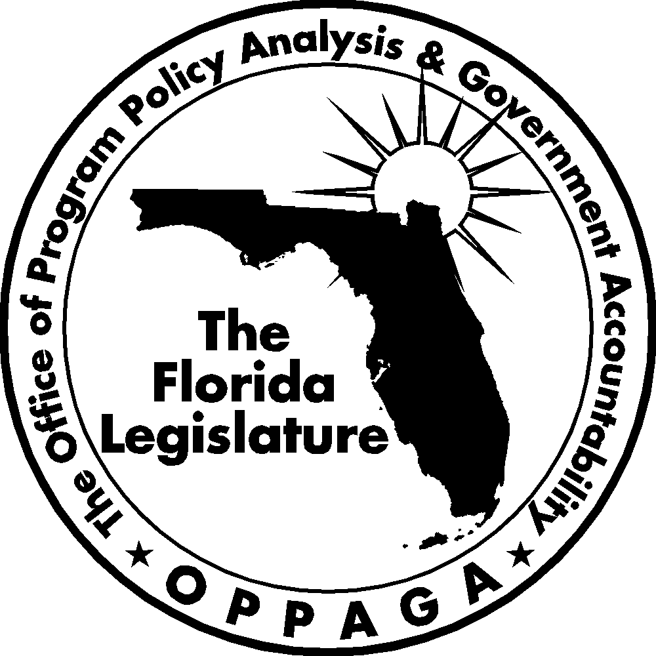
The Florida Legislature
Office of Program Policy Analysis and Government Accountability
The Florida Government Accountability Act Sunset Reviews
The 2006 Legislature passed the Florida Government Accountability Act (Ch. 2006-146, Laws of Florida) to create a Sunset review process. The act
- establishes the process, criteria, and schedule for the Legislature to assess whether state agencies and advisory committees need to continue to exist;
- provides for the creation of a Legislative Sunset Advisory Committee and describes the membership and organization of the committee and committee duties; and
- requires reports and assistance from state agencies and the Legislature’s Office of Program Policy Analysis and Government Accountability (OPPAGA).
Using these reports and other information, the Sunset Advisory Committee is to produce a report that includes recommendations to abolish, continue, or reorganize an agency or advisory committee under review.
Second Year Schedule for Agency Reviews
Agencies to be reviewed by July 1, 2010:
(a) Department of Children and Family Services
(b) Department of Community Affairs
(c) Department of Management Services
(d) Department of State

Project conducted by Darwin Gamble (850/487-9247)
Tom Roth, Staff Director
Cover photo by Kent Hutchinson
Gary R. VanLandingham, Ph.D. OPPAGA Director

Office of Program Policy Analysis and Government Accountability
111 W. Madison Street, Room 312 ■ Claude Pepper Building ■ Tallahassee, Florida 32399-1475
(850) 488-0021 Fax: (850) 487-3804
www.oppaga.state.fl.us

Sections 11.901-11.920, F.S.
Included in our review were advisory committees that the department was directed to include in its Agency Report to the Sunset Committee. These included advisory committees established in statute or by managerial initiative and defined in ss. 20.03 (3), (7), (8), (9), (10), and (12), F.S. The statutory definitions include commissions that exercise limited powers independently of the head of the department and boards of trustees that serve as an adjunct to a department to administer a public program.

