DEPARTMENT OF MANAGEMENT SERVICES
ADVISORY COMMITTEES ASSESSMENT
December 2008 Report No. 08-S11

Scope
The Florida Government Accountability Act directs OPPAGA to review state agencies and their advisory committees, examine their costs, and evaluate their operations. As part of our review, we examined the advisory committees of the Department of Management Services to access their purposes, related costs, and need for continuation. Our review addressed the following questions for each advisory committee to determine its purpose, effectiveness, and public accessibility.
- Why was the advisory committee created and has it fulfilled its specific purpose?
- Does the advisory committee’s advice and support significantly contribute to the agency’s mission?
- Are advisory committee members representative of the public and stakeholders affected by its actions and can the public readily access advisory committee proceedings, materials, and products?
Background
The Department of Management Services (DMS) is an administrative arm of state government. DMS delivers services to state and local governments to help these governmental entities deliver front line services to citizens and provides tools for managers to manage effectively and employees to work efficiently. Its mission is “providing smarter, better, faster services.” In addition, eight independent programs are administratively housed in DMS. However, the department does not exercise control, supervision, or direction over the day-to-day operations of these programs. These programs are the Agency for Workforce Innovation, Division of Administrative Hearings, Enterprise Florida, Inc., Southwood Shared Resource Center, Florida Commission on Human Relations, Public Employees Relation Commission, Black Business Investment Board, and Governor’s Commission on Disabilities.
The department reported having eight advisory committees in Fiscal Year 2007-08. Each of these committees was established by Florida statutes. Collectively, these committees incurred travel, staff, pass-through grants, and other expenses totaling $157,322,805 in Fiscal Year 2007-08 (see Exhibit 1), with the majority of costs being pass-through grants. As shown in the exhibit, one of the committees, the E911 Board, accounted for 99.6% of the funding for advisory committees in Fiscal Year 2007-08, with a reported cost of $156,699,730.

Exhibit 1
The Department of Management Services Reported $157,322,805 in Advisory Committee Costs in Fiscal Year 2007-08
Advisory Committee | Reported  Cost
State Retirement Commission | $ 158,910
Governor’s Mansion Commission | 0
Florida State Employee Wellness Council | 2,594
Council on Efficient Government | 456,882
Minority Business Certification Task Force | 0
Florida Advisory Council on Small and Minority Business Development | 2,043
Joint Task Force on State Agency Law Enforcement | 2,646
E911 Board | 156,699,730
Total | $157,322,805
Source: Department of Management Services.
Assessment and Recommendations
In assessing department advisory committees, we considered criteria including the intended purpose of the committee and if it had fulfilled that purpose, if it is effective in contributing to the department’s mission, if committee members are representative of the public and stakeholders affected by its actions, and public accessibility to the committee.
We concluded that most of the department’s advisory committees continue to serve a public purpose by providing opportunities for stakeholder input or expertise. In general, meetings are noticed through the Florida Administrative Weekly, and public participation is facilitated by holding meetings in various locations around the state and via
teleconference. Based on our assessment, we recommend that the Legislature continue three committees, continue two with modifications, and abolish three. Specifically, we recommend that the Legislature:

Continue
- State Retirement Commission
- Joint Task Force on State Agency Law Enforcement Communications
- E911 Board

Continue with Modifications
- Florida Advisory Council on Small and Minority Business Development
- Council on Efficient Government

Abolish
- Governor’s Mansion Commission
- Florida State Employee Wellness Council
- Minority Business Certification Task Force
We recommend that the department continue the practice of using teleconferencing to contain costs and facilitate public participation in committee meetings. The department should also enhance citizen access to committee proceedings and products by using the department’s website to announce all committee meetings and provide documentation of activities such as minutes of committee meetings.
For more detailed information on our assessment and recommendations, please see Exhibit 2.

Exhibit 2
The Department of Management Services Had Eight Advisory Committees in Fiscal Year 2007-08
State Retirement Commission
Fiscal Year 2007-08 ▪ Cost: $158,910 ▪ Authorization: Statutory, created in 1997, s. 121.22-121.24, F. S.
Purpose: The State Retirement Commission was created to adjudicate disputes regarding disability retirement and special risk benefits between members of the Florida Retirement System and the Division of Retirement.
Effectiveness: The commission hears appeals when the Division of Retirement denies a member special risk or disability benefits. The commission accomplishes its mission by conducting hearings with the actions of the commission reviewable by a district court of appeals. If the commission did not exist, the Division of Administrative Hearings would hear such appeals.
Public Access: By law, the five-member commission is to be composed of two members who are retired under the state retirement system, two members who are active members of the state retirement system, and one member who is neither a retiree, beneficiary, or member of the state retirement system. The commission conducts its hearings at a number of locations across the state, with meeting notices advertised in the Florida Administrative Weekly. The commission held 10 hearings in Fiscal Year 2007-08.
Assessment: The State Retirement Commission continues to fulfill a public purpose by adjudicating appeals of Division of Retirement decisions that deny disability or special risk benefits. The effectiveness of the decisions rendered is evidenced by none of the commission’s Fiscal Year 2006-07 decisions being overturned by a district court of appeals. Specifically, 8 of the 69 cases heard by the commission during this period were appealed to a district court of appeals; 1 of these cases was appealed for only attorney fees. The attorney fees case was voluntarily dismissed; the remaining seven appeals were affirmed by the court (commission decision upheld).
Recommendations: Continue the State Retirement Commission.

Governor’s Mansion Commission
Fiscal Year 2007-08 ▪ Cost: $0▪ Authorization: Statutory, created in 1957, s. 272.18, F. S.
Purpose: The Governor’s Mansion Commission was created to maintain the structure, style, and character of the Governor’s Mansion, its grounds, and structures. The commission is also charged with preserving and protecting the antique furnishings in the private quarters of the Governor’s Mansion and the articles of furniture, fixtures, and decorative objects used or displayed in the staterooms of the mansion.
Effectiveness: The commission recommends for approval by the Governor and Cabinet any major changes in the architecture, furniture, furnishings, fixtures, or decorative objects of the mansion. In addition, the commission catalogs and inventories the antique furnishings in the private quarters and items in the staterooms. The Department of Management Services employs a full-time curator on behalf of the commission; the curator performs numerous duties, including cataloging and inventorying.
Public Access: The eight member commission has five citizen members appointed by the Governor; the remaining three members are the Secretary of Management Services or his/her designee, the director of the Department of Environmental Protection’s Division of Recreation and Parks, and a Department of State employee with curatorial and museum expertise. The spouse of the Governor or the designated representative of the Governor is an ex officio member of the commission but has no voting rights except in the case of a tie vote. The governor recently appointed members to fill three vacant commission positions. The commission did not meet during Fiscal Year 2007-08.
Assessment: The commission did not meet in Fiscal Year 2007-08, and the majority of the citizen member positions were not filled during this period. Accordingly, the commission does not appear to provide a necessary service to the Department of Management Services. The functions of the commission are largely being performed by an employee of the Department of Management Services, including cataloging and maintaining the inventory of the antique furnishings, aiding in the care and upkeep of the furnishings, training Governor’s Mansion docents, and assisting the commission.
Recommendations: Abolish the Governor’s Mansion Commission, with the Department of Management Services assuming the commission’s duties; this change will require legislative action. Specifically, eliminating the commission and transferring its responsibilities to the Department of Management Services will require modification of s. 272.18, F.S., which specifies the duties and responsibilities of the commission. Per s. 272.185, F.S., the department is currently responsible for maintaining the Governor’s Mansion and inventorying all equipment and furnishings, so assumption of commission duties is consistent with current legislative intent. The department does not concur with this recommendation.

Florida State Employee Wellness Council
Fiscal Year 2007-08 ▪ Cost: $2,594 ▪ Authorization: Statutory, created in 2006, s. 100.123(13), F. S.
Purpose: The Florida State Employee Wellness Council was created to advise the Department of Management Services on providing health education information to state employees and to assist the department in developing minimum benefits for all health care providers when providing age-and gender-based wellness benefits.
Effectiveness: The council is mandated to encourage participation in wellness programs by state employees. This can include informational programs and brochures for state agencies and employees. The council is also charged with developing standards and criteria for age- and gender-based wellness programs, in consultation with the Department of Management Services.
Public Access: The council is composed of nine members appointed by the Governor, with council members to be knowledgeable in the health and medical field and represent the broadest spectrum of the health industry and the geographic areas of the state. In Fiscal Year 2007-08, the council conducted three meetings—one in Jacksonville, one in Tallahassee, and one via conference call. These meetings were publically noticed in the Florida Administrative Weekly.
Assessment: The council does not appear to be fulfilling its statutory mission. The Department of Management Services is not aware of any documentation showing that the council has encouraged state employees to participate in wellness programs as required by statutes. In addition, the department is not aware of any standards and criteria developed by the council for age- and gender-based wellness programs (also required by statute). The council’s reported Fiscal Year 2007-08 major accomplishments were a tour of a private employer’s wellness program in Jacksonville; making recommendations to the Secretary of the Department of Management Services on smoking cessation; and making a presentation on the council responsibilities and activities to the department secretary.
In addition, council duties related to wellness programs have also been assigned to other state entities. For example, the Department of Health is statutorily mandated to collaborate with other state agencies to promote healthy lifestyles of state employees; this includes a comprehensive tobacco prevention and control program. Moreover, the Governor’s Council on Physical Fitness was established in 2007 with the goal of developing a state plan of action to increase physical fitness among Floridians of all ages, including state employees.
Recommendations: Abolish the Florida State Employee Wellness Council; this change will require legislative action. Specifically, eliminating the commission will require repeal of s. 110.123, F.S., which specifies the duties and responsibilities of the council. In lieu of the council, the Department of Management Services should coordinate with the Department of Health and the Governor’s Council on Physical Fitness for assistance in disseminating health education information to state employees and developing minimum health care benefits for all health providers.

Minority Business Certification Task Force
Fiscal Year 2007-08 ▪ Cost: $ 0 ▪ Authorization: , created in 1985, s. 287.0943 (2), F.S.
Purpose: The Minority Business Certification Task Force was formed to propose uniform criteria and procedures by which participating entities and organizations can qualify business to participate in procurement or contracting programs as certified minority business enterprises.
Effectiveness: The primary purpose of the task force is to propose a final list of the criteria and procedures for consideration by the Department of Management Services secretary. The task force is also authorized to seek technical assistance from qualified providers of technical, business, and managerial expertise to ensure the reliability of the certification criteria developed.
Public Access: The 19-member task force is intended to be regionally balanced and comprised of officials representing governmental entities who administer programs to assist minority businesses procure or develop government-sponsored programs. Six organizations (Florida League of Cities, Florida Association of Counties, Florida School Boards Association, Association of Special Districts, Florida Association of Minority Business Enterprise Officials, and Florida Association of Government Purchasing Officials) are authorized to appoint up to two members to the task force. The Department of Management Service’s Office of Supplier Diversity appoints seven members, consisting of three representatives of minority business enterprises, two office representatives, and two at-large members. The task force did not meet at all in Fiscal Year 2007-08.
Assessment: The task force has fulfilled its statutory mandate to propose uniform minority business certification criteria; the Department of Management Services placed these criteria in the Florida Administrative Code 13 years ago. According to department officials, the task force has not met in recent years, because use of reciprocal agreements (agreements to accept a business’s certified minority enterprise status issued by other entities) ended in 2003. Although the department secretary wishes to reestablish reciprocal agreements with other certification entities, such as cities and school districts, it is not necessary to reconvene the task force to pursue such agreements; the Florida Advisory Council on Small and Minority Business Development can pursue reciprocal agreements under its existing statutory authority (see below).
Recommendations: Abolish the Minority Business Certification Task Force; this change will require legislative action. Specifically, eliminating the task force will require repeal of section 287.0943(2), F.S., which specifies the duties and responsibilities of the task force.

Florida Advisory Council on Small and Minority Business Development
Fiscal Year 2007-08 ▪ Cost: $ 2,043 ▪ Authorization: Statutory, created in 1985, s. 287.0947, F.S.
Purpose: The Florida Advisory Council on Small and Minority Business Development is statutorily mandated to advise and assist the Secretary of the Department of Management Services in carrying out his/her duties involving minority business and economic development.
Effectiveness: The council’s primary duties include researching and reviewing the role of small and minority businesses in the state economy, reviewing issues and emerging topics related to small and minority economic development, and advising the Governor, the secretary, and the Legislature on matters related to small and minority business development of importance to the state. The council is also required to produce an annual report detailing its business transactions and making recommendations to improve business opportunities for small and minority businesses.
Public Access: The council is statutorily mandated to include 19 members appointed by the department’s secretary. The members are to include representatives of local and federal small and minority business assistance programs, certified minority business enterprises, the banking and insurance industry, local government, and private construction and commodities industries. Currently, the council consists of 11 members representing both private companies and local governmental entities. The council did not publish public notices for its meetings in Fiscal Year 2007-08, but council staff has recently begun to post public meeting notices on the department’s website. The council met four times in Fiscal Year 2007-08.
Assessment: The council does not appear to be fulfilling its statutory mission. Specifically, Department of Management Services staff report that they have been unable to find any record of council annual reports being submitted to the secretary; staff are currently in the process of drafting an annual report for the council. In addition, council records demonstrate that it has spent significant time reviewing and editing the department’s Office of Supplier Diversity’s 2006-2007 Annual Report, a duty not statutorily assigned to the council. In addition, the council did not advise the secretary or the Legislature on small and minority business developments are required by statute. Moreover, council recommendations provided to the Governor’s office in September 2008 were proposed to increase minority and women business participation in state contracting but did not also focus on small business development, a core mission for the council. The recommendations sent to the Governor were not discussed and approved by the council as a whole. The value of the council appears to be in input given to the Office of Supplier Diversity (OSD). According to OSD officials, the council provides valuable input on office events such as the MatchMaker conferences and activities such as the Loan Mobilization and Mentor Protégé programs.
Recommendations: Continue the Florida Advisory Council on Small and Minority Business Development with modification; this change will require legislative action to section 287.0947, F.S. Modifications include directing the council to advise and assist the department’s Office of Supplier Diversity rather than the department secretary; the requirements to advise the Governor, the department’s secretary, and the Legislature along with the submission of annual reports to the secretary should be eliminated. In addition, the council’s responsibilities related to small business should be assigned to the Small Business Regulatory Advisory Council that was created by Ch. 2008-149, Laws of Florida.

Joint Task Force on State Agency Law Enforcement Communications
Fiscal Year 2007-08 ▪ Cost: $2,646 ▪ Authorization: Statutory, created in 1988, s. 282.1095, F.S.
Purpose: The purpose of the Joint Task Force on State Agency Law Enforcement Communications is to advise the Department of Management Services on member-agency needs for planning, designing, and establishing the statewide radio communications system.
Effectiveness: The task force, in consultation with the department, has the authority to permit other state agencies to use the communications system under the terms and conditions established by the task force. The task force is also to work with the department, the Division of Emergency Management of the Department of Community Affairs, and the Department of Law Enforcement to establish policies, procedures, and standards as part of a comprehensive management plan for the network.
Public Access: The eight-member task force consists of representatives from state agencies with law enforcement responsibilities, including the Department of Business and Professional Regulation, Fish and Wildlife Conservation Commission, Department of Environmental Protection, Department of Law Enforcement, Department of Highway Safety and Motor Vehicles, and Department of Corrections. The task force held three meetings in Fiscal Year 2007-08; all meetings were in Tallahassee. Even though all meetings were in Tallahassee, local and federal government representatives attended meetings when subjects of interest to them were discussed. The meetings were noticed in the Florida Administrative Weekly.
Assessment: It appears that the taskforce is fulfilling its statutory mandate to advise the Department of Management Services on needs for planning, designing, and establishing the statewide radio communications system. Specifically, department staff report and a review of meeting minutes reveals that the taskforce provides the department with feedback from end-users that helps the department meet the needs of law enforcement and other system users.
Recommendations: Continue the Joint Task Force on State Agency Law Enforcement Communications.

E911 Board
Fiscal Year 2007-08 ▪ Cost: $156,699,730 ▪ Authorization: Statutory, created in 1999, s. 365.172 (5), F.S.
Purpose: The E911 Board was established to administer, with oversight from the Department of Management Services, the E911 fees collected by wireless and non-wireless communication service providers. These fees are imposed monthly on each wireless and non-wireless telephone customer in the state.
Effectiveness: The board collects and distributes E911 fees to wireless providers, counties, and the Department of Management Service’s technology program to allow telephone users rapid access to public safety agencies. The E911 Board’s responsibilities include receiving revenues derived from the monthly fee paid by consumers; distributing portions of the revenues to providers, counties, and the department; accounting for revenues; and providing annual reports to the Governor and the Legislature.
Public Access: The nine-member board consists of the statewide emergency communication number E911 system director and eight members appointed by the Governor. These appointments consist of county 911 coordinators; representatives from rural, medium, and large counties; local exchange carrier members; and representatives of the wireless communications industry. The E911 board holds monthly meetings throughout the state, including Tallahassee, Amelia Island, Altamonte Springs, Tampa, and Key West. Meetings are advertised in the Florida Administrative Weekly. Twelve meetings were held in Fiscal Year 2007-08.
Assessment: It appears that the E911 Board is fulfilling its statutory mission. The E911 Board makes distributions from the Emergency Communications Number E911 System Fund to county governments and wireless providers in accordance with statutory guidelines. The board also administers an E911 state grant program that supports the deployment of new E911 systems and other E911 activities; additionally, the board administers a rural county grant program to assist in deploying and maintaining enhanced 911 systems. Moreover, the board provides technical and training assistance to counties. Wireless 911 Phase I (determining the location of a cell phone by triangulating the signal using several cell phone towers) and Phase II (determining the location of a cell phone by using geographic positioning system (GPS) features on cell phones) have been completed statewide. In Fiscal Year 2007-08, the board received revenues totaling $124.7 million and it approved $126.3 million in pass-through disbursements and $29.4 million in grants.
Recommendations: Continue the E911 Board.

Council on Efficient Government
Fiscal Year 2007-08 ▪ Cost: $456,882 ▪ Authorization: Statutory, created in 2006, s. 287.0573, F. S.
Purpose: The Council on Efficient Government is statutorily required to review, evaluate, and issue advisory reports on state agency outsourcing business cases that propose projects over specific cost thresholds.
Effectiveness: The council evaluates business cases and submits advisory reports on proposed outsourcing projects having an estimated cost exceeding $10 million in any fiscal year. Projects involving outsourcing having an estimated cost not exceeding $10 million in any fiscal year are submitted to the council but not evaluated by staff unless requested by the Governor or the state agency head. The council is also charged with developing standards and best practices for developing, reviewing, and evaluating business cases to outsource.
Public Access: The seven-member council includes the Secretary of the Department of Management Services (who serves as chair), a cabinet member other than the Governor or their designee, the heads of two executive branch agencies, and three members of the private sector with experience in procurement and implementing complex projects in the private sector business environment. The council held two meetings in Fiscal Year 2007-08, with both meetings held in Tallahassee. The meetings were publically noticed in the Florida Administrative Weekly.
Assessment: According to the council’s annual report, it has developed standards and best practice procedures for agencies to use when developing business cases as well as a standardized process for reviewing business cases. In addition, in Fiscal Year 2007-08, the council reviewed 21 business cases for projects with a cumulative value of over $94 million; the agencies submitting the business cases estimated the projects would save the state $29 million. None of the projects was fully reviewed by the council, as they did not meet the minimum $10 million threshold required by statutes for full council reviews. The council also issued reports on MyFloridaMarketPlace, People First, and Project Aspire. The training on business case development and use of best practices that council staff provides to agency purchasing staff has the potential to improve the procurement processes used by state agencies.
Recommendations: Continue the Council on Efficient Government with modification; this change will require legislative action. Since there are cases when currently outsourced state functions can be insourced and improve efficiency and effectiveness, the council’s responsibilities should be expanded to include reviewing business cases that propose insourcing.
Source: OPPAGA analysis.

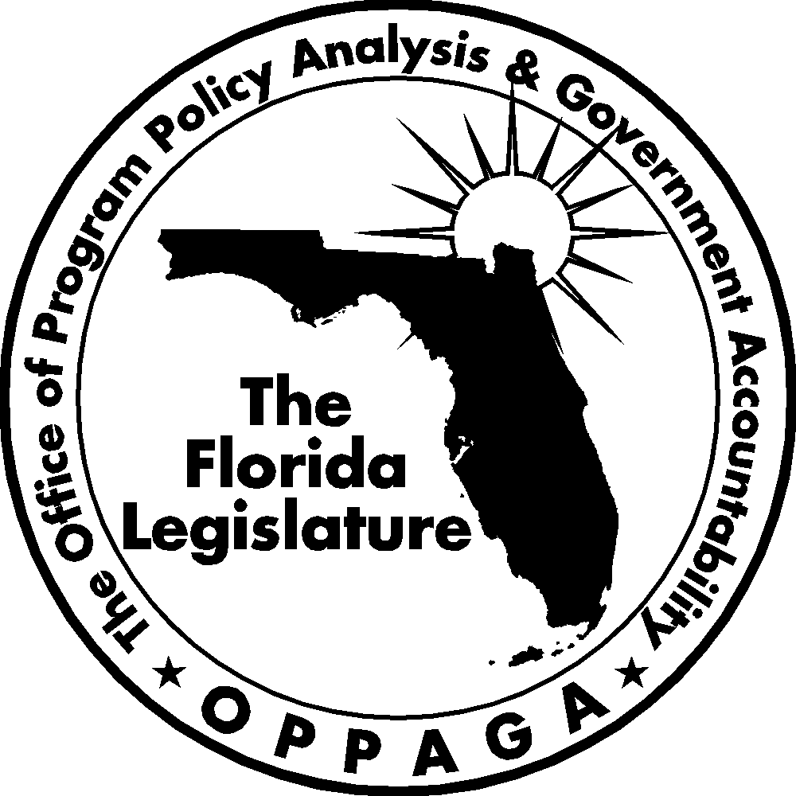
The Florida Legislature
Office of Program Policy Analysis and Government Accountability
The Florida Government Accountability Act Sunset Reviews
The 2006 Legislature passed the Florida Government Accountability Act (Ch. 2006-146, Laws of Florida) to create a Sunset review process. The act
- establishes the process, criteria, and schedule for the Legislature to assess whether state agencies and advisory committees need to continue to exist;
- provides for the creation of a Legislative Sunset Advisory Committee and describes the membership and organization of the committee and committee duties; and
- requires reports and assistance from state agencies and the Legislature’s Office of Program Policy Analysis and Government Accountability (OPPAGA).
Using these reports and other information, the Sunset Advisory Committee is to produce a report that includes recommendations to abolish, continue, or reorganize an agency or advisory committee under review.
Second Year Schedule for Agency Reviews
Agencies to be reviewed by July 1, 2010:
(a) Department of Children and Family Services
(b) Department of Community Affairs
(c) Department of Management Services
(d) Department of State

Project conducted by Rich Woerner (850/487-9217)
Kara Collins-Gomez, Staff Director
Cover photo by Kent Hutchinson
Gary R. VanLandingham, OPPAGA Director

Office of Program Policy Analysis and Government Accountability
111 W. Madison Street, Room 312 ■ Claude Pepper Building ■ Tallahassee, Florida 32399-1475
(850) 488-0021 Fax: (850) 487-3804
www.oppaga.state.fl.us

Sections 11.901-11.920, F.S.
Included in our review were advisory committees that the department was directed to include in its Agency Report to the Sunset Committee. These included advisory committees established in statute or by managerial initiative and defined in ss. 20.03 (3), (7), (8), (9), (10), and (12), F.S.
The department does not concur with this recommendation.

