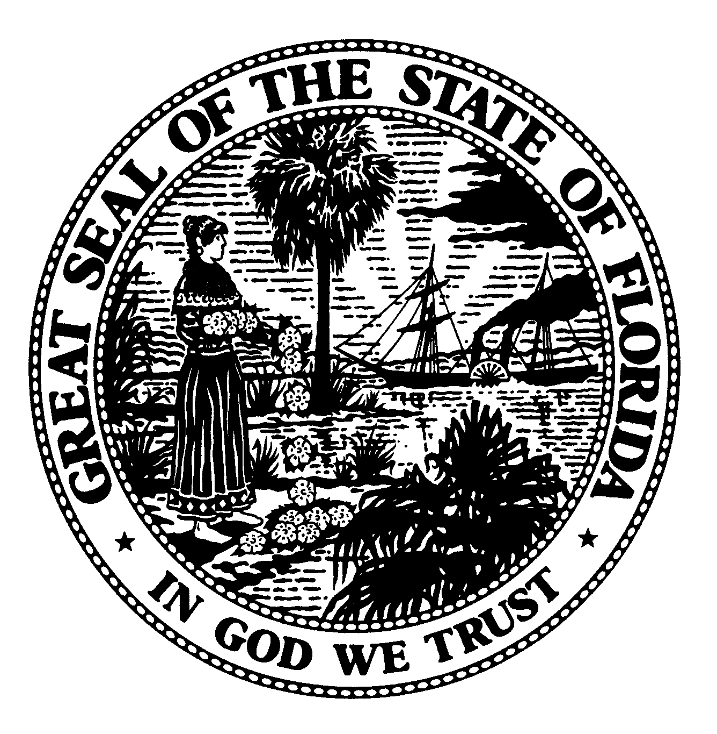 | The Florida Legislature  Office of Program Policy Analysis and  Government Accountability | 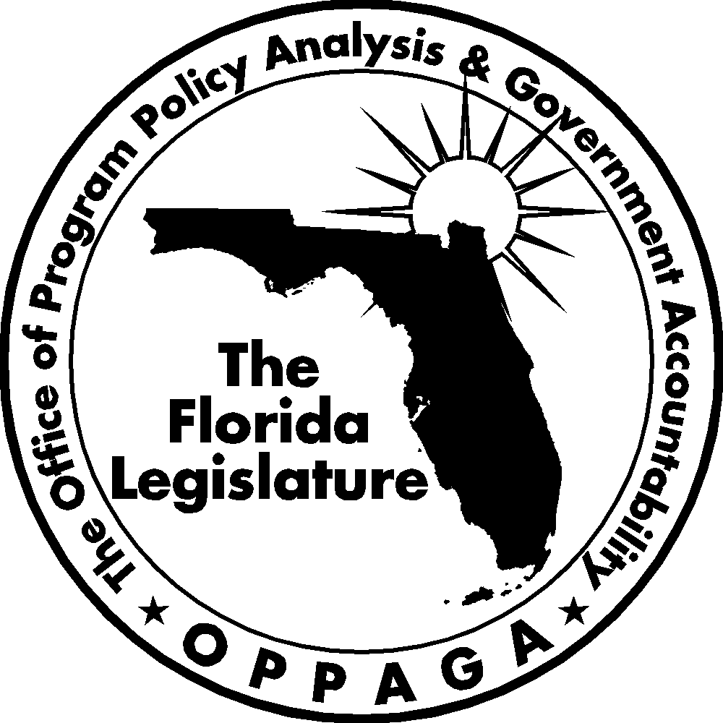
 | Gary R. VanLandingham, Ph.D., Director

MEMORANDUM

DATE: September 5, 2007

TO: Senator Don Gaetz, Co-Chair Joint Legislative Sunset Committee
Representative Kevin Ambler, Co-Chair Joint Legislative Sunset Committee

CC: Rick Mahler, Staff Director Joint Legislative Sunset Committee
Jaime Deloach, Staff Director Senate Committee on General Government Appropriations
Wayne Kiger, Staff Director Senate Committee on Environmental Preservation and Conservation
Tom Hamby, Council Director House Environmental and Natural Resources Council

FROM: Tom Roth, Staff Director (850/488-1024)
Claire Mazur, Chief Legislative Analyst (850/487-9211)

RE: Fish and Wildlife Conservation Commission Advisory Committees

Summary

In response to a request from the Joint Legislative Sunset Committee, we have reviewed the advisory committees of the Fish and Wildlife Conservation Commission We reviewed the commission’s advisory committees and identified and examined their purposes, activities, and related costs and assessed the need for continuation.

We found that eleven Fish and Wildlife Conservation Commission Advisory Committees could be discontinued. Specifically, we found that the Fish and Wildlife Conservation Commission had 19 advisory committees in Fiscal Year 2006-07 that incurred travel, staff, and other expenses totaling $228,597. In general, these advisory committees provided the commission with input and recommendations from stakeholders and technical experts on a variety of matters, including land management planning and species and habitat conservation. However, only 10 of the 19 advisory committees were active and held meetings in Fiscal Year 2006-07.

Eleven of the committees could be discontinued. The Legislature may wish to consider discontinuing three statutorily created advisory committees as they have either completed their objectives (the Harmful Algal Bloom Task Force and the Trap Certificate Technical Advisory and Appeals Board) or are duplicative of other commission committees (Nongame Wildlife Advisory Council). In addition, the commission plans to discontinue seven of its internally created advisory committees and should consider discontinuing another committee that has been inactive the last two fiscal years (the Stone Crab Advisory Board).

Background
The Florida Fish and Wildlife Conservation Commission’s mission is to manage fish and wildlife resources for their long-term well-being and the benefit of people. The Florida Constitution grants the commission the state’s executive and regulatory powers over wild animal life, freshwater aquatic life and marine fish. The Legislature may also assign other duties and responsibilities to the commission in statute as long as they do not conflict with the commission’s constitutional powers.
The Governor appoints seven members to the commission. Members are confirmed by the Senate and serve five-year terms. The commission appoints an executive director to manage the agency and its programs.
The commission reported having 19 advisory committees. Eight of these committees were established by statute while 11 were created by the commission. Collectively, these committees incurred travel, staff, and other expenses totaling $228,597 in Fiscal Year
2006-07 (see Exhibit 1).
As shown in Exhibit 1, three committees accounted for approximately 77% of the funding for advisory committees in Fiscal Year 2006-07: the Ad Hoc Spiny Lobster Advisory Board, the Snook Workgroup, and the Captive Wildlife Technical Assistance Group. These advisory committees served as a means for the commission to obtain stakeholder input regarding potential changes in rules and regulations. For example, the Snook Workgroup met five times in Fiscal Year
2006-07 and presented its recommendations concerning changes in snook regulation at a February 2007 commission meeting. The commission reports that these committees will be discontinued once it evaluates their recommendations.
Exhibit 1
The Commission Reported $228,597 in Costs for Advisory Committees in Fiscal Year 2006-07
Advisory Committee | Reported Cost
Ad hoc Spiny Lobster Advisory Board | $70,946
Snook Workgroup | 69,904
Captive Wildlife Technical Assistance Group | 34,815
Boating Advisory Council | 31,243
Red Drum Workgroup | 9,800
Marine Stock Enhancement Advisory Board | 4,247
Ad Hoc Blue Crab Advisory Board | 2,929
Florida Wildlife Magazine Advisory Council | 2,223
Florida Panther Technical Advisory Council | 1,374
Waterfowl Advisory Council | 1,116
Artificial Reef Advisory Board | 0
Harmful Algal Bloom Task Force | 0
Listing Process Stakeholder Panel | 0
Management Advisory Groups | 0
Manatee Technical Advisory Council | 0
Marine Life Workgroup | 0
Nongame Wildlife Advisory Council | 0
Stone Crab Advisory Board | 0
Trap Certificate Technical Advisory and Appeals Board | 0
Total | $228,597
Source: Florida Fish and Wildlife Commission.
See Appendix A for more information on the commission’s advisory committees.
Assessment
In assessing commission advisory committees, we considered various criteria, including whether the committees
- serve a public purpose;
- facilitate public participation in an agency’s activities and provide agency staff with stakeholder expertise without duplicating the efforts of other entities;
- are mandated by federal law; and
- fulfill their public purposes.
We concluded that most of the commission’s advisory committees serve a public purpose by providing opportunities for stakeholder input or expertise in a variety of matters. Commission managers report that involving stakeholders helps increase support and future compliance for commission programs and actions, such as changes in rules or new regulation.
However, we recommend that the Legislature repeal the statutes that authorize three
of the commission’s advisory committees. Specifically, the Legislature should consider repealing the following sections.
- Section 372.992, Florida Statutes, which would abolish the Nongame Wildlife Advisory Council. The commission often forms ad hoc workgroups and advisory committees to deal with management issues regarding specific species, including nongame wildlife. As such, the Nongame Wildlife Advisory Council could be duplicative of other workgroups and committees tasked with addressing specific species. Agency managers report that abolishing this committee would have minimal effect as there are other venues for obtaining public input on nongame wildlife issues;
- Section 370.06092, Florida Statutes, which would abolish the Harmful Algal Bloom Task Force. Commission managers reported that this advisory committee has completed its statutory responsibilities and is inactive; and
- Section 370.142(4), Florida Statutes, which would abolish the Trap Certificate Technical Advisory and Appeals Board. Commission managers reported that this advisory committee has also completed its statutory responsibilities and is inactive.
We also recommend that the Legislature consider modifying s. 372.0222(2), Florida Statutes, which creates the Florida Wildlife Magazine Advisory Council, so that the council is no longer required to meet on a quarterly basis. Department managers report that while the council has provided useful advice, it can likely fulfill its purpose with less frequent meetings.
In addition, we recommend that the commission consider discontinuing the Stone Crab Advisory Board. This board has been inactive for the last two fiscal years. Further, department managers report that 7 of 11 commission-created advisory committees have been discontinued or will be discontinued once their recommendations have been reviewed by the commission.
In conclusion, the Legislature and the commission may wish to consider discontinuing 11 of the commission’s 19 advisory committees. Discontinuing these 11 advisory committees would avoid $185,465 in costs that were spent on their activities in Fiscal Year 2006-07.

Appendix A
The Fish and Wildlife Conservation Commission Had 19 Advisory Committees in Fiscal Year 2006-07
Advisory committees are listed in order of costs (highest to lowest) incurred in Fiscal Year 2006-07.

Advisory Committee | Purpose |  | Agency Reported Activities |  | Impact of Abolition
Ad hoc Spiny Lobster Advisory Board |  | Provide the commission advice and recommendations as part of a three-year evaluation of Florida’s spiny lobster fishery.  The board’s reported cost for Fiscal Year 2006-07 was $70,946. |  | The Spiny Lobster Advisory Board involves the affected public in decision making regarding the fishery. The board’s recommendations will be considered and evaluated by the commission. The board met five times in Fiscal Year 2006-07. |  | The FWC will discontinue this ad hoc board once the three-year evaluation concludes in Fiscal Year 2007-08.
Snook Workgroup |  | Work with stakeholders to review and discuss recent stock assessment results for snook, set goals and objectives for the fishery, and suggest regulations to accomplish these goals.  The workgroup’s reported cost for Fiscal Year 2006-07 was $69,904. |  | The FWC reports that the Snook Workgroup involved the affected public in decision making regarding the management of the snook fishery. The goal of the workgroup was to facilitate the efficient management and long-term sustainability of the resource, as well as the conservation and preservation of marine habitats. The workgroup presented its recommendations to the commission in February 2007. The workgroup met five times in Fiscal Year 2006-07. |  | The FWC finalized rules regarding the snook fishery in June 2007 and discontinued this workgroup.
Captive Wildlife Technical Assistance Group |  | Provide the commission with advice and recommendations on captive wildlife regulations and other issues.  The group’s reported cost for Fiscal Year 2006-07 was $34,815. |  | The Captive Wildlife Technical Assistance Group provides recommendations concerning captive wildlife rules and regulations, including recent legislation regarding the possession of exotic species in Florida. The group met five times in Fiscal Year 2006-07. |  | Impact of abolition would be minimal. FWC managers reported that the group will no longer be active after August 2007, but that individual members of the group will be available if needed to provide input on issues within their area of expertise.
Boating Advisory Council |  | Make recommendations to the commission and Department of Community Affairs regarding issues affecting the boating community, including boating and diving safety education, boating-related facilities, including marinas and boat testing facilities, boat usage, boat access, and working waterfronts. Authorized by  s. 327.803, F.S.  The council’s reported cost for Fiscal Year 2006-07 was $31,243. |  | The council has provided input from boating groups and the public through its members on boating-related legislation and issues and trends. The council met three times in Fiscal Year 2006-07. |  | Abolition would eliminate a means by which boating groups and public can bring issues to the FWC’s attention.
Red Drum Workgroup |  | Work with stakeholders to review and discuss recent stock assessment results for the red drum species, set goals and objectives for the fishery, and suggest regulations to accomplish these goals.  The workgroup’s reported cost for Fiscal Year 2006-07 was $9,800. |  | The FWC reports that the Red Drum Workgroup involves the affected public in decision making regarding the red drum fishery. The goal of the workgroup is to facilitate the efficient management and long-term sustainability of the resource, as well as the conservation and preservation of marine habitats. The workgroup’s recommendations will be considered and evaluated by the commission. The workgroup met three times in Fiscal Year 2006-07. |  | Impact of abolition would be minimal. The FWC will discontinue the group once it presents its recommendations regarding red drum fishery management to the commission.
Marine Stock Enhancement Advisory Board | Determine research priorities for stocking marine fisheries species and provide recommendations to the Fish and Wildlife Research Institute.  The board’s reported cost for Fiscal Year 2006-07 was $4,247. |  | The Marine Stock Enhancement Advisory Board solicits input from the recreational fishing community. The board meets periodically with FWC scientists to plan strategies and make decisions on marine fish stocking issues. The board met one time in Fiscal Year 2006-07. |  | Abolition would eliminate a venue through which the FWC receives input from the public, stakeholders, and outside scientists on marine stock issues.
Ad Hoc Blue Crab Advisory Board | Provide the commission advice and recommendations on managing Florida's blue crab fishery.  The board’s reported cost for Fiscal Year 2006-07 was $2,929. |  | The Blue Crab Advisory Board involves the affected public in decision making regarding Florida’s blue crab fishery. The board met one time in Fiscal Year 2006-07. |  | The FWC will discontinue the board once the Blue Crab Effort Management Program is implemented. It will be replaced by a permanent advisory board that will be initially composed of a subset of the ad hoc board. The permanent board will continue to address issues relating to the blue crab fishery.
Florida Wildlife Magazine Advisory Council | Provide advice and guidance to the commission regarding the development, publication and sale of Florida Wildlife magazine. Authorized by  s. 372.0222(2), F.S.  The council’s reported cost for Fiscal Year 2006-07 was $2,223. |  | The council helped the editor re-establish the magazine in 2004 and advised the commission to contract the magazine’s operations to an outside publisher. However, the contract was terminated after three issues due to non-fulfillment by the vendor. Subsequently, the commission assumed responsibility for publishing the magazine in-house. During 2004 and 2005, the council reviewed the magazine’s content and made suggestions for articles. The council has not taken any formal action during the last year. The council met four times, once in-person and three times by conference call, in Fiscal Year 2006-07. |  | Abolition would reduce stakeholders oversight of the subject matter covered in the magazine. However, abolition of the council would not affect the day-to-day operations of the magazine.
Florida Panther Technical Advisory Council | Serve in an advisory capacity to the commission on technical matters of relevance to the Florida Panther Recovery Program, including reviewing and commenting on research and management programs and practices. Authorized by s. 372.673, F.S.  The council’s reported cost for Fiscal Year 2006-07 was $1,374. |  | The Florida Panther Technical Advisory Council provides the FWC with expert review of its panther recovery program activities. The council met one time in Fiscal Year 2006-07. |  | Impact of abolition is unclear because the council had been inactive for several years, but in Fiscal Year 2006-07 new members were appointed and appears set to resume its activities. Abolition would eliminate a potential means for the commission to receive outside expert advice on its panther conservation activities.
Waterfowl Advisory Council | Provide advice and guidance for the Waterfowl Management Program, and advise the commission regarding the administration of revenues generated by the sale of the Florida waterfowl hunting permits. Authorized by  s. 372.5714, F.S.  The council’s reported cost for Fiscal Year 2006-07 was $1,116. |  | The Waterfowl Advisory Council is a venue for public involvement in the management of waterfowl in Florida. The council developed a waterfowl draft management plan in 2007. The council met one time in Fiscal Year 2006-07. |  | The commission recommends discontinuing the Waterfowl Advisory Council. The impact of abolition would be minimal as the commission reports that it would seek public input through a new waterfowl stakeholder group with a broader and more diverse membership than the current council.
Artificial Reef Advisory Board | Provide the commission advice and recommendations on strategic and operational plan goals and objectives for the state's artificial reef program.  There were no reported costs for the board in Fiscal Year 2006-07. |  | The Artificial Reef Advisory Board involves the affected public in decision making on the development of artificial reefs in Florida and to meet the goals and objectives of creating quality marine habitat consistent with the National Artificial Reef Plan, and Florida’s Strategic Artificial Reef Plan. The board did not meet in Fiscal Year 2006-07. |  | If abolished, the commission would lose a mechanism for review draft policy documents. The reduced level of stakeholder input could lessen stakeholder acceptance of, and compliance with, future management actions.
Harmful Algal Bloom Task Force | Determine research, monitoring, control and mitigation strategies for red tide and other harmful algal blooms in Florida waters. The task force provides its recommendations to the Fish and Wildlife Research Institute. Authorized by s. 370.06092, F.S.  There were no reported costs for the task force in Fiscal Year 2006-07. |  | The Harmful Algal Bloom Task Force finished its statutorily required work and published its recommendations in October 1999. Since then, the commission has continued the task force, but has not provided funding for the last three fiscal years. The FWC reports that it may want to obtain input in the future from an advisory board to develop management strategies for harmful algal blooms. |  | Abolition would eliminate a potential venue through which the FWC can receive input from the public, stakeholder groups, and outside scientists. However, the impact of abolition would be minimal because the task force has completed its statutory responsibilities and has been inactive for several years.
Listing Process Stakeholder Panel | Provide the commission with advice and recommendations on how to address issues regarding the state listing process for determining if a species is endangered, threatened, or of special concern.  There were no reported costs for the panel in Fiscal Year 2006-07. |  | The FWC created this panel to assist it in developing and implementing a new listing process. The panel was originally created in 1998 and reconstituted in 2002 to revise the newly created listing process. The panel has not meet during the previous three fiscal years. |  | Impact of abolition would be minimal. The panel is not legislatively created and is currently disbanded. FWC managers reported that the panel could be reconstituted if needed to assist in evaluating and/or revising the listing process.
Management Advisory Groups | Engage stakeholders and the public in drafting 10-year Conceptual Management Plans for all FWC-managed areas, which include wildlife management areas, wildlife environmental areas, and mitigation parks. Authorized by  s. 259.032, F.S.  There were no reported costs for Management Advisory Groups in Fiscal Year 2006-07. |  | Management Advisory Groups hold meetings to gather local expert and stakeholder input for conceptual management plans for state lands managed by the FWC. The FWC uses this input to develop land management goals, objectives, and strategies. Management Advisory Groups did not meet in Fiscal Year 2006-07. |  | Abolition of Management Advisory Groups would decrease public input, especially at the local level, on developing land management plans.
Manatee Technical Advisory Council | Provide the commission with advice and recommendations concerning manatee issues.  There were no reported costs for the council in Fiscal Year 2006-07. |  | The Manatee Technical Advisory Council is inactive and has not met during the previous three fiscal years. |  | There would be no impact if abolished because the council was created by the FWC initiative and the commission has discontinued its activities. The council has been inactive for several years.
Marine Life Workgroup | Provide the commission with advice and recommendations on the biological and management needs of Florida's marine life industry.  There were no reported costs for the workgroup in Fiscal Year 2006-07. |  | The FWC reports that the Marine Life Workgroup involves the affected public in decision-making regarding the marine fishery. The goals of the workgroup include facilitating the efficient management and long-term sustainability of the marine resource, as well as the conservation and preservation of marine habitat. The workgroup’s recommendations will be considered and evaluated by the Commission. The workgroup has not meet since Fiscal Year 2005-06. |  | The impact of abolishment would be minimal. FWC managers report that the workgroup will be terminated once its recommendations regarding specific marine life fishery management issues have been presented to the commission.
Nongame Wildlife Advisory Council | Recommend policies, objectives, and specific actions for nongame wildlife research and management to the commission. Authorized by  s. 372.992, F.S.  There were no reported costs for the council in Fiscal Year 2006-07. |  | The Nongame Wildlife Advisory Council provides input from other agencies, universities, conservation groups, and landowners concerning nongame wildlife. The council did not meet in Fiscal Year 2006-07. |  | Impact of abolition would be minimal. FWC managers report that there could be some loss of outside input if the council was abolished, but that there are other venues for obtaining public and expert input on nongame wildlife issues. Additionally, the FWC’s increased use of advisory committees and workgroups to obtain input on specific species and management plans reduces the need for this statutorily required committee, which does not have specific goals or responsibilities.
Stone Crab Advisory Board | Advise the commission on management strategies for the stone crab fishery. This board has evolved from the Stone Crab Appeals and Advisory Board, which was created in 2001.  There were no reported costs for the board in Fiscal Year 2006-07. |  | The FWC reports that the Stone Crab Advisory Board involves the affected public in decision-making regarding the fishery. The goal of the workgroup is to facilitate the efficient management and long-term sustainability of the resource, as well as the conservation and preservation of marine habitats. The board has not met during the previous two fiscal years. |  | If abolished, the FWC would lose a venue for obtaining stakeholder input regarding future stone crab fishery management issues. FWC managers contend that this could lessen stakeholder acceptance of and compliance with future fishery management actions.
Trap Certificate Technical Advisory and Appeals Board | Initially created to advise the former Department of Natural Resources on disputes and other problems arising from the implementation of the Spiny Lobster Trap Certificate Program. Authorized by  s. 370.142(4), F.S.  There were no reported costs for the board in Fiscal Year 2006-07. |  | The Trap Certificate Technical Advisory and Appeals Board provided the affected public with input into decisions and actions regarding the state’s spiny lobster fishery. The board did not meet in Fiscal Year 2006-07. |  | The impact of abolishment would be minimal. The board is inactive and its purpose was completed as of July 1, 1994.

Included in our review were advisory committees that are defined in ss. 20.03(3), (7), (8), (9), (10), and (12), F. S., or were created through executive order.
s. 20.052(1),F.S.
s. 20.052(2), F.S.
These advisory committees include the Captive Wildlife Technical Assistance Group, the Ad Hoc Spiny Lobster Board, the Red Drum Workgroup, the Snook Workgroup, the Listing Process Stakeholder Panel, the Manatee Technical Advisory Council, and the Marine Life Workgroup.

