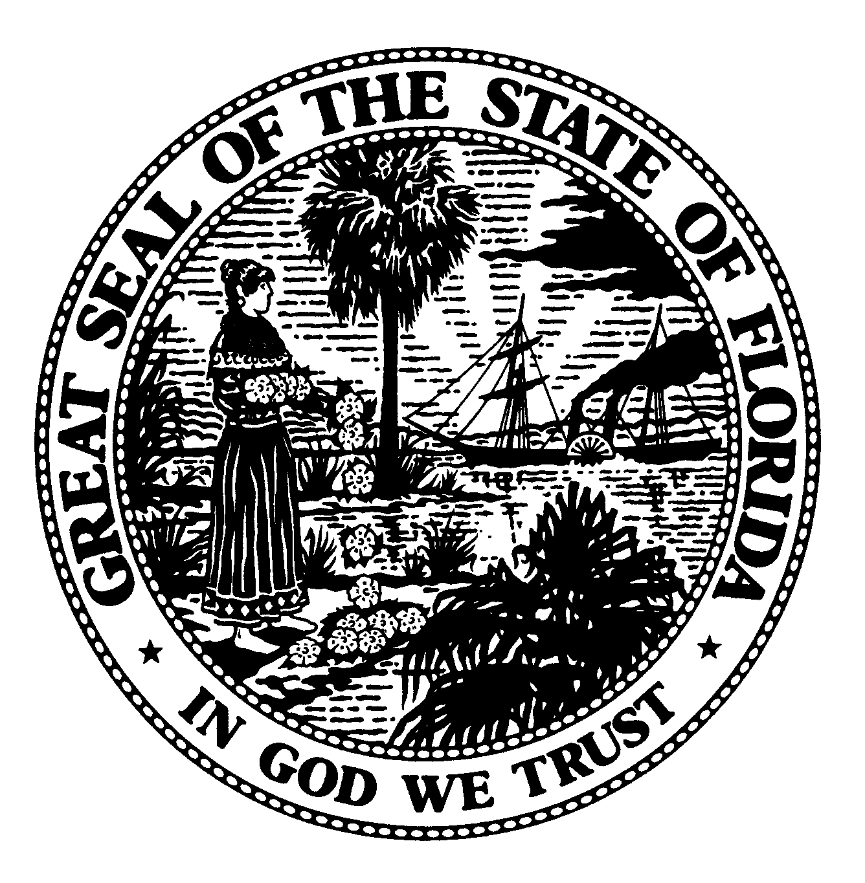 | The Florida Legislature  Office of Program Policy Analysis and  Government Accountability | 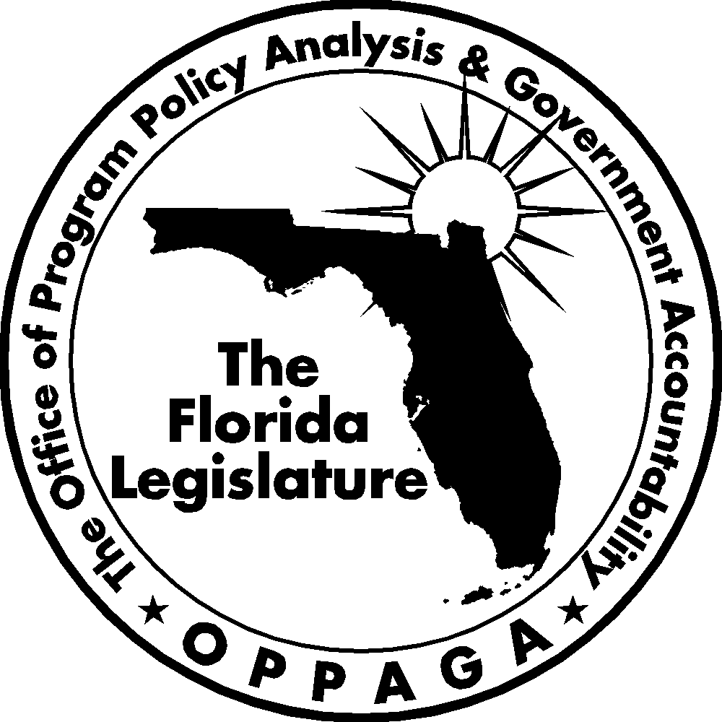
 | Gary R. VanLandingham, Ph.D., Director

Sunset Memorandum

Governance of Florida’s Water Management Districts
Options for Legislative Consideration

December 19, 2007

Summary
To support the Sunset Review process, the Legislature directed OPPAGA to examine Florida’s water management districts. This memo is part of a series that reviews the districts’ operations, and focuses on district governance and options for legislative consideration. These options include requiring the Legislative Budget Commission to review and comment on district budgets (Option 1), revising dates for the water management district budget review process to match the state fiscal year (Option 2), directing districts with basin boards to assess the value of their basin boards (Option 3), eliminating the authority of district governing boards to designate basin boards (Option 4), and providing for the election of governing board members (Option 5). For each option, we describe the advantages, and disadvantages.

Purpose, Organization, and Responsibilities
Florida’s five water management districts are responsible for managing and protecting the state’s water resources and related natural systems. As shown in Exhibit 1, the districts are regionally based with boundaries that match the state’s hydrological geography, and include Northwest Florida, Suwannee River, St. Johns River, Southwest Florida, and South Florida. The districts are governed by boards whose members are appointed by the Governor and must be confirmed by the Florida Senate. The governing board of each district is composed of nine members, except the Southwest Florida Water Management District, which has 13 members. The term of office for a governing board member is four years. Vacancies are filled according to residency requirements that are unique to each district, such as requirements that appointees reside in a certain county. For example, two members of the South Florida Water Management District Governing Board must reside in Dade County.
District governing boards, which meet on a monthly basis, oversee district operations, establish policy, hire an executive director, issue orders to implement or enforce regulations, and approve contracts. Governing boards are also authorized by the Florida Constitution and by statute to levy ad valorem taxes to fund district operations. As specified by the Florida Constitution, four districts are limited to a maximum property tax rate of 1.00 mill, which is $1 for every $1,000 of taxable property value; the Northwest Florida Water Management District is limited to 0.05 mill.
In addition, governing boards can designate areas as subdistricts or hydrological basins. Two districts have designated such basins. The basins are represented by boards composed of at least one member from each county in the basin. The Southwest Florida Water Management District has established eight basin boards with 44 members. There are two basins in the South Florida Water Management District; the district’s Big Cypress Basin has a six-member board and the district’s governing board serves as the board for the Okeechobee Basin. Basin board members are appointed to three-year terms by the Governor and must be confirmed by the Florida Senate. A governing board member serves as the ex-officio chair of each basin board.
Basin boards assist districts in implementing their mission within a hydrological area. The basin boards do not have regulatory authority but are statutorily responsible for planning and developing water resources and water control facilities that connect to and complement the primary engineering works in the basin. The two districts utilize their boards differently. In the Southwest Florida Water Management District, the basin boards plan for and carry out the works of the basin including construction and maintenance of water control structures, work with local governments and regional water supply authorities to identify local needs and priorities (e.g., alternative water supplies), and develop projects and budgets to address those needs. In contrast, the Big Cypress Basin Board in the South Florida Water Management District emphasizes planning, building, operating, and maintaining canals, and water control structures in the region.
The Basin Boards may request the district governing board to levy ad valorem taxes within a basin to finance that basin board’s works and functions. These taxes are not in addition to the water management district taxes, but represent an allocation of the total authorized millage rate. Specifically, the total authorized millage rate is divided for district and basin purposes and cannot exceed the statutory maximum total millage rate. For example, the statutory maximum millage rate in the Southwest Florida Water Management District is one mill, with the maximum millage assessed for district purposes not to exceed 50% of the total authorized millage when there are one or more basins in the district, and the maximum millage assessed for basin purposes not to exceed 50% of the total authorized millage.
Resources
The water management districts reported total budgeted expenditures of $2.4 billion for Fiscal Year 2006-07. Of this total, $813,578 was spent to support the governing boards (see Exhibit 1), including travel, equipment, advertising, office supplies, subscriptions, memberships, and estimated staff support. As shown in Exhibit 1, board-related costs reported by the South Florida Water Management District exceeded the total reported by the other four districts combined, which may be attributed in part to $216,215 incurred for outside counsel to provide additional qualified representation for the district’s governing board in legal affairs.
Exhibit 1
Water Management Districts Reported $813,578 in Governing Board Costs in Fiscal Year 2006-07
District | Reported Costs
Northwest Florida | $ 68,933
Suwannee River | 64,792
St. Johns River | 92,838
Southwest Florida | 112,961
South Florida | 474,054
Total Funds | $813,578
Source: Water Management Districts.
The water management districts also reported spending $509,046 during the fiscal year to support basin boards. The Southwest Florida Water Management District reported $478,222 (approximately $60,000 per basin board) in operating and staff costs for its eight basin boards. The South Florida Water Management District reported $30,824 in staff support for the Big Cypress Basin Board. Since the district governing board also serves as the Okeechobee Basin Board and has no separate meetings, operating expenses for this basin board are included in the district costs reported above.
Several Long-Standing Issues Relate to District Governance
Over the years, citizens and policymakers have raised several concerns about the current governance structure of Florida’s water management districts. These concerns are related to board member selection, the budget approval process, and basin board expenditures.
Some stakeholders have raised the concern that appointed governing boards result in “taxation without representation” because the boards have taxing authority but governing members are not elected. According to a 1995 Water Management District Review Commission Report, the Legislature in creating the districts reasoned that appointed governing board members from across a district’s jurisdiction would better manage regional resources for the benefit of the entire region, since each member would not be elected by and represent a discrete constituency. However, as board members are not elected, citizens who are dissatisfied with decisions about district funding and operation cannot address these concerns through the electoral process.
A second and related concern is that some stakeholders assert that there is a lack of accountability over district funding decisions. This issue arises because the Florida law provides that the Governor, rather than the Legislature, has the authority to approve or disapprove, in whole or in part, the budget of each water management district. The Legislature’s appropriation committee chairs may provide comments and objections to the districts on their proposed budgets. While the district’s governing board has final budget approval, any provision rejected by the Governor cannot be included in the district’s final budget. This approval process was established to avoid a separation of powers issue because the state is constitutionally prohibited from levying ad valorem taxes, which is a source of district revenues.
Third, concerns have also been raised about the purpose and benefits of basin boards relative to time and effort expended on supporting them; in particular, the Southwest Florida Water Management District, which has eight basin boards and 44 members. Basin boards provide a mechanism for local input and guidance for water resource programs and projects. Property taxes recommended to the governing board and raised by basin board assessments also provide a dedicated funding source to address local needs and priorities. However, taxpayers incur $509,046 in costs to support the basin boards, due mainly to considerable staff time spent preparing and attending basin board meetings (an average of five meetings per year per basin), responding to board requests and inquires, and developing budgets for each board.
Numerous accountability mechanisms can help address these issues. There are several accountability mechanisms in place that address some of these concerns. These include statutory millage caps, budget reporting requirements, Department of Environmental Protection oversight authority, and the Legislature’s ability to modify governing board composition.
Statutory millage caps. The Legislature has exercised its authority to reduce the districts’ maximum millage rate. The Florida Constitution provides a millage cap of .05 mill for Northwest Florida Water Management District and limited the remaining four districts to 1 mill. However, the Legislature has further restricted the taxing authority for three districts: Suwannee River (0.75 mill), St. Johns River (0.6 mill), and South Florida (0.80 mill).
Budget reporting requirements. The districts must submit their proposed annual budgets to several entities, including the Governor, the President of the Senate, the Speaker of the House of Representatives, and the chairs of all substantive and fiscal committees by August 1 of each year. The House and Senate appropriation committee chairs may submit comments and objections to each district on their proposed budgets by September 5. In adopting their final budget, the district governing board must include a written response to any comments and objections of the appropriation chairs.
The Executive Office of the Governor is required to review the districts’ proposed budgets and may veto all or part of these proposed budgets. The office must report annually to the Legislature the results of its review of the districts’ proposed budgets; the report also identifies those districts that do not comply with reporting requirements. State funds can be withheld from a water management district that fails to comply with these reporting requirements.
Water management district staff indicates that they have not received comments or objections on their proposed budgets from the Legislature in recent years. One possible reason is that the legislators are not in session during the comment period. Districts have made presentations on their budget to committees and legislative staff during the regular legislative sessions to assist in their review of water management district budgets. The Executive Office of the Governor and water management districts also indicate that the Governor has never vetoed a water management district budget. Instead, the districts receive and follow direction from the governor’s office in developing their budgets.
Department of Environmental Protection oversight. The Department of Environmental Protection has general supervisory authority of the water management districts. The department carries out its oversight responsibilities in several ways including
- receiving copies of spending plans and budgets;
- auditing funds granted or contracted to the districts for water related projects;
- reviewing water management district rules for consistency with state water policy;
- monitoring the status, expenditures, and revenues for the Comprehensive Everglades Restoration Program; and
- administering trust funds used for land acquisition and management such as the Florida Forever Trust Fund.
The department’s secretary also conducts monthly conference calls with district executive directors and meets quarterly with the governing board chairs and executive directors to enhance coordination and discuss concerns between the agencies.
Legislative modification of governing boards. Over the years, the Legislature has enacted legislation to revise the number of governing board members and associated residence requirements. For example, the 2007 Legislature provided for two additional members to be appointed to the Southwest Florida Water Management District Governing Board. It also specified that one of the governing board members must reside in Polk County and revised the qualifications for the “at large” seats to specify that one member must reside in Hardee, DeSoto, or Highland counties and one must reside in Sarasota or Charlotte counties, and one member must reside in Marion or Hernando counties.
Options for Legislative Consideration
If the Legislature wishes to take additional actions to address the accountability concerns that have been raised regarding the current governance structure of the water management districts, it could consider several options, as discussed in Exhibit 2. These options include requiring the Legislative Budget Commission to review and comment on district budgets (Option 1), revising dates for the water management district budget review process to match the state fiscal year (Option 2), directing districts with basin boards to reduce the number of basins and associated boards (Option 3), eliminating the authority of district governing boards to designate basin areas (Option 4), and providing for the election of governing board members (Option 5). The exhibit outlines the policy options and describes the advantages and disadvantages associated with each option.
Exhibit 1
The Legislature Could Consider Several Options to Enhance Water Management District Accountability Mechanisms
Option | Advantages | Disadvantages
Option 1 – Require the Legislative Budget Commission to Review Water Management District Budgets
The Legislature would amend s. 373.536, F.S. to require the districts to provide a copy of their proposed budget to the Legislative Budget Commission. The commission would review the proposed budget and provide comments and objections to each district. | - Provides additional legislative review of water management district budgets. | - Would require a statutory change.  - Legislative Budget Commission does not always meet during the timeframe necessary to timely consider water management district budgets.
Option 2 – Revise the Water Management District Budget Review Process
The Legislature would amend s. 373.536, F.S. to revise the water management district budget process. These changes would result in the actions described below.  - Revise the water management district fiscal year (October 1 through September 30) to run concurrent with the state fiscal year.  - Remove the requirement that the tentative budget be submitted to the governing board by July 15.  - Revise the date from August 1 to February 1 for the submittal of the district tentative budgets to the Governor, the President of the Senate, the Speaker of the House, and the chairs of all substantive and fiscal committees.  - Revise the date from September 5 to March 5 for the submittal of comments and objections on district proposed budgets by the House and Senate Appropriation chairs.  - Revise the date from December 15 to May 15 for the submittal of a report on its review of district budgets by the Executive Office of the Governor. | - Provides additional legislative review of water management district budgets.  - Provides the Legislature with information on district budgets prior to the legislative session, which would help facilitate state funding decisions related to district activities. | - Would require a statutory change.  - Would complicate local government taxation, as Florida law requires county property appraisers to provide certification of taxable values by July 1 of each year to the water management districts. The districts use this information in setting their millage rates and developing their budgets. If the submittal date of the districts’ tentative budget is revised to February, then the district’s governing board would not have certified taxable values to set their millage rates and develop their budgets.  - Changes to the water management district fiscal year could be disruptive to county property appraisers. Currently, the water management districts and local governments are on the same fiscal year. Florida law requires the county property appraisers to provide an estimate of the total assessed value of non-exempt property to each taxing authority by June 1 of each year. This estimate is provided for budget planning purposes. Changing the districts’ budget submission date would result in having the county property appraiser provide this estimate to the districts and local governments at different times.  - Local governments and water management districts are partners in developing and funding projects, such as alternative water supply development projects. A change in the water management district fiscal year could be disruptive to the working relationship between local governments and the districts.
Option 3 – Require Districts to Assess Value of Basin Boards
The Legislature could direct the water management districts to periodically assess the costs and benefits of their basin boards to ensure that the boards provide adequate value to justify their continued existence and taxpayer support. This could lead to reducing the number of basins and associated boards through consolidation. | - Could identify opportunities to reduce the number of boards and/or reduce their expenses.  - Consolidated basin boards covering larger geographic areas may facilitate regional projects, rather than smaller projects.  - Larger basins could facilitate projects that would not normally be approved by smaller basins because of a desire to restrict tax levels or inability to raise funds due to their existing tax base. | - Consolidated or eliminated boards would reduce local decision making over the types of projects and funding levels.  - Spreading ad valorem taxes over larger area may result in higher tax rates for those areas that had lower tax rates.  - Potential opposition from basin residents who may feel that their interests are no longer represented.  - Hydrological considerations could be overlooked to the disadvantage of the area’s water resources.
Option 4 – Eliminate Basin Boards
The Legislature would repeal  ss. 373.0693-373.0698, F.S., thereby eliminating the ability for water management districts to create basin areas. | - Maximizes ad valorem revenues available for overall district purposes because the millage rate would no longer be divided between the district and basin boards.  - Reduces costs associated with supporting basin boards.  - Eliminates district staff time associated with supporting basin boards, which could facilitate staff reductions. | - Would require a statutory change.  - May reduce local feedback mechanism, thus limiting information available for funding and project decisions.  - Potential opposition from basin residents who may feel that their interests are no longer represented.
Option 5 – Require Governing Board Members to be Elected
The Legislature would amend s. 373.073, F.S. to provide for the election of governing board members. | - Increased accountability over board members.  - Increased voter awareness of governing board member positions on water policy, due to information provided to the public during campaigning. | - Could require a constitutional amendment because the water management districts are under Department of Environmental Protection in the executive branch of government.  - Would require a statutory change.  - Would result in additional costs associated with establishing an election process.  - May require salaries and office expenses for elected board members.  - Elected officials would more likely be expected to represent the interests of a group of residents from one area rather than the entire region. Thus, elected officials may not collectively represent the range of stakeholders’ interests that appointed board members could represent.
Source: OPPAGA analysis.

Sections 11.901-11.920, F.S.
Chapter 2007-120, Laws of Florida, revised the composition of the Southwest Florida Water Management District’s Governing Board from 11 to 13 members.
The executive director must be approved by the Governor and confirmed by the Senate.
The St. Johns River Water Management District cannot establish basins without legislative approval.
The ninth basin is the Green Swamp, the headwaters for four major rivers. Given its hydrologic importance to the district, the governing board serves as the basin board.
The water management district fiscal year runs from October 1 to September 30.
The Northwest Florida and Suwannee River Water Management District also incurred $13,219 and $20,740 for outside counsel, respectively.
According to Southwest Florida Water Management District Officials, the governing board costs represent direct costs including staffing costs to conduct the meetings; whereas the basin board costs include indirect costs associated with staff preparing, attending, and following up on basin board meetings.
Bridge Over Troubled Water: Recommendations of the Water Management District Review Commission, Water Management District Review Commission, December 1995.
Article VII, Section 1(a) of the Florida Constitution.
Section 373.536(1), F.S.
Ch. 2007-120, Laws of Florida.

