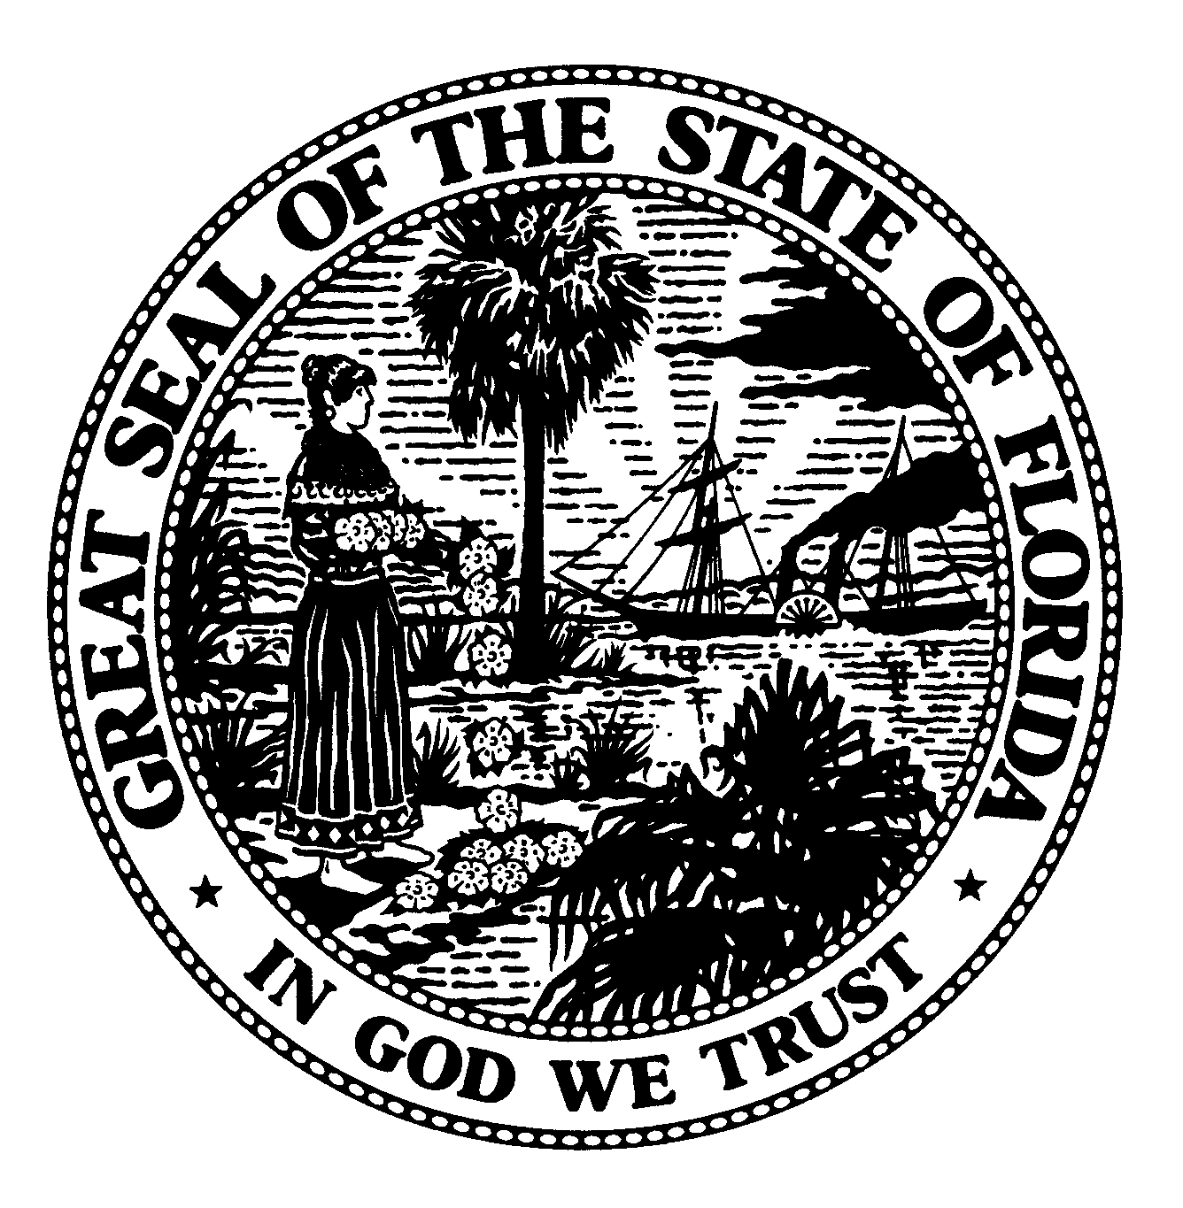 | The Florida Legislature  Office of Program Policy Analysis and  Government Accountability | 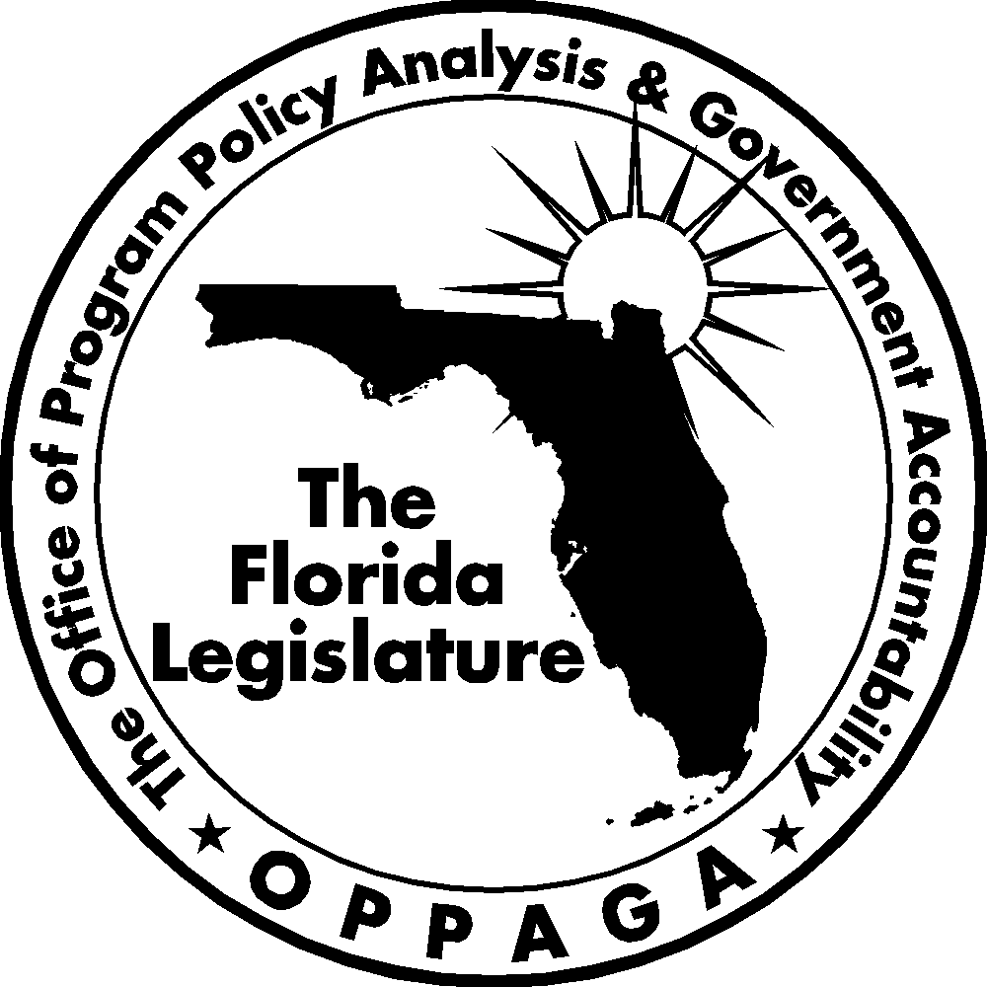
Sunset Memorandum

Florida’s Water Management District Land Management
Options for Legislative or District Governing
Board Consideration

January 28, 2008

Summary
To support the Sunset Review process, the Legislature directed OPPAGA to assess the state’s five water management districts. This memo assesses the districts’ land management activities. A separate memo addresses the land management activities conducted by the Department of Agriculture and Consumer Services, the Department of Environmental Protection, and the Fish and Wildlife Conservation Commission.
This memo provides information about public access to the water management districts’ conservation lands and assesses the districts’ effectiveness in managing these lands. It also presents five policy options for the Legislature and district governing boards to consider regarding conservation land management. These options include maintaining the current system for managing district-owned lands (Option 1); increasing cooperative agreements with other agencies to perform some district conservation land management activities (Option 2); increasing vehicle access to and availability of recreational activities on district lands (Option 3); limiting district land management to mission critical activities (Option 4); establishing and reporting comprehensive performance information (Option 5); and centralizing the districts’ land management activities under the Department of Environmental Protection (Option 6). The memo discusses the advantages and disadvantages of each option.

Agency Responsibilities
Florida’s five water management districts are responsible for managing and protecting the state’s water resources and related natural systems. The districts include Northwest Florida, Suwannee River, St. Johns River, Southwest Florida, and South Florida. The districts have acquired large amounts of land to fulfill their statutory responsibilities to reduce the risk of flooding, protect and improve water quality, protect water recharge areas for water supply, and restore and protect natural systems as well as to provide public access and recreational opportunities. State law requires that district-owned lands be managed and maintained to ensure a balance between public access, recreational opportunities, and environmental restoration and protection.
As shown in Exhibit 1, the five water management districts own 2.7 million acres of land, and serve as “lead manager” for 1.4 million of these acres (the remaining 1.3 million acres are managed by other state agencies and local governments). For the 1.3 million acres that are not managed primarily by the water management districts, they have established cooperative agreements with state agencies or local governments to manage all or portions of the land. When a district acquires land, its staff evaluates the property to determine public access points, restoration needs, presence of invasive nonnative plants, recreational opportunities, and the best use of the land. If the evaluation reveals that another entity would be a more suitable lead manager, the district contacts that entity and pursues a cooperative agreement. If the other entity agrees to manage the newly acquired land, a cooperative agreement is written and approved by the district governing board. For example, if the property is suitable for a park, the district will inquire with the Department of Environmental Protection to determine if they want to develop the land as a state park and assume the lead manager role. All five districts also have cooperative agreements with the Fish and Wildlife Conservation Commission to enforce wildlife rules and regulations in wildlife management areas on district lands. Similarly, several districts have agreements with the Department of Agriculture and Consumer Services, Division of Forestry, to manage district lands as state forests.
Exhibit 1
Water Management Districts Own 2.7 Million Acres and Serve as Lead Manager on 1.4 Million Acres
District | Acres Owned | Acres Managed
Northwest Florida | 206,943 | 206,943
South Florida | 1,333,133 | 373,738
Southwest Florida | 330,737 | 274,391
St. Johns River | 682,896 | 409,407
Suwannee River | 157,082 | 136,048
Total Acres | 2,710,791 | 1,400,527
Source: Water Management Districts.
Florida statutes require districts to conduct several activities to protect, maintain, and restore lands as well as provide recreational opportunities. Major land management activities include hydrologic restoration, land restoration, prescribed burning, removal of invasive plants and animals, and providing public access and recreation.
- Hydrologic Restoration includes activities that restore and protect natural water flow, such as removing a logging road that blocks water flow through a creek and erosion control.
- Prescribed Burning reduces hazardous fuel loads and maintains fire dependent habitats.
- Land Restoration includes harvesting or thinning unwanted tree species; conducting prescribed burns to eliminate unwanted or invasive species of grass, brush, or trees; replanting areas with desired vegetation; and controlling nonnative plants.
- Removal of Invasive Plants and Animals includes application of chemical herbicides, mechanical clearing, hunting programs and trapping.
- Public Access and Recreation includes making access road improvements; fencing perimeters; providing public recreation facilities, such as campgrounds and trails; and providing law enforcement and security.
Districts are statutorily required to develop land management plans to guide the long-term objectives and activities for each parcel they own. These plans are developed through a process that includes an internal review by district management and staff, an external review by cooperating state agencies, public feedback, and the plans are approved by districts’ governing boards.
Districts are statutorily required to conduct periodic land management reviews to determine whether their conservation, preservation, and recreation lands are being managed for the purposes for which they were acquired in accordance with the parcels’ land management objectives. Review teams are composed of representatives from the local community, water management district, local soil and water conservation district, conservation organization, the Department of Agriculture and Consumer Services, the Department of Environmental Protection, the Fish and Wildlife Conservation Commission, and a private land manager. Districts must submit a report to their governing board each year indicating which properties have been reviewed and the review team findings. In 2006, the districts completed 12 land management reviews.
Resources
The districts spent over $32 million on land management activities in Fiscal Year 2006-07 (see Exhibit 2). The primary funding source for these activities was the state’s Water Management Lands Trust Fund, which receives funding from 4.2% of documentary stamp taxes, interest earnings, and penalty assessments. Other funding sources were timber sales, ad valorem funds, grants, and mitigation funds from the Florida Department of Transportation. The districts allocated 147.5 full-time equivalent employees to land management activities in Fiscal Year 2006-07. However, the districts have outsourced many land management functions, and almost half (47%) of the districts’ land management expenditures were for contracts with outside entities for services such as mowing, garbage removal, prescribed burning, and security. The Suwannee River district most heavily relies upon on contractors for land management, with contract expenditures representing 77% of its land management costs.
Exhibit 2
Water Management Districts Spent $32 Million on Land Management Activities in FY 2006-07
District | Total Funds | FTE | Contracted Funds
Northwest Florida | $ 3,927,291 | 9 | $ 1,166,358
South Florida | 9,561,980 | 35 | 4,602,129
Southwest Florida | 6,244,665 | 46 | 1,733,079
St. Johns River | 7,097,473 | 45 | 3,538,672
Suwannee River | 5,398,038 | 12.5 | 4,166,084
Total | $32,229,447 | 147.5 | $15,206,322
Source: Water Management Districts.
Over the past three fiscal years, the largest land management expenditures were for nonnative invasive plant control, capital improvement, and contracted services for public access and recreational areas. Land management expenditures increased by $7.8 million between Fiscal Years 2004-05 and 2005-06. According to district staff, this increase was due to enhanced state funding for capital improvements, land restoration activities, and increased management responsibilities for newly acquired lands that lie idle until construction projects begin. Expenditures remained relatively unchanged between Fiscal Year 2005-06 and 2006-07.
Most Lands Owned by Water Management Districts Are Accessible to the Public for a Wide Variety of Recreational Activities
Florida statutes require district land managers to provide public access to natural resource-based recreation where feasible and consistent with the goals of protection and conservation of natural resources. Most district-owned lands (90%) are open to the public, including 312 recreational areas encompassing 2.4 million acres accessible for a wide variety of recreational purposes (see Exhibit 3). The public can generally access these areas on foot, bicycle, horseback, and boat. However, vehicle access on district lands is often limited, and is allowed on only 40% of district recreation areas. Vehicle access can be denied in cases where land includes wetlands and other sensitive ecosystems and endangered species that cannot tolerate increased human activity or where no interior roads exist and cannot be constructed without negatively affecting water resources. In other areas, vehicle access is allowed only during hunting season, when the Fish and Wildlife Conservation Commission patrols these areas.
Exhibit 3
Most District Lands Are Open to the Public for Recreational Activities
District | Number of  Recreational Areas | Acres  Open | Acres  Closed
Northwest Florida | 10 | 206,893 | 50
South Florida | 68 | 1,179,196 | 100,859
Southwest Florida | 56 | 345,140 | 1,190
St. Johns River | 54 | 562,378 | 14,600
Suwannee River | 124 | 153,390 | 3,562
Total | 312 | 2,446,997 | 120,261
Source: Water Management Districts.
The districts report that 120,261 acres are totally closed to the public. As shown in Exhibit 3, most of these acres (84%) are owned by the South Florida Water Management District, which has closed the lands to protect critical infrastructure (e.g., pumps) and because of ongoing construction and restoration activities such as those being undertaken as part of the Comprehensive Everglades Restoration Plan. The district plans to open these lands to public access once it completes the infrastructure projects.
The water management districts provide a variety of recreational activities on their lands (see Exhibit 4). The activities the districts most frequently offer to the public are hiking (available in 288 or 92% of recreational areas), fishing (available in 249 or 80% of areas), and wildlife viewing (available in 312 or 100% of areas). However, some recreational activities are limited. For example, swimming is only allowed in five recreational areas due to safety concerns—Econfina Creek, Suwannee Springs, Falmouth Springs, Atsena Otie Key, and Weekiwachee Preserve. Hunting is permitted on 1,484,227 acres or 55% of district lands.
Exhibit 4
A Variety of Recreational Activities Are Allowed on District-Owned Land
Recreational Opportunity¹ | Northwest Florida | South Florida | Southwest Florida | St. Johns River | Suwannee River | Total  312 Areas  (2,447,047 Acres)
Recreational Opportunity¹ | 10 Areas  (206,893 Acres) | 68 Areas  (1,179,196 Acres) | 56 Areas  (345,140 Acres)² | 54 Areas  (562,378 Acres) | 124 Areas  (153,390 Acres) | Total  312 Areas  (2,447,047 Acres)
Hiking | 10 | 58 | 51 | 52 | 117 | 288
Wildlife Viewing | 10 | 68 | 56 | 54 | 124 | 312
Fishing | 10 | 46 | 38 | 43 | 112 | 249
Recreational Infrastructure | 9 | 43 | 46 | 54 | 75 | 227
Biking | 2 | 23 | 28 | 47 | 86 | 186
Canoeing or Kayaking | 9 | 39 | 25 | 25 | 30 | 128
Hunting | 9 | 47 | 12 | 27 | 23 | 118
Equestrian Activities | 8 | 13 | 25 | 44 | 16 | 106
Watercraft Access Points | 7 | 16 | 18 | 18 | 31 | 90
Camping | 6 | 26 | 18 | 37 | 1 | 88
Motorized Boating | 9 | 30 | 19 | 19 | 11 | 88
Swimming and Beach Activities | 1 | 0 | 1 | 0 | 3 | 5
¹ The level of recreational opportunities provided by the districts varies. For example, camping may include primitive camping, group camping, equestrian camping, and RV camping.
² The Southwest Florida district reported more recreational acreage (345,140) than acreage owned (330,737) because some recreational areas include both district acreage and acreage owned by other government agencies.
Source: OPPAGA analysis of data provided by the Water Management Districts.
The Districts’ Performance Measures and Evaluations Provide Useful Information but Could Be Improved
The water management districts assess their land management activities through performance measures, quantitative and qualitative monitoring, and land management reviews that assess individual parcels. However, the districts’ measures are limited and lack adopted standards, which makes it difficult to for the Legislature to assess performance gains or deficiencies over time. In addition, the five districts do not report consistent performance information, making it difficult to for the legislature to assess statewide performance.
Performance measures provide limited data. As shown in Exhibit 5, the water management districts report performance measures to the Executive Office of the Governor and the Legislature. In general, these measures provide information about the volume of land management activities conducted, acres of land currently under restoration, and acres of invasive aquatic and upland plants. For example, the measures show that for Fiscal Year 2006-07, the districts identified, through their land management plans, 131,356 acres of land needing restoration. In addition, four districts (South Florida, Southwest Florida, St. Johns River, and Suwannee River) reported completing between 87% and 98% of their planned management activities. Most districts track and report performance information related to their invasive plant control activities. These measures show that these three districts manage 32,340 acres of public waters with invasive nonnative aquatic plants; these acres represent 1% of their lands. The performance measures also demonstrate the amount of land the districts are managing in an effort to control invasive nonnative upland plants. Specifically, the five districts manage 137,463 acres with these types of invasive plants, which amounts to less than 12% of their managed lands.
Exhibit 5
Water Management Districts Generally Report Several Performance Measures on the Condition of Managed Lands
Performance Measures | Northwest | South  Florida | Southwest  Florida | St. Johns River | Suwannee River | Total
Management Plan Activities
Number of land management plan activities being implemented according to plan schedules | N/A | 44 | 469 | 220 | 716 | 1449
Percentage of land management plan activities being implemented according to plan schedules | N/A | 88% | 98% | 87% | 87% | 90%
Restoration
Acres with restoration activities completed | 10,321 | 1,425 | 5,946 | 20,279 | N/A | 37,971
Acres undergoing restoration | 1,550 | 70,800¹ | 4,755 | 2,126 | 14,908 | 94,139
Acres of district-owned land identified in land management plans as needing restoration | 28,271 | 6,200 | 11,294 | 17,864 | 67,727 | 131,356
Invasive Plant Control
Acres of invasive nonnative aquatic plants in inventoried public waters | N/A | 20,010 | 830 | 11,500 | N/A | 32,340
Acres of district managed land infested with invasive nonnative upland  plants, by degree of land coverage | 25 | 74,270 | 7,700 | 54,150 | 1,318 | 137,463
¹ The South Florida district is also restoring another 920,000 acres in the Comprehensive Everglades Restoration Program and the Kissimmee River Restoration Program.
Source: Water Management Districts.
However, the districts have not established standards for any of these measures, nor have they used uniform definitions or calculation methods, which limits their usefulness in determining whether the districts are achieving intended land management results. The districts should set such standards by reviewing historical data and using trend data to establish realistic expectations for future performance. For example, to set a standard for the measure “Percentage of land management plan activities being implemented according to plan schedules,” the districts could review prior performance for a five-year period to set a performance objective that at least 90% of such activities are to be implemented as planned.
In addition, the districts’ current performance measures provide limited information about the condition and uses of the conservation lands they manage. For example, the districts lack performance measures for the condition of managed lands, status of endangered species, and acres burned according to schedule. Lack of comprehensive performance measures related to the districts’ primary land management goals and activities hinders policymakers’ ability to identify the conservation status of these lands, track progress towards achieving conservation and recreational goals, or assess funding needs.
To address these problems, the Legislature could direct the districts to establish and report comprehensive performance measures on the condition and uses of conservation lands they own. At a minimum, each district should report the following data as noted below.
- Percentage and number of acres of managed lands in good/fair/poor condition
- Percentage and number of acres identified for restoration activities that attain restoration goals
- Percentage and number of acres of public conservation lands in which upland invasive, exotic plant control operations have been conducted
- Status of endangered/threatened/special concern species on publicly managed conservation areas
- Percentage and number of acres burned according to the prescribed burning schedule
- Percentage and number of acres of public lands that are open to various recreational uses
- Percentage and number of visitors satisfied with their recreational experiences
The districts should work with the state’s other land managing agencies (the Department of Agriculture and Consumer Services, the Department of Environmental Protection, and the Florida Fish and Wildlife Conservation Commission) to jointly develop such measures and create a uniform system to assess, quantify, and rate the condition of state lands. This system would enable the districts and state agencies to report annually the condition of lands on a report card using the grades of poor, fair, good, and excellent. These ratings should be based on management objectives and performance measures.
Quantitative and qualitative monitoring and land management reviews assess individual parcels but do not provide comprehensive information about all district lands. In addition to performance measures, the districts also use a variety of quantitative and qualitative monitoring techniques and their land management review process to assess the condition of individual areas they manage. However, the monitoring activities generally are limited to individual parcels of land and the land management review process should be improved.
Quantitative monitoring includes permanently designated vegetation monitoring transects, water quality sampling, and wildlife census. Qualitative monitoring includes permanent photo points, user surveys, and staff observation of popular sites or sensitive areas. These monitoring techniques determine whether land management activities are achieving the goals of the land management plan for individual parcels, but do not provide information about the condition of entire areas. For example, the St. John River Water Management District staff conducted prescribed burning and mechanical clearing to restore 740 acres of a 7,770 acre area with sand hill scrub habitat. District staff used aerial photos and permanent photo points to assess the effects of their restoration efforts and determined that the efforts were successful. However, these techniques provided information about only a small portion of the entire area under district management, which limits their usefulness.
The districts are also statutorily required to conduct periodic reviews to determine whether district lands are managed for the purposes for which they were acquired and in accordance with land management objectives. Four of the five water management districts regularly conduct these reviews. Northwest Florida does not conduct formal land management reviews because approximately 70% of its land holdings consist of mixed bottomland hardwood habitat that requires little management; instead this district facilitates public workshops and have stakeholder committees of user groups to address and evaluate contentious land management concerns.
Our survey of persons who had participated in land management reviews indicated that 83% of the respondents generally believe that the reviews are beneficial in providing feedback for improving the lands under review. District land managers report that review findings and recommendations are incorporated into land management plan updates, annual work plans, and budgets. For example, 79% of respondents believed that the reviews effectively evaluate management plans, 89% believed they provide sufficient review time, and 81% believe adequate materials are provided to understand the condition of the land.
However, both district staff and land management reviewers report that the review team composition should be evaluated. Reviewers reported that team composition was sufficient to complete the reviews, but should include representatives of other state agencies as well as people with expertise to assess specific aspects of land management such as native land management, fire management, restoration, hydrogeology, and invasive species.
In addition, the review process could be improved by requiring districts to utilize the same land management plan criteria as state agencies. While district and state agencies use the same criteria for conducting land management reviews, districts are not statutorily required to use the same criteria for writing the land management plans. The Legislature should consider requiring the districts to use the same criteria to write their plans, which would aid in conducting consistent plan reviews and comparing the results, and would include
- the purpose for which the lands was acquired;
- key management activities necessary to preserve and protect natural resources and restore habitat, control nonnative invasive plants and animals, and conduct prescribed burns and other appropriate management activities;
- how the managing agency plans to identify, locate, protect, and preserve, or otherwise use fragile, nonrenewable natural and cultural resources;
- a priority schedule for conducting management activities;
- cost estimates for conducting priority and other management activities; and
- identified public uses and access to the parcel.

Options for Legislative and District Governing Boards Consideration
Florida’s five water management districts own 2.7 million acres of land and are the primary land managers for 1.4 million acres at a cost of more than $32 million annually. As the districts continue to acquire lands, these costs will increase, as will the need to effectively and efficiently manage these lands, provide greater access and more recreational opportunities, and evaluate and report performance. However, it is difficult for the Legislature to assess the outcomes of these activities as the current management system is decentralized among districts, the existing accountability system should be improved, and there may be additional opportunities for increasing public access and the number of available recreational opportunities.
Exhibit 6 below presents five policy options for the Legislature and district governing boards to consider. These options include maintaining the current system for managing district-owned lands (Option 1); increasing cooperative agreements with other agencies to perform some district conservation land management activities (Option 2); increasing vehicle access to and availability of recreational activities on district lands (Option 3); limiting district land management to mission critical activities (Option 4); establish and report comprehensive performance information (Option 5); and centralizing all land management activities under the Department of Environmental Protection (Option 6). The exhibit summarizes the policy options and describes the advantages and disadvantages of each option.
Exhibit 6
The Legislature or District Governing Boards Could Consider Several Options for Improving District Land Management Activities
Option | Advantages | Disadvantages
Option 1 – Maintain Current System of District Conservation Land Management
The Legislature would maintain the current management of district-owned lands. | - Districts would retain the ability to focus on specialized land management activities related to district’s individual missions and goals.  - Would preserve the established funding mechanism | - Current structure may not provide adequate mechanisms for coordinating management activities.  - Would not address concerns about the inadequacy of the current performance measurement system
Option 2 – Maximize Opportunities to Increase Cooperative Agreements with Other Agencies
District governing boards would increase cooperative land management agreements to shift land management activities to other agencies (e.g., Department of Agriculture and Consumer Services, Department of Environmental Protection, Fish and Wildlife Conservation Commission, local governments, federal agencies). | - Could reduce land management costs for activities assumed by another agency, if the agency had local infrastructure (such as adjoining parcels) that allowed economies of scale. Could shift costs to federal or local governments that assumed responsibility for land management.  - Would allow districts to reallocate land management staff to other priority areas  - May facilitate the reduction of district staff | - Districts would lose control of land management activities.  - Federal or local governments may not have adequate funding to take on additional land management activities.
Option 3 – Increase Vehicle Access to and Availability of Recreational Activities on District Lands
The Legislature would direct the districts to expand vehicle access and expand recreational activities on district lands to the maximum extent practicable. This could include expanding vehicle access and increasing the number of recreational areas that offer activities such as camping, biking, and hunting when appropriate based on land condition, land conservation value, and public safety considerations. | - May increase visitation to district land  - More district land would be available for recreational use  - Would increase recreational activities | - Would likely increase land management costs due to need to make infrastructure improvements and increase security  - May result in negative environmental impacts such as loss of habitat and expansion of exotic and invasive species due to shift of priorities and expanded public use
Option 4 – Limit District Land Management to Mission Critical Activities
District governing boards would limit land management activities to only mission critical functions such as prescribed burning and restoring natural water flow. This would reduce funding for expanding public access and recreational activities such as improving access roads and recreational facilities (e.g. campgrounds and trails). | - Would reduce land management costs associated with constructing and maintaining district recreational facilities  - Would allow districts to reallocate land management staff to other priority areas | - May reduce public access and use, if infrastructure is not maintained  - Could lead to higher long-term costs if infrastructure or land conditions deteriorate
Option 5 – Establish and Report Comprehensive Performance Information
The Legislature would direct the districts to establish and report comprehensive performance measures on the condition and uses of district conservation lands. The districts would  - establish standards for existing performance measures;  - establish uniform definitions and methods of calculation for performance measures;  - adopt new performance measures; and  - standardize criteria for land management plans.  This will be done jointly with state land manage agencies. | - The Legislature would be able to track progress and assess land management funding needs  - The condition of managed lands would be comparable between districts and between districts and state land management agencies. | - Would likely result in additional costs associated with collecting and reporting data
Option 6 – Centralize All District Land Management Activities Under the Department of Environmental Protection
The Legislature would centralize the district’s land management responsibilities under the Department of Environmental Protection, which as supervisory authority over the districts. Under this option, the five water management districts’ land management responsibilities, functions, activities, funding and some staff would be transferred to the Department of Environmental Protection. DEP would oversee all district-owned conservation and recreational areas. In addition, DEP would undertake all management activities currently conducted by the districts, including facility construction and maintenance, prescribed burning, control of exotic species and invasive plants, and restoration of natural habitats. (NOTE : These responsibilities could also be transferred to another state agency with land management responsibilities, such as the Department of Agriculture and Consumer Services Division of Forestry.) | - Would reduce administration costs because district management staff could be eliminated as existing DEP staff assumes responsibilities  - Would consolidate policy, decision- making, and accountability in DEP, which has general supervisory authority over water management districts | - Would reduce local control of recreation areas and other conservation lands currently managed by districts  - May create disruptions if current district staff did not accept transfers to DEP and conflicts from integrating staff from entities with differing various missions and goals
Source: OPPAGA analysis.

Section 373.1391 (1)(a), F.S.
The districts also have purchased development rights to an additional one million acres that remain in private ownership. These less-than-fee acquisitions enable the districts to promote land conservation at a lower cost than converting the land to public ownership.
Section 373.1391(1)(a), F.S.
Section 373.591 (4), F.S.
Section 373.591, F.S.
Suwannee River completed one plan review; Southwest Florida completed four; St. John’s River completed five; and the South Florida water management district completed two plan reviews.
Section 373.59, F.S.
Section 373.1391(1) (a), F. S.
Vehicle access is defined as being able to drive a licensed car or truck onto district land. Access is limited in cases when a vehicle can be driven to some locations such as to a campsite but is prohibited elsewhere in recreational area.
The Northwest Florida district did not report results for this measure.
An example of a vegetation monitoring transect is a line placed perpendicular across a new trail and extended out several meters that will provide data on the trail’s impact on surrounding vegetation and communities.
Photo points are permanent sites where photos are taken to assess the vegetation present over time, and to monitor the progress of restoration activities over time.
The survey was sent to 151 individuals and 66 responded for a 44% response rate.
Section 259.032(10)(e), F.S.

