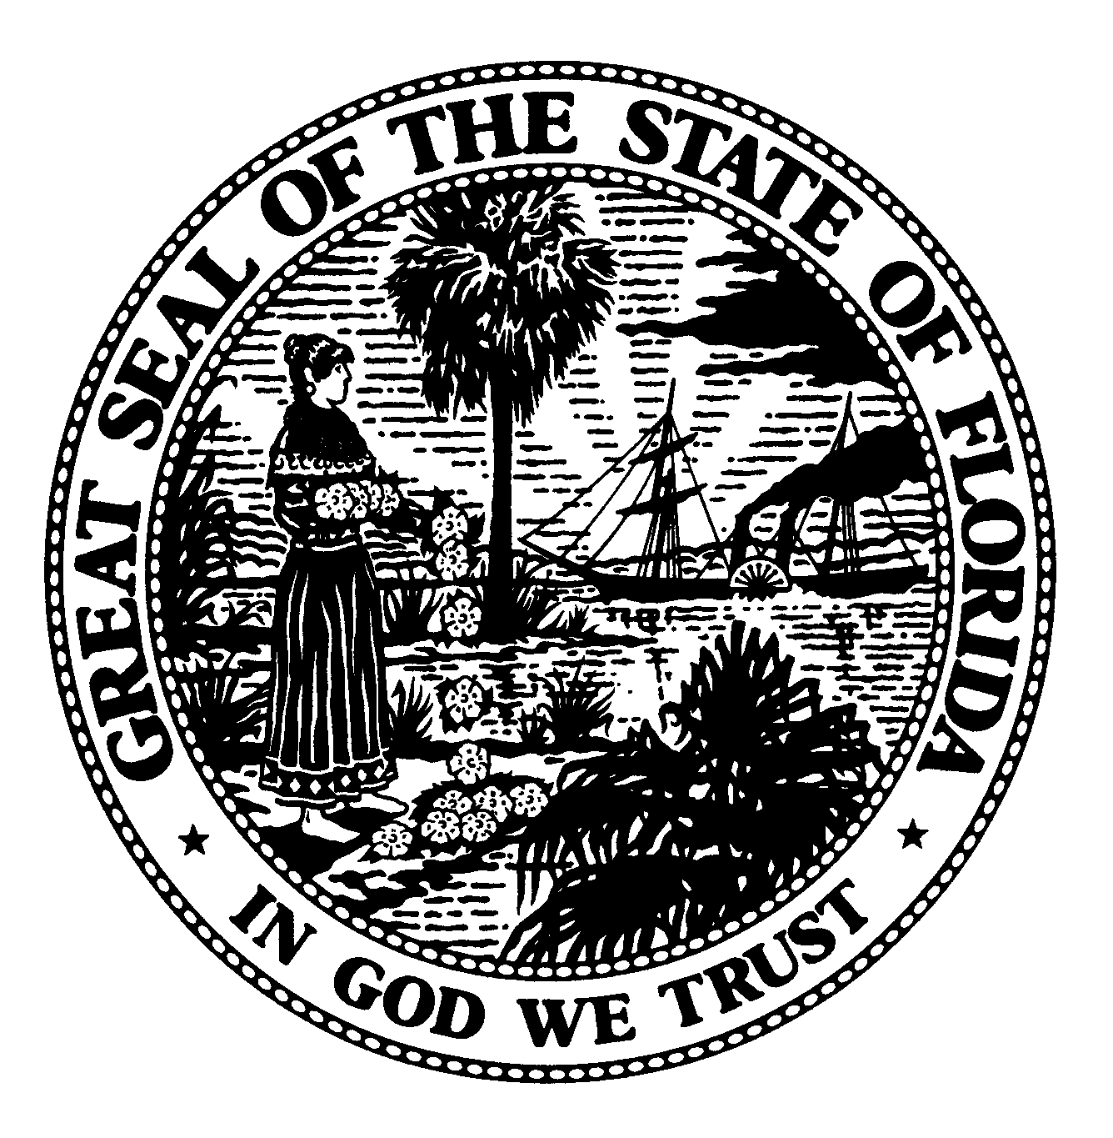 | The Florida Legislature  Office of Program Policy Analysis and  Government Accountability | 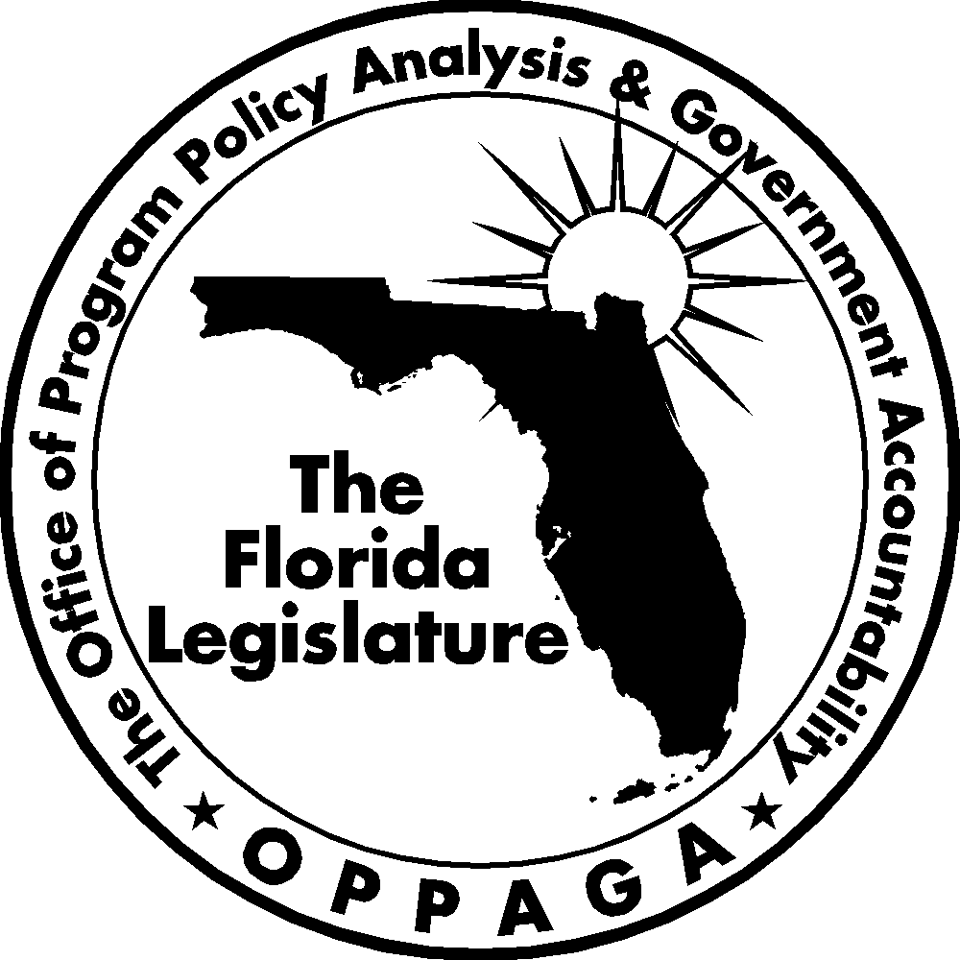
 | Gary R. VanLandingham, Ph.D., Director

MEMORANDUM

DATE: September 11, 2007

TO: Senator Don Gaetz, Co-Chair Joint Legislative Sunset Committee
Representative Kevin Ambler, Co-Chair Joint Legislative Sunset Committee

CC: Rick Mahler, Staff Director Joint Legislative Sunset Committee
Jaime Deloach, Staff Director Senate Committee on General Government Appropriations
Wayne Kiger, Staff Director Senate Committee on Environmental Preservation and Conservation
Tom Hamby, Council Director House Environmental and Natural Resources Council

FROM: Kara Collins-Gomez, Staff Director (850/487-4257)
Alex Regalado, Senior Legislative Analyst (850/487-9234)

RE: Water Management Districts Advisory Committees

Summary

In response to a request from the Joint Legislative Sunset Committee, we have reviewed the advisory committees of the five water management districts. We reviewed the district’s advisory committees and identified and examined their purposes, activities, and related costs and assessed the need for continuation.

Florida’s water management districts had 11 advisory committees in Fiscal Year 2006-07 that incurred travel, staff, and other expenses totaling $378,842. In general, these advisory committees served a public purpose by providing the districts’ governing boards with stakeholder input or expertise in a variety of matters, including regional water supply issues, land management activities, and the restoration plans for the Everglades.

The Legislature and district governing boards may wish to consider continuing 10 of the 11 advisory committees because they generally provide useful citizen input into district decision making. However, the Legislature should repeal the statute creating the St. Johns River Water Management District's Ocklawaha River Basin Advisory Council. This council, which was created to advise the district’s governing board on water management issues affecting the Ocklawaha River Basin, has achieved its purpose and is no longer active.

Background
Florida has five water management districts that manage and protect the state’s water resources and related natural systems: Northwest Florida, Suwannee, St. Johns River, Southwest Florida, and South Florida. The districts are responsible for water supply, water quality, flood protection, and natural systems. The Governor appoints a governing board to each district and its members are subject to confirmation by the Florida Senate; the governing boards oversee district operations.
Of the five water management districts, three districts reported having 11 advisory committees; the committees reported by the remaining two districts, Northwest and Suwannee, did not meet the criteria we used for inclusion in this report. The committees that met our review criteria incurred travel, staff, and other expenses totaling $378,842 in Fiscal Year 2006-07 (see Exhibit 1). The advisory committees are funded by district ad valorem taxes.
As shown in Exhibit 1, the South Florida Water Management District’s Water Resources Advisory Commission accounted for most (69%) of the total cost reported during the fiscal year. This commission provides technical advice to the district’s governing board and the South Florida Ecosystem Restoration Task Force on water resource issues in south and central Florida. The relatively large cost of this committee can be attributed to its number
of members and level of activities. The
Exhibit 1
Water Management Districts Reported $378,842 in Costs for Advisory Committees in Fiscal Year 2006-07
District | Advisory Committee | Reported Cost
South Florida | Water Resources Advisory Commission | $261,558
Southwest Florida | Environmental Advisory Committee | 15,353
 | Agricultural Advisory Committee | 11,015
 | Well Drilling Advisory Committee | 10,355
 | Public Supply Advisory Committee | 9,816
 | Green Industry Advisory Committee | 6,881
 | Industrial Advisory Committee | 6,864
St. Johns River | Harris Chain of Lakes Restoration Council | 50,000
 | Agricultural Advisory Committee | 4,500
 | Indian River Lagoon Basin Advisory Council | 2,500
 | Ocklawaha River Basin Advisory Council | 0
Total |  | $378,842
Source: St. Johns River Water Management District, Southwest Florida Water Management District, South Florida Water Management District. Data reported for Fiscal Year 2006-07 (October 2006 to September 2007).
commission has 47 current members representing different constituencies including agriculture, business, environmentalists, public interest groups, water supply utilities, and local, state, federal and tribal government. Between July 2006 and July 2007, the commission held 29 meetings and workshops throughout the district. In addition, the district allocated two full-time staff members to manage the committee’s activities.
Total reported costs of the advisory committees for St. Johns River and the Southwest Florida Water Management Districts totaled $57,000 (four committees) and $60,284 (six committees), respectively. The Ocklawaha River Basin Advisory Council has been inactive for over a decade and no costs were reported.
See Appendix A for more information about the districts’ advisory committees.
Assessment
In assessing districts’ advisory committees, we considered various criteria, including whether the committees
- serve a public purpose;
- facilitate public participation in an agency’s activities and provide agency staff with stakeholder expertise without duplicating the efforts of other entities; and
- fulfill their public purposes.
We concluded that most of the districts’ advisory committees serve a public purpose by providing the district governing boards with stakeholder input or expertise in a variety of matters. For example, the South Florida Water Management District’s Water Resources Advisory Commission reviews and comments on regional water supply plans, land management activities, and restoration plans for the Everglades and Lake Okeechobee. Southwest Florida Water Management District’s six advisory committees represent different constituencies (e.g., the agricultural industry, well drillers, and landscapers) and provide input on the district’s programs, projects, and resource management issues. Similarly, the St. Johns River Water Management District’s advisory committees provide input on protecting and restoring water resource areas such as the Indian River Lagoon Basin and Harris Chain of Lakes.
However, we recommend that the Legislature repeal s. 373.0693(8)(a), Florida Statutes, which would abolish the St. John’s River Water Management District’s Ocklawaha River Basin Advisory Council. The Legislature initially created this council to receive public input and advise the district's governing board on water management issues affecting the Oklawaha River Basin. However, the council has not met in over 10 years. District managers report that the council’s purpose has been fulfilled and it is no longer active. The district continues to receive public input on the Ocklawaha River Basin through public meetings and workshops held in the basin.
In conclusion, the Legislature and district governing boards may wish to consider continuing 10 of the districts’ 11 committees. Although the governing boards could implement policies without these committees, they generally provide useful citizen input into agency decision making and eliminating them would not reduce state costs.

Appendix A
The Water Management Districts Had 11 Advisory Committees in Fiscal Year 2006-07
Advisory committees are listed by water management district in order of costs (highest to lowest) incurred in Fiscal Year 2006-07.

Table A-1
St. Johns River Water Management District Advisory Committees
Advisory Committee | Purpose | Agency Reported Activities | Impact of Abolition
Harris Chain of Lakes Restoration Council | Advises the district’s governing board on restoration activities of the Harris Chain of Lakes. The council is authorized by s.373.467(1)(a), F.S.  The council’s reported cost for Fiscal Year 2006-07 was $50,000. | The council meets monthly to review lake restoration and population recovery strategies; evaluate the need for additional studies; explore possible funding sources for restoration activities. The council also provides an annual report to the Legislature. | Discontinuing the council may decrease the input received by the district on issues related to the Harris Chain of Lakes and implementation of restoration activities. Eliminating the council would require repealing s.373.467(1)(a), F.S.
Agricultural Advisory Committee | Provides recommendations to the governing board regarding district programs that affect agriculture.  The committee’s reported cost for Fiscal Year 2006-07 was $4,500. | The committee met twice in the past year to discuss issues affecting agriculture, such as water use. | Discontinuing the committee may reduce communication with and input from the agricultural community.
Indian River Lagoon Basin Advisory Council | Provides recommendations to the governing board on the district’s role in protecting and restoring the Indian River Lagoon.  The council’s reported cost for Fiscal Year 2006-07 was $2,500. | The council met three times in the past year to discuss the implementation of management projects for the Indian River Lagoon. | Discontinuing the council may reduce the technical input from and communication with various entities related to the protection and restoration of the Indian River Lagoon.
Ocklawaha River Basin Advisory Council | Advises the governing board on water management issues affecting the Ocklawaha River Basin. The council is authorized by s.373.0693 (8)(a), F.S.  There were no reported costs for Fiscal Year 2006-07. | The council has not met in over a decade. | None. The council has not met in over a decade. The Legislature would have to repeal  s.373.0693 (8)(a), F.S.
Source: St. Johns River Water Management District.
Table A-2
Southwest Florida Water Management District Advisory Committees
Advisory Committee | Purpose | Agency Reported Activities | Impact of Abolition
Environmental Advisory Committee | Provides professional and technical input to the district’s governing board on water management district programs and activities.  The committee’s reported cost for Fiscal Year 2006-07 was $15,353. | The committee provides input into regulatory programs, rule revisions, water conservation activities, water resource planning, water resource and supply development projects, research and other water resource management projects that relate to the environment. The committee meets on a quarterly basis or as needed. | Discontinuing the committee would reduce communication with and input from the environmental community on water management district issues.
Agricultural Advisory Committee | Provides professional and technical input to the district’s governing board on water management district programs and activities.  The committee’s reported cost for Fiscal Year 2006-07 was $11,015. | The committee provides input into regulatory programs, rule revisions, water conservation activities, water resource planning, water resource and supply development projects, research and other water resource management related to the agricultural industry. The committee meets on a quarterly basis or as needed. | Discontinuing the committee would reduce communication with and input from the agricultural community on water management district issues.
Well Drilling Advisory Committee | Provides professional and technical input to the district’s governing board on water management district programs and activities.  The committee’s reported cost for Fiscal Year 2006-07 was $10,355. | The committee provides input into regulatory programs, rule revisions, water conservation activities, water resource planning, water resource and supply development projects, research and other water resource management related to the well construction industry. The committee meets on a quarterly basis or as needed. | Discontinuing the committee would reduce communication with and input from the well construction community on water management district issues.
Public Supply Advisory Committee | Provides professional and technical input to the district’s governing board on water management district programs and activities.  The committee’s reported cost for Fiscal Year 2006-07 was $9,816. | The committee provides input into regulatory programs, rule revisions, water conservation activities, water resource planning, water resource and supply development projects, research and other water resource management projects that relate to the environment. The committee meets on a quarterly basis or as needed. | Discontinuing the committee would reduce communication with and input from the water supply community on water management district issues.
Green Industry Advisory Committee | Provides professional and technical input to the district’s governing board on water management district programs and activities.  The committee’s reported cost for Fiscal Year 2006-07 was $6,881. | The committee provides input into regulatory programs, rule revisions, water conservation activities, water resource planning, water resource and supply development projects, research and other water resource management related to the green industry. The green industry refers to entities involved in outdoor landscaping or irrigation. The committee meets on a quarterly basis or as needed. | Discontinuing the committee would reduce communication with and input from the green industry on water management district issues.
Industrial Advisory Committee | Provides professional and technical input to the district’s governing board on water management district programs and activities.  The committee’s reported cost for Fiscal Year 2006-07 was $6,864. | The committee provides input into regulatory programs, rule revisions, water conservation activities, water resource planning, water resource and supply development projects, research and other water resource management projects that relate to the environment. The committee meets on a quarterly basis or as needed. | Discontinuing the committee would reduce communication with and input from the industrial community on water management district issues.
Source: Southwest Florida Water Management District.

Table A-3
South Florida Water Management District Advisory Committee
Advisory Committee | Purpose | Agency Reported Activities | Impact of Abolition
Water Resources Advisory Commission | Provides technical advice to the district’s governing board and the South Florida Ecosystem Restoration Task Force on water resource issues in south and central Florida.  The commission’s reported cost for Fiscal Year  2006-07 was $261,558. | The commission provides technical expertise and input on various issues including: ecosystem restoration plans for the Everglades, Kissimmee River, and Lake Okeechobee; regional water supply plans; and recreational access and public use of district lands. The commission provides its comments to the district’s governing board. The commission meets monthly and often holds workshops on issues. | Discontinuing the commission would result in a loss of technical expertise and stakeholder input on water resource issues.
Source: South Florida Water Management District.

Included in our review were advisory committees that are defined in ss. 20.03(3), (7), (8), (9), (10), and (12), F. S., or were created through executive order.
² Our research found that the Northwest and Suwannee water management districts have established a committee of three staff members, established by administrative rule, to evaluate and certify firms interested in providing professional services to the district. These staff committees make recommendations on the selection of certified firms to its governing board. Similar staff committees also were reported by the other water management districts.
The governing board of each district is authorized by the Florida Constitution and by statute to levy ad valorem property taxes to fund district operations.
The Water Resource Advisory Commission also has a Lake Okeechobee Subcommittee with 25 current members representing different constituencies. The costs for the subcommittee are included in those for the commission.
Section 20.052(1), F. S.
Section 20.052(2), F. S.

